## DAILY ONLINE ACTIVITIES SUMMARY

|  |  |  |  |  |  |  |
| --- | --- | --- | --- | --- | --- | --- |
| **Date:** | **16th June 2020** | | | | **Name:** | **Dsouza Elston Ronald** |
| **Sem & Sec** | **6th A section** | | | | **USN:** | **4AL17CS029** |
| **Assesment Test Summary** | | | | | | |
| **Subject** | | **Assessment test** | | | | |
| **Max. Marks** | | **20** | **Score** | | | **13** |
| **Coding Challenges** | | | | | | |
| 1. Write a Python program to check whether a given a binary tree is a valid binary search tree (BST) or not? . | | | | | | |
| **Status: Completed** | | | | | | |
| **Uploaded the report in Github** | | | | **Yes** | | |
| **If yes Repository name** | | | | <https://github.com/alvas-education-foundation/elston-dsouza> | | |
| **Uploaded the report in slack** | | | | **Yes** | | |

Online Test Details: (Attach the snapshot and briefly write the report for the same)

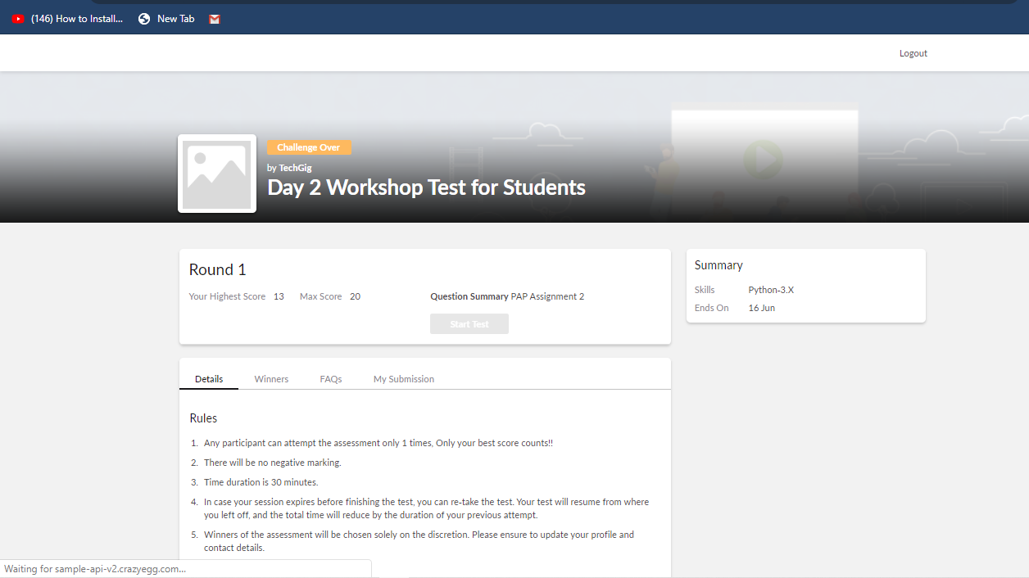

Assesment details:

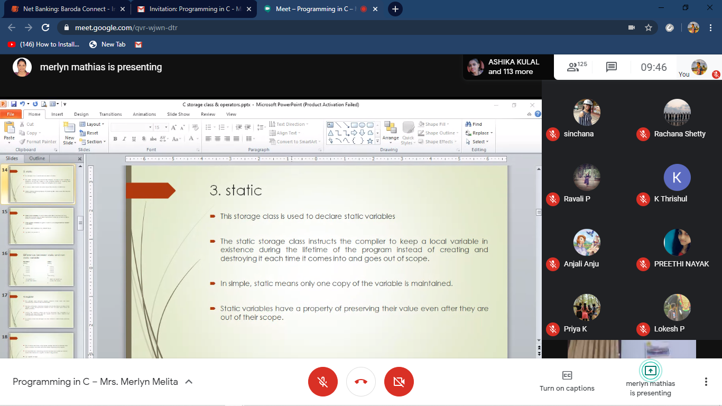

The following are the details of the session 1 on “Programming in C” by Mrs.Melita Mathias.Details are as above.

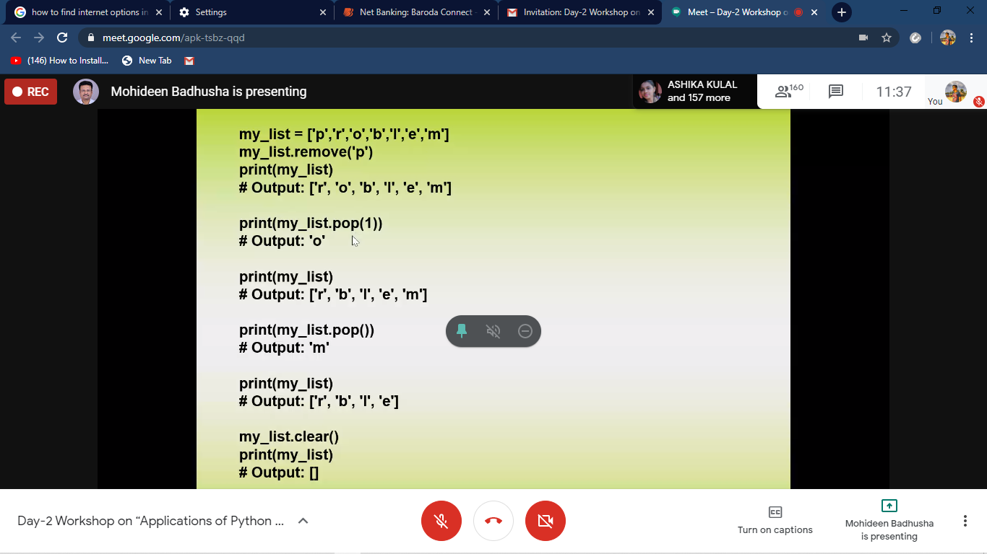

The following are the details of the session 2 on “Python applications in Machine Learning and Data analytics” by Dr.Moideen Badusha.Details are as above.

The solutions of the above course are uploaded in github.link is <https://github.com/elstonds/Python_application_in_DA_and_ML>

Coding Challenges Details: (Attach the snapshot and briefly write the report for the same)

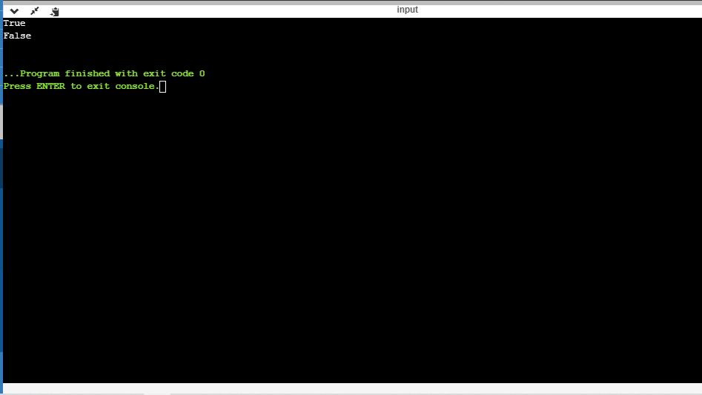

The above the programs were written and executed and the output of the same is displayed above. The code for the given 1 program have been uploaded to the github repository and the link to the same is provided on the form.