## DAILY ONLINE ACTIVITIES SUMMARY

|  |  |  |  |  |  |  |
| --- | --- | --- | --- | --- | --- | --- |
| **Date:** | **23rd June 2020** | | | | **Name:** | **Dsouza Elston Ronald** |
| **Sem & Sec** | **6th A section** | | | | **USN:** | **4AL17CS029** |
| **Assesment Test Summary** | | | | | | |
| **Subject** | | **Assessment test** | | | | |
| **Max. Marks** | | **10** | **Score** | | | **9** |
| **Coding Challenges** | | | | | | |
| 1. Write a Java Program to traverse a binary tree using PreOrder traversal without recursion . 2. Write a C Program to Sort a stack using a temporary stack | | | | | | |
| **Status: Completed** | | | | | | |
| **Uploaded the report in Github** | | | | **Yes** | | |
| **If yes Repository name** | | | | <https://github.com/alvas-education-foundation/elston-dsouza> | | |
| **Uploaded the report in slack** | | | | **Yes** | | |

Online Test Details: (Attach the snapshot and briefly write the report for the same)

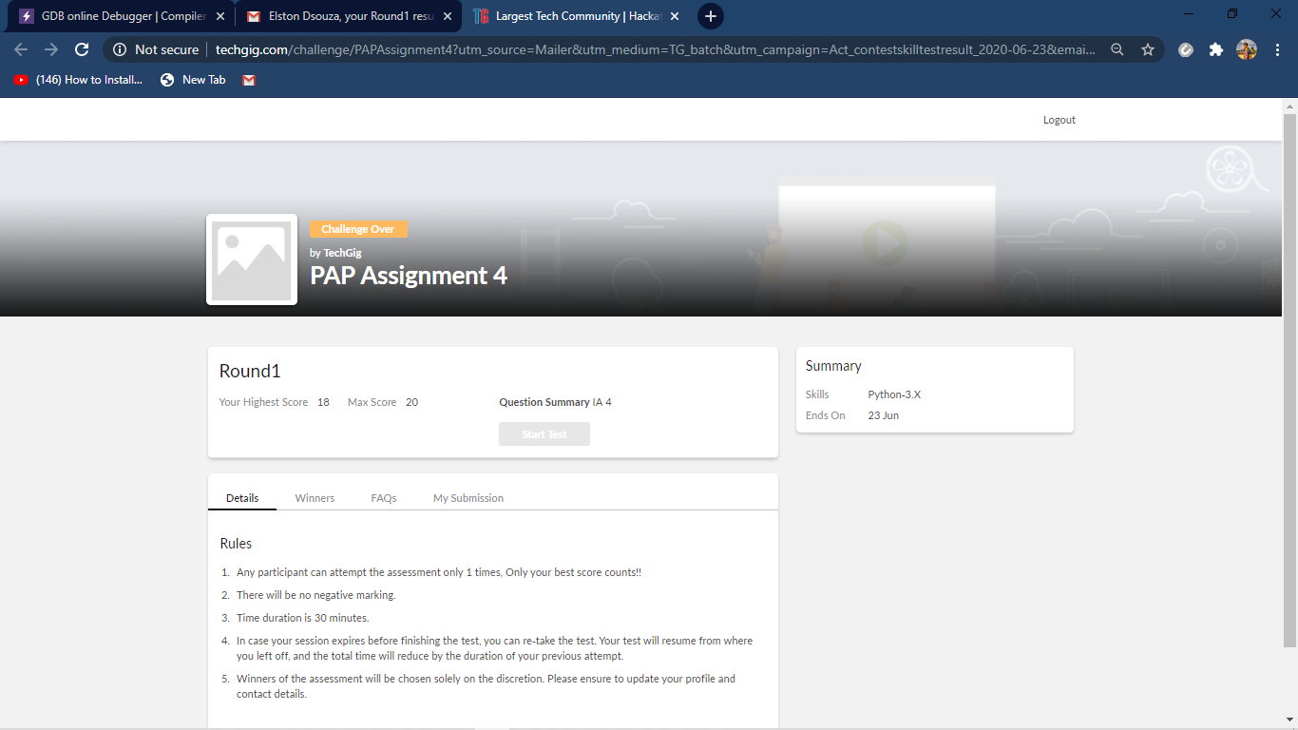

Python assignment 4 details

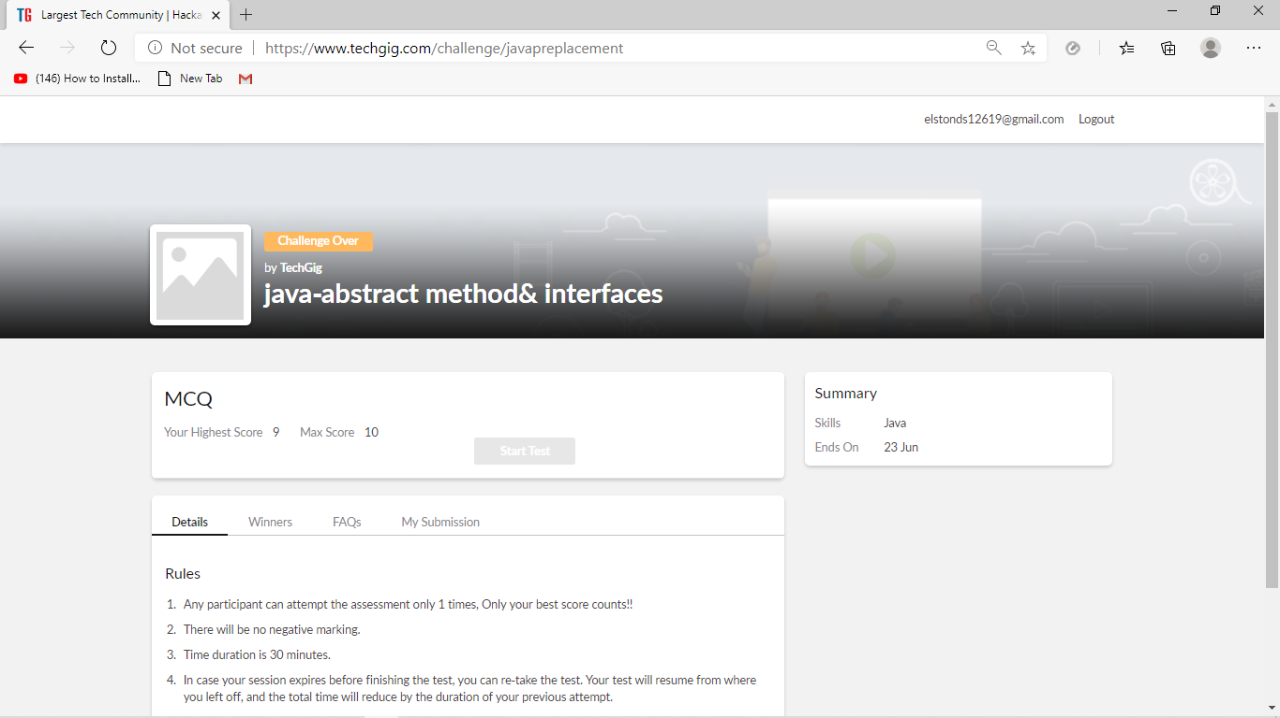

Placement assessment test details

Assesment details:

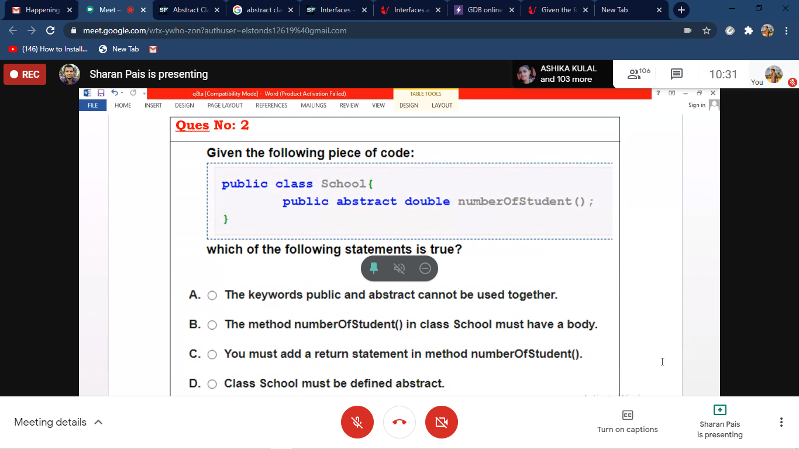

The following are the details of the session 1 on “JAVA and J2EE” by Mr.Sharan Pais .Details are as above.The details are as follows :

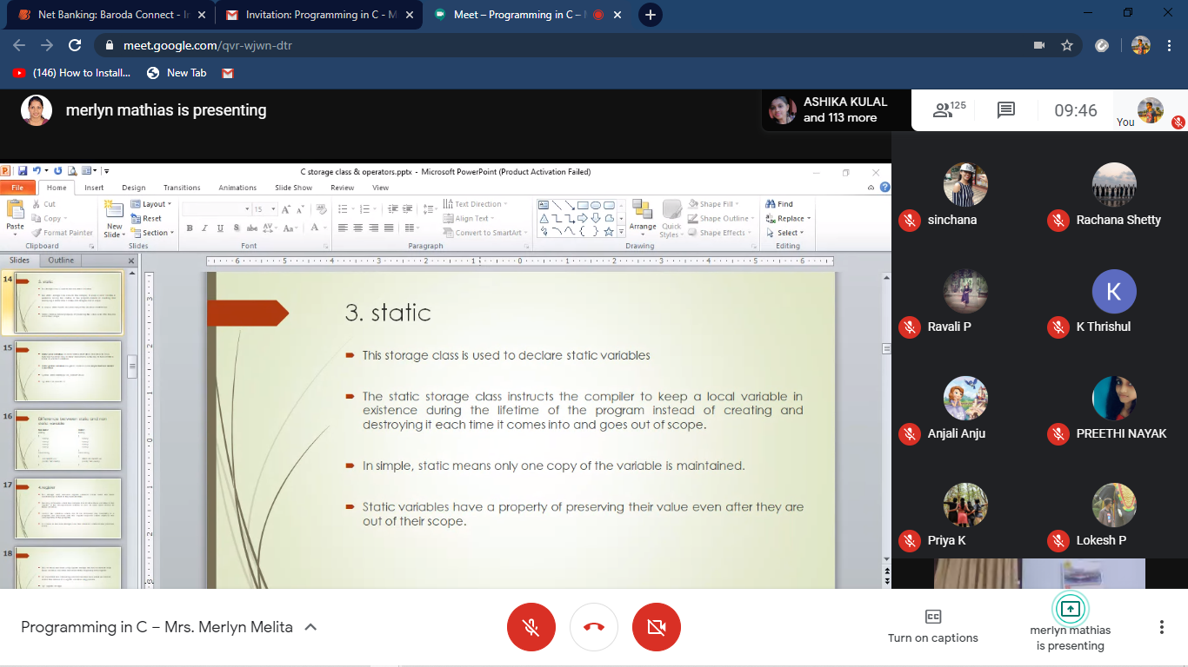

The following are the details of the session 2 on “Data Structures” by Mrs.Merlyn.

Coding Challenges Details: (Attach the snapshot and briefly write the report for the same)

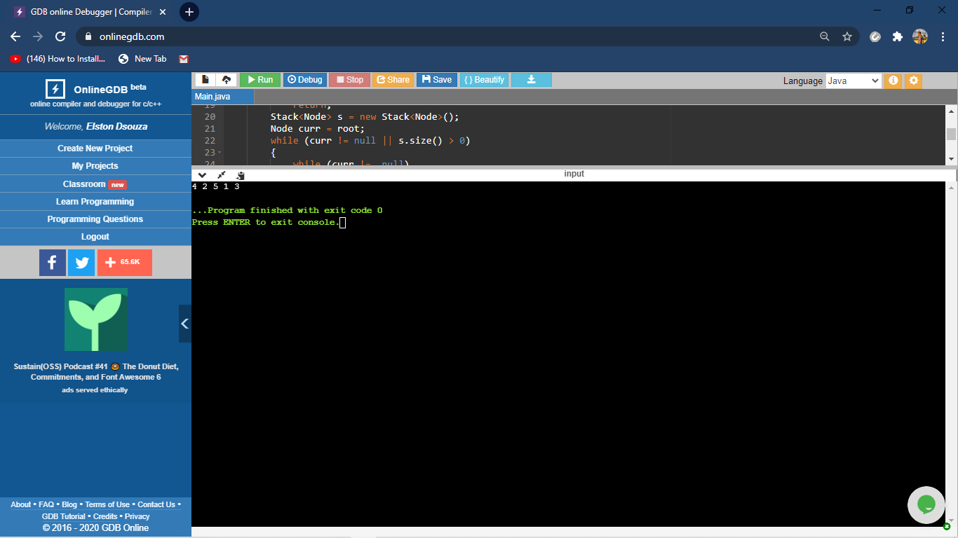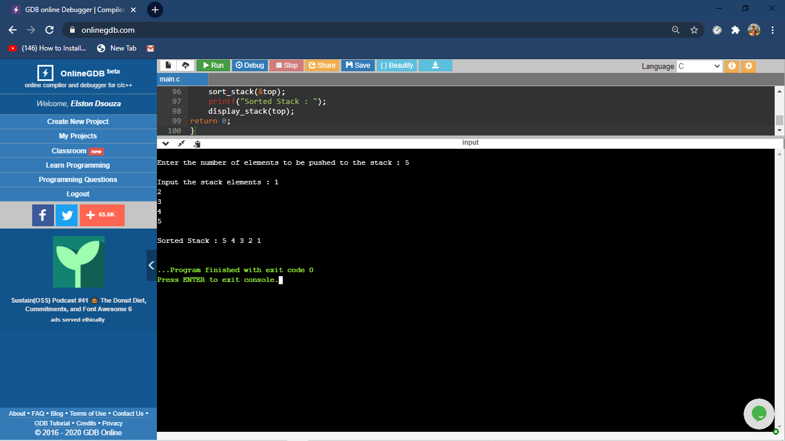

The above the programs were written and executed and the output of the same is displayed above. The code for the given 2 programs have been uploaded to the github repository and the link to the same is provided on the form.