## DAILY ONLINE ACTIVITIES SUMMARY

|  |  |  |  |  |  |  |
| --- | --- | --- | --- | --- | --- | --- |
| **Date:** | **24th June 2020** | | | | **Name:** | **Dsouza Elston Ronald** |
| **Sem & Sec** | **6th A section** | | | | **USN:** | **4AL17CS029** |
| **Assesment Test Summary** | | | | | | |
| **Subject** | | **Assessment test** | | | | |
| **Max. Marks** | |  | **Score** | | |  |
| **Coding Challenges** | | | | | | |
| 1. Create a class named 'Shape' with a method to print "This is This is shape". Then create two other classes named 'Rectangle', 'Circle' inheriting the Shape class, both having a method to print "This is rectangular shape" and "This is circular shape" respectively. Create a subclass 'Square' of 'Rectangle' having a method to print "Square is a rectangle". Now call the method of 'Shape' and 'Rectangle' class by the object of 'Square' class | | | | | | |
| **Status: Completed** | | | | | | |
| **Uploaded the report in Github** | | | | **Yes** | | |
| **If yes Repository name** | | | | <https://github.com/alvas-education-foundation/elston-dsouza> | | |
| **Uploaded the report in slack** | | | | **Yes** | | |

Online Test Details: (Attach the snapshot and briefly write the report for the same)

Assesment details:

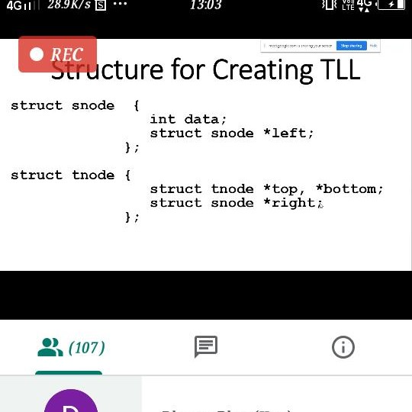

The following are the details of the session 1 on “JAVA and J2EE” by Ms.Shilpa .Details are as above.The details are as follows :

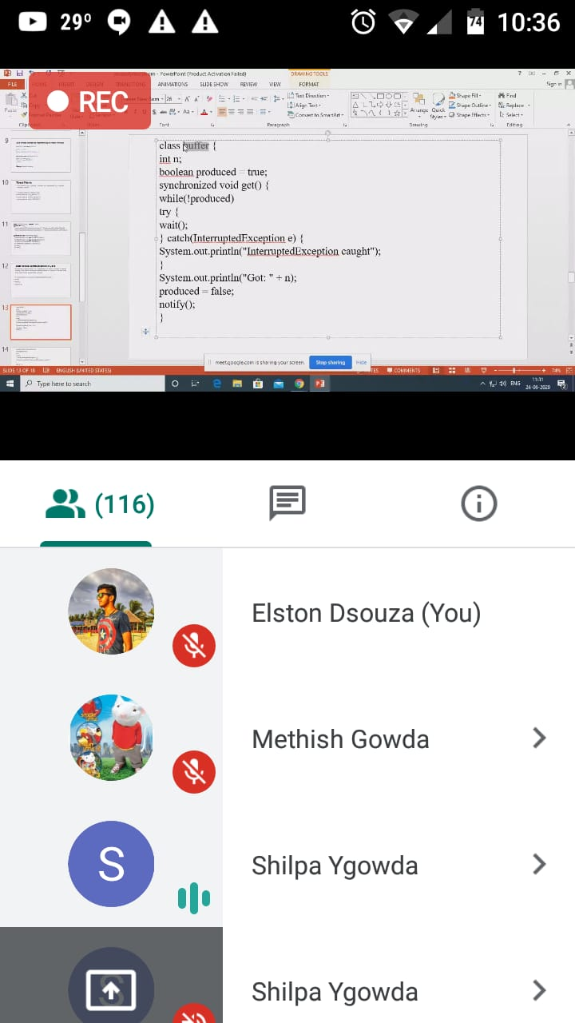

The following are the details of the session 2 on “Data Structures” by Prof.Venkatesh Bhat.

Coding Challenges Details: (Attach the snapshot and briefly write the report for the same)

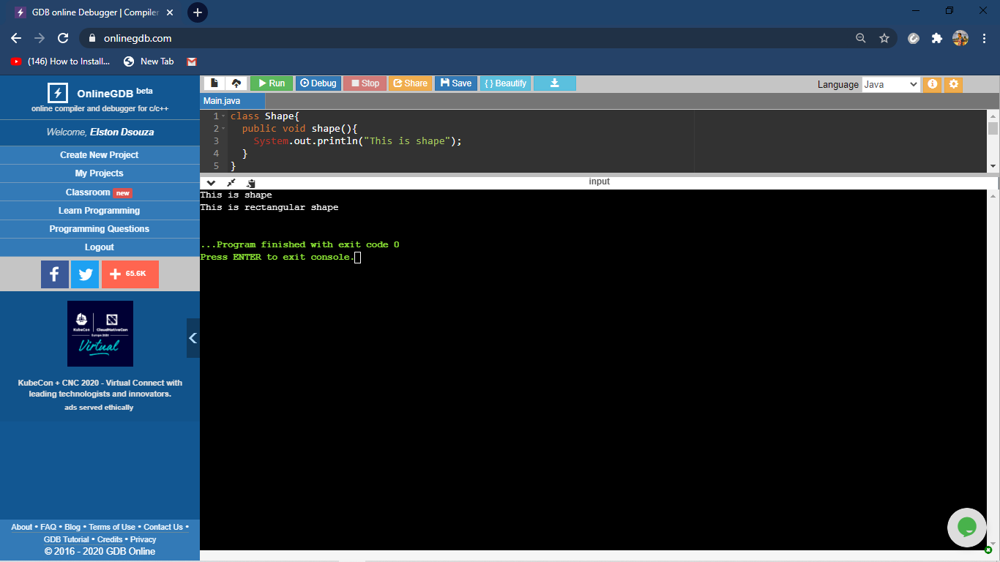

The above the programs were written and executed and the output of the same is displayed above. The code for the given 1 program have been uploaded to the github repository and the link to the same is provided on the form.