## DAILY ONLINE ACTIVITIES SUMMARY

|  |  |  |  |  |  |  |
| --- | --- | --- | --- | --- | --- | --- |
| **Date:** | **26th June 2020** | | | | **Name:** | **Dsouza Elston Ronald** |
| **Sem & Sec** | **6th A section** | | | | **USN:** | **4AL17CS029** |
| **Assesment Test Summary** | | | | | | |
| **Subject** | | **Assessment test** | | | | |
| **Max. Marks** | |  | **Score** | | |  |
| **Coding Challenges** | | | | | | |
| 1.Java program to get all the permutations of the given string. | | | | | | |
| **Status: Completed** | | | | | | |
| **Uploaded the report in Github** | | | | **Yes** | | |
| **If yes Repository name** | | | | <https://github.com/alvas-education-foundation/elston-dsouza> | | |
| **Uploaded the report in slack** | | | | **Yes** | | |

Online Test Details: (Attach the snapshot and briefly write the report for the same)

Assesment details:

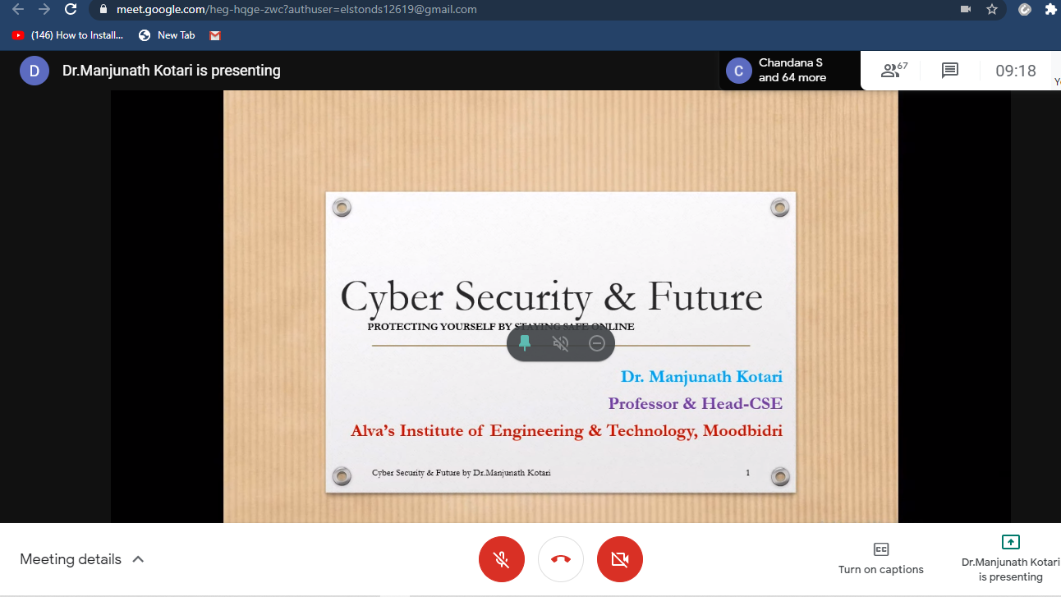

The following are the details of the session 1 on “CyberSecurity” by Dr.Manjunath Kottari .Details are as above.The details are as follows :

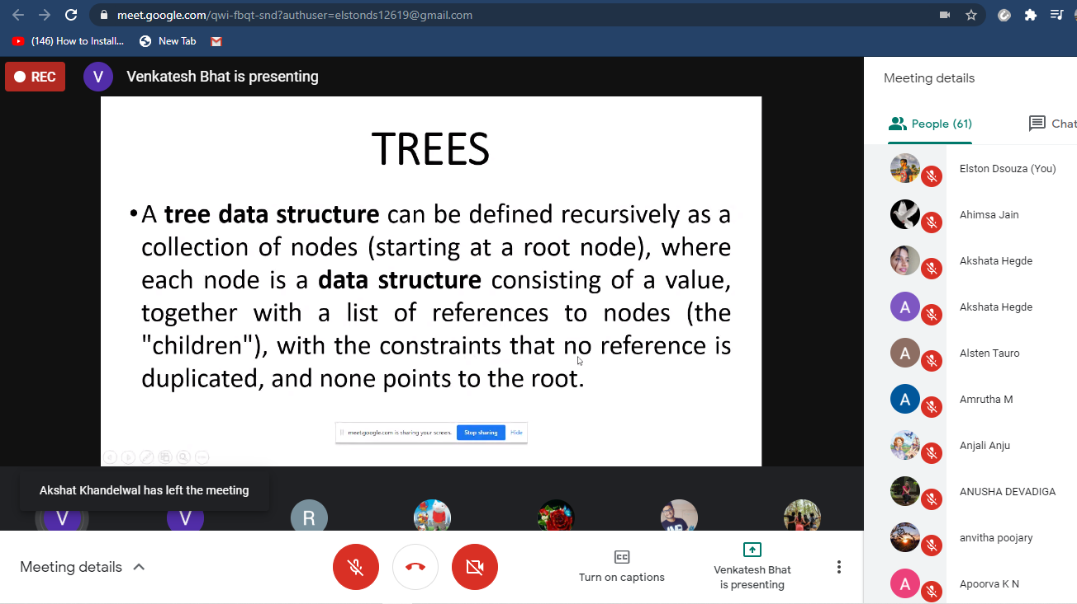

The following are the details of the session 2 on “Data Structures:Linked lists” by Prof.Venkatesh Bhat. The solutions are included in the following: <https://github.com/elstonds/Programming_in_C/tree/master/linkedlist>

Coding Challenges Details: (Attach the snapshot and briefly write the report for the same)

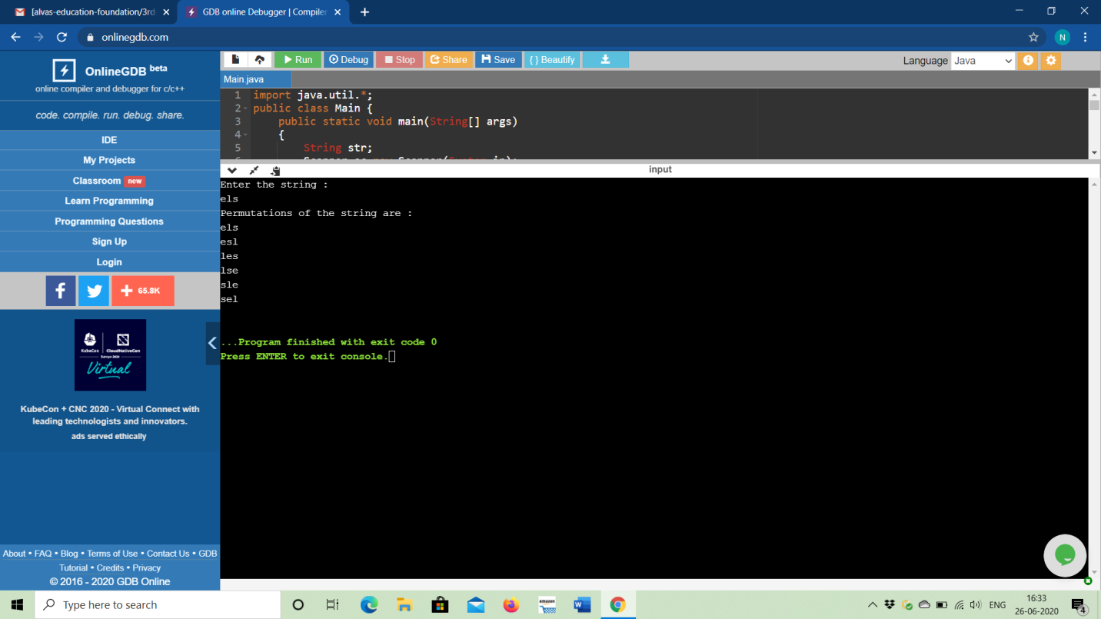

The above the programs were written and executed and the output of the same is displayed above. The code for the given program have been uploaded to the github repository and the link to the same is provided on the form.