**DAILY ONLINE ACTIVITIES SUMMARY**

|  |  |  |  |  |  |  |  |  |
| --- | --- | --- | --- | --- | --- | --- | --- | --- |
| **Date:** | **20th May 2020** | | | | | **Name:** | **Dsouza Elston Ronald** | |
| **Sem & Sec** | **6th A section** | | | | | **USN:** | **4AL17CS029** | |
| **Online Test Summary** | | | | | | | | |
| **Subject** | | **System Software and Compiler Design(SSCD)** | | | | | | |
| **Max. Marks** | | **30** | | **Score** | | | **20** | |
| **Certification Course Summary** | | | | | | | | |
| **Course** | **Full Stack Web Developer-Beginner to Advanced** | | | | | | | |
| **Certificate Provider** | | | **Udemy** | | **Duration** | | | **20 hours** |
| **Coding Challenges** | | | | | | | | |
| 1. Write a simple Python program to implement Diffie–Hellman Key Exchange Example 2. Python Program to Exchange the Values of Two Numbers using ^ (exclusive or operator) 3. Write Python Program to Reverse a Given Number. 4. [Write a C Program to Reverse a Linked List in groups of given size.](https://github.com/orgs/alvas-education-foundation/teams/3rd-year/discussions/13) | | | | | | | | |
| **Status: Completed** | | | | | | | | |
| **Uploaded the report in Github** | | | | | **Yes** | | | |
| **If yes Repository name** | | | | | <https://github.com/alvas-education-foundation/Elston-Dsouza-4al17cs029-> | | | |
| **Uploaded the report in slack** | | | | | **Yes** | | | |

Online Test Details: (Attach the snapshot and briefly write the report for the same)

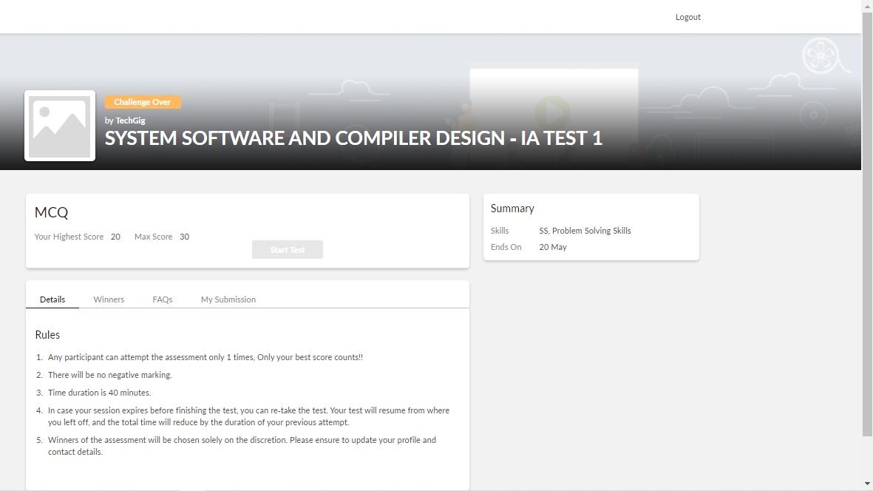

The above assessment was done by me on 20th May 2020 from 9 to 10 am and the details of assessment is as above.

Certification Course Details: (Attach the snapshot and briefly write the report for the same)

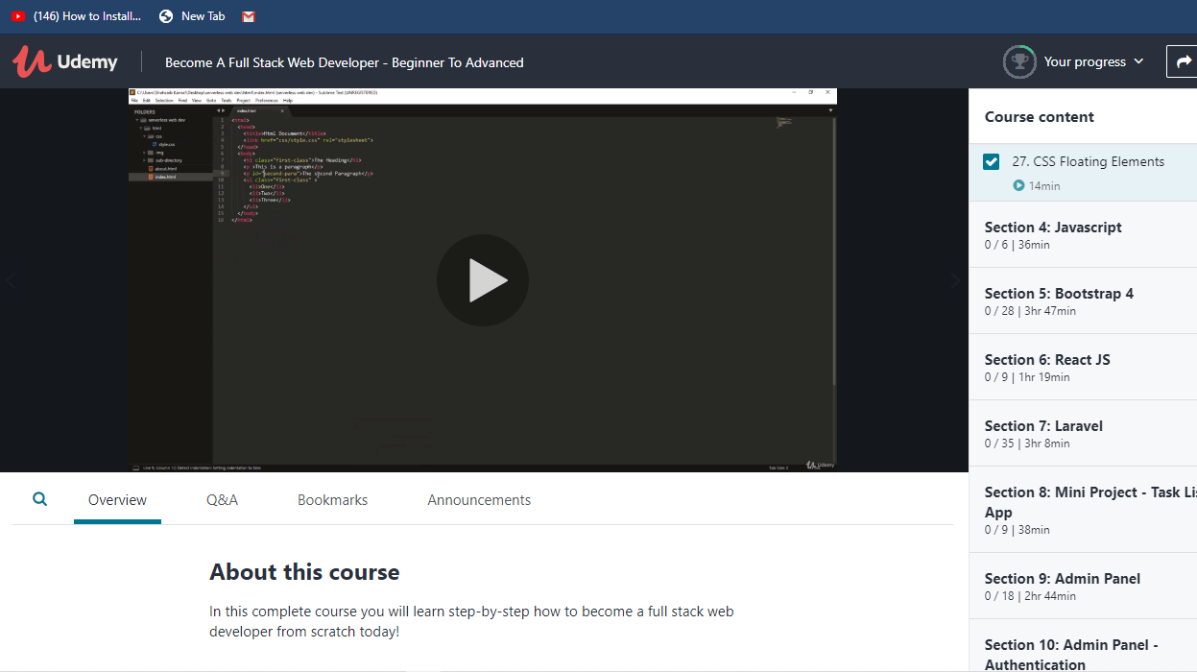

The above course is being taken up by me which is based on full stack web development. The course has started with the HTML basics as well as the various concepts in HTML. The details of the course and certificate provider is mentioned in the above form.

Coding Challenges Details: (Attach the snapshot and briefly write the report for the same)

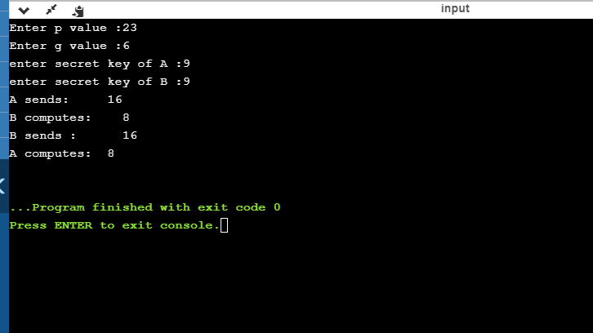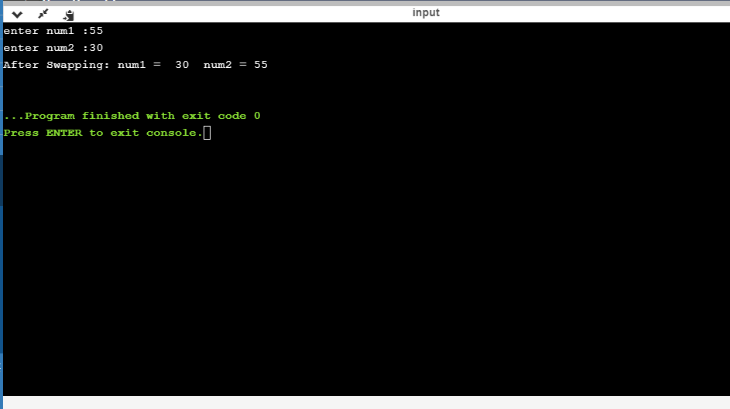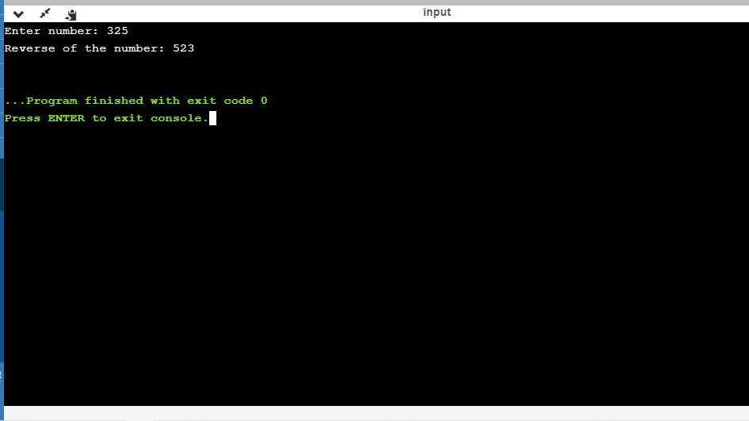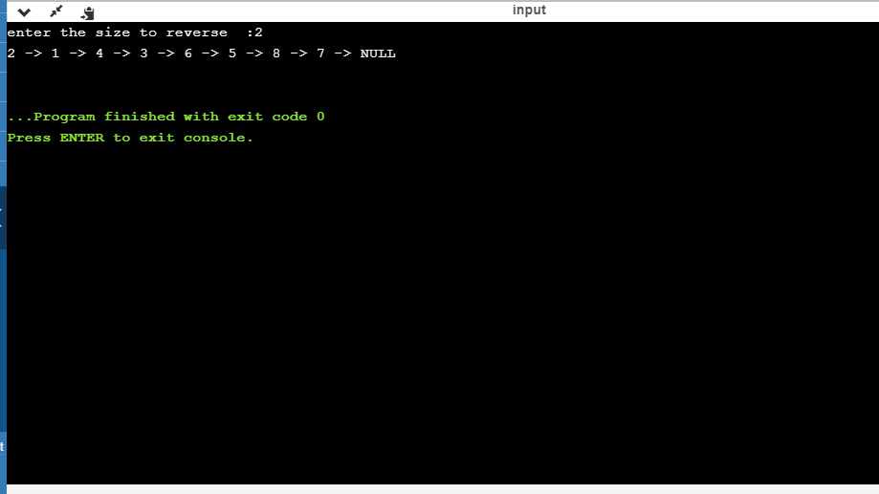

The above the programs were written and executed and the output of the same is displayed above. The code for the given 4 programs have been uploaded to the github repository and the link to the same is provided on the form.