## DAILY ONLINE ACTIVITIES SUMMARY

|  |  |  |  |  |  |  |
| --- | --- | --- | --- | --- | --- | --- |
| **Date:** | **29th June 2020** | | | | **Name:** | **Dsouza Elston Ronald** |
| **Sem & Sec** | **6th A section** | | | | **USN:** | **4AL17CS029** |
| **Assesment Test Summary** | | | | | | |
| **Subject** | | **Assessment test** | | | | |
| **Max. Marks** | |  | **Score** | | |  |
| **Coding Challenges** | | | | | | |
| 1Java program to find maximum and minimum ocuring character in string.. | | | | | | |
| **Status: Completed** | | | | | | |
| **Uploaded the report in Github** | | | | **Yes** | | |
| **If yes Repository name** | | | | <https://github.com/alvas-education-foundation/elston-dsouza> | | |
| **Uploaded the report in slack** | | | | **Yes** | | |

Online Test Details: (Attach the snapshot and briefly write the report for the same)

Assesment details:

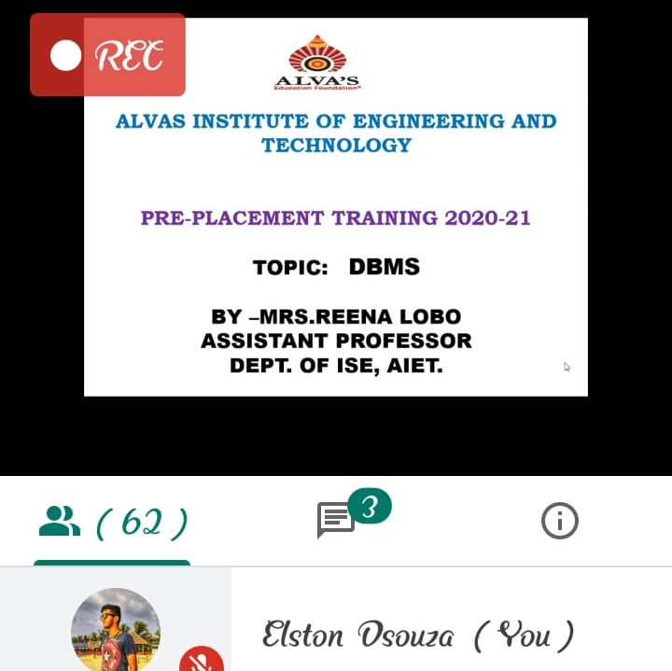

The following are the details of the session 1 on “DBMS” by Mrs.Reena Lobo .Details are as above.The details of the assessment are as follows :

<https://github.com/alvas-education-foundation/elston-dsouza/blob/master/coding_solutions/day40(27-06-2020)/assesment(27-06-2020).pdf>

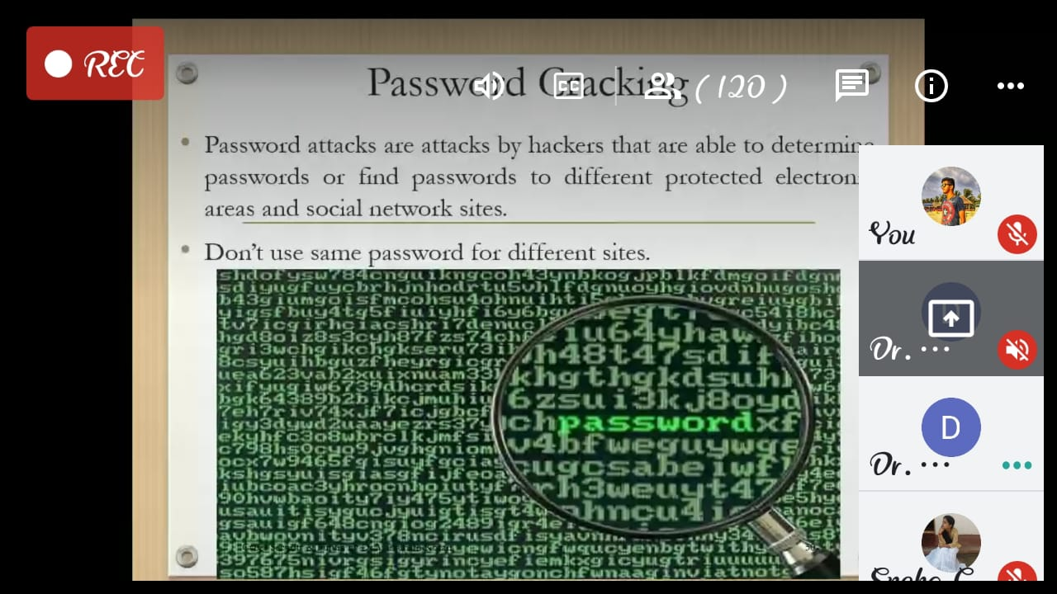

The following are the details of the session 2 on “Cybersecurity” by Dr.Manjunath Kottari.

Coding Challenges Details: (Attach the snapshot and briefly write the report for the same)

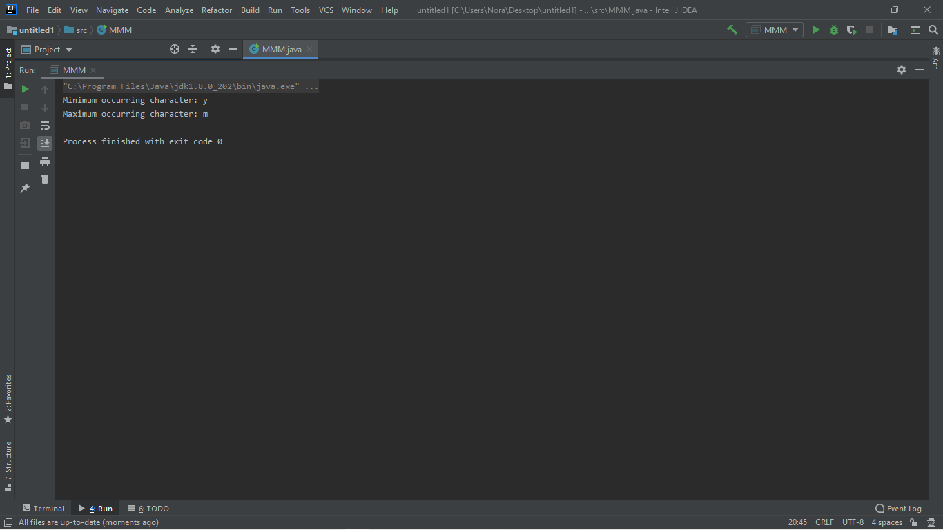

The above the programs were written and executed and the output of the same is displayed above. The code for the given 1 program have been uploaded to the github repository and the link to the same is provided on the form.