## DAILY ONLINE ACTIVITIES SUMMARY

|  |  |  |  |  |  |  |
| --- | --- | --- | --- | --- | --- | --- |
| **Date:** | **30th June 2020** | | | | **Name:** | **Dsouza Elston Ronald** |
| **Sem & Sec** | **6th A section** | | | | **USN:** | **4AL17CS029** |
| **Assesment Test Summary** | | | | | | |
| **Subject** | | **Assessment test** | | | | |
| **Max. Marks** | |  | **Score** | | |  |
| **Coding Challenges** | | | | | | |
| 1.C program to generate first n ugly numbers.  2. Write a Java Program to determine whether one string is a rotation of another. | | | | | | |
| **Status: Completed** | | | | | | |
| **Uploaded the report in Github** | | | | **Yes** | | |
| **If yes Repository name** | | | | <https://github.com/alvas-education-foundation/elston-dsouza> | | |
| **Uploaded the report in slack** | | | | **Yes** | | |

Online Test Details: (Attach the snapshot and briefly write the report for the same)

Assesment details:

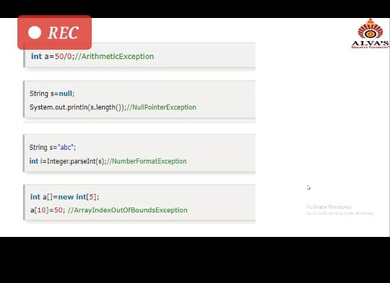

The following are the details of the session 1 on “JAVA” by Mr.Sharan Pais .Details are as above.

Coding Challenges Details: (Attach the snapshot and briefly write the report for the same)

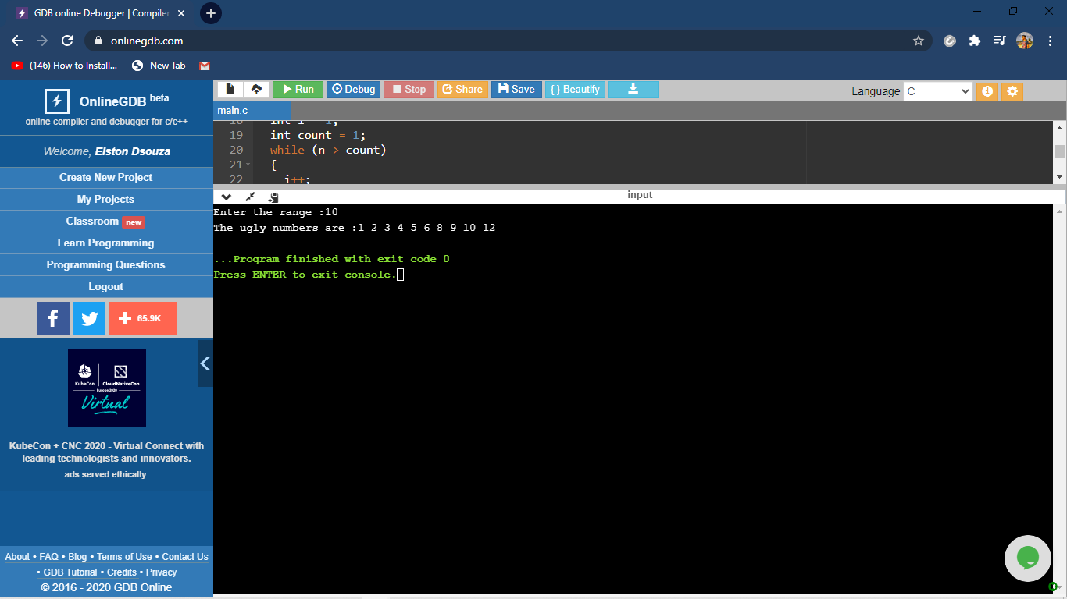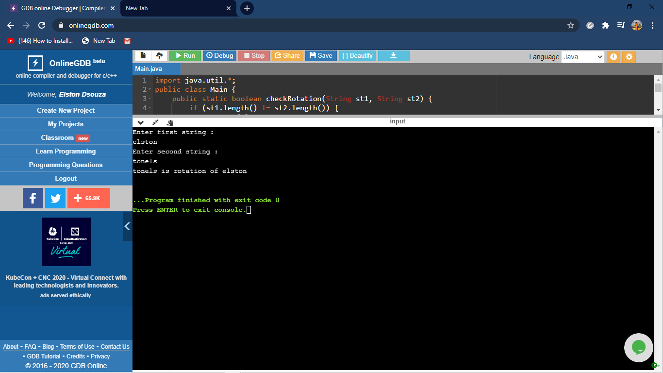

The above the programs were written and executed and the output of the same is displayed above. The code for the given 2 programs have been uploaded to the github repository and the link to the same is provided on the form.