**DAILY ONLINE ACTIVITIES SUMMARY**

|  |  |  |  |  |  |  |  |  |
| --- | --- | --- | --- | --- | --- | --- | --- | --- |
| **Date:** | **21th May 2020** | | | | | **Name:** | **Dsouza Elston Ronald** | |
| **Sem & Sec** | **6th A section** | | | | | **USN:** | **4AL17CS029** | |
| **Online Test Summary** | | | | | | | | |
| **Subject** | | **Operating System(OS)** | | | | | | |
| **Max. Marks** | | **30** | | **Score** | | | **30** | |
| **Certification Course Summary** | | | | | | | | |
| **Course** | **Full Stack Web Developer-Beginner to Advanced** | | | | | | | |
| **Certificate Provider** | | | **Udemy** | | **Duration** | | | **20 hours** |
| **Coding Challenges** | | | | | | | | |
| 1. Write C Program to create Singly Liked List with n elements and reverse the elements 2. Write a C program to construct a singly linked list by removing duplicate elements in the sorted linked list 3. Write a java program to implement round robin scheduling algorithm. 4. Write a Java Program to Demonstrate a Basic Calculator using Applet | | | | | | | | |
| **Status: Completed** | | | | | | | | |
| **Uploaded the report in Github** | | | | | **Yes** | | | |
| **If yes Repository name** | | | | | <https://github.com/alvas-education-foundation/Elston-Dsouza-4al17cs029-> | | | |
| **Uploaded the report in slack** | | | | | **Yes** | | | |

Online Test Details: (Attach the snapshot and briefly write the report for the same)

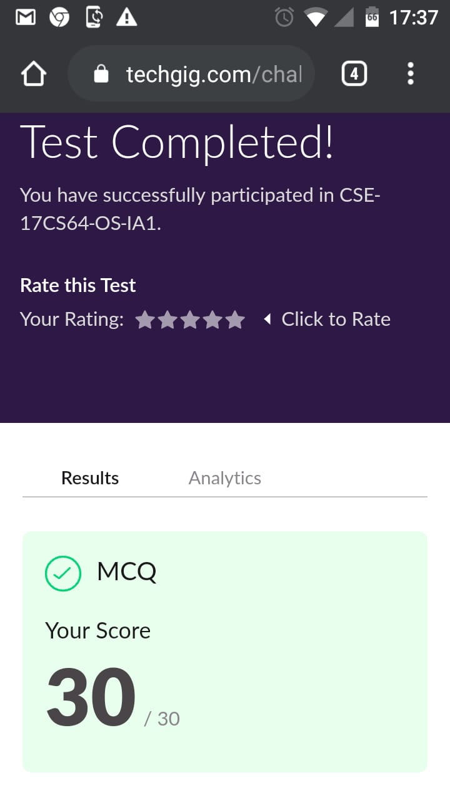

The above assessment was done by me on 21th May 2020 from 9 to 10 am and the details of assessment is as above.

Certification Course Details: (Attach the snapshot and briefly write the report for the same)

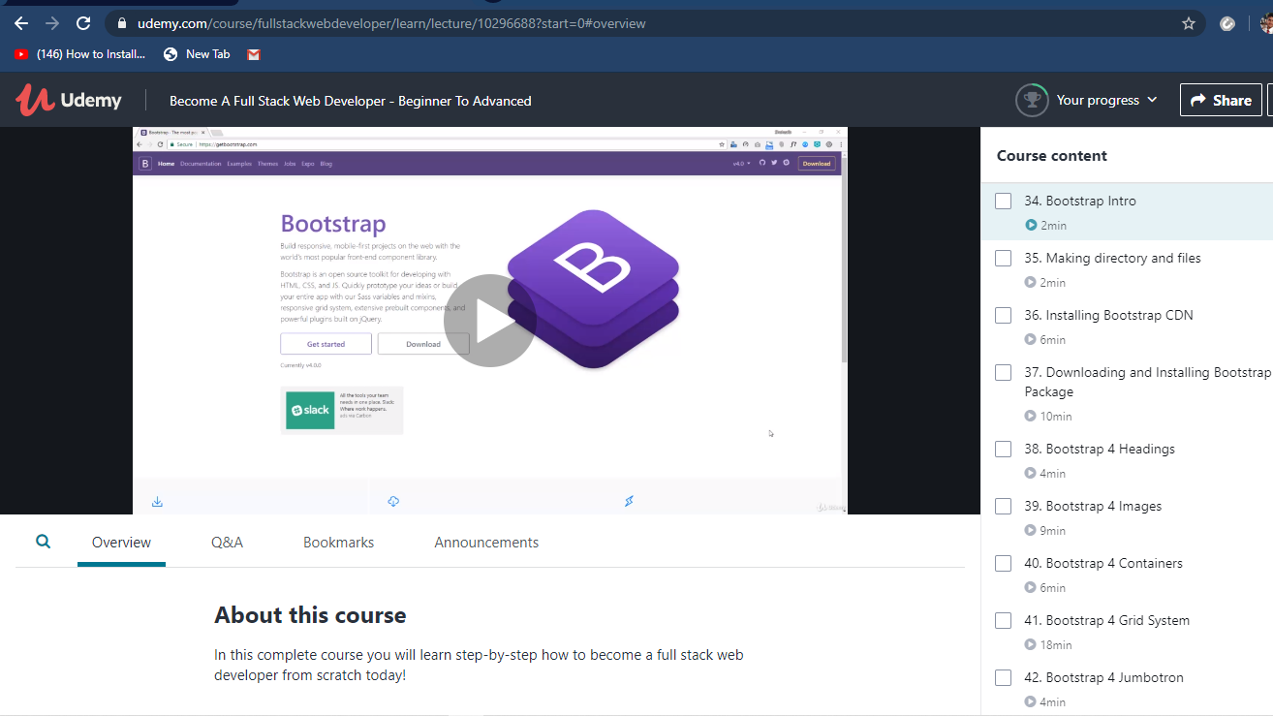

The above course is being taken up by me which is based on full stack web development. The course has started with the HTML basics as well as the various concepts in HTML. The details of the course and certificate provider is mentioned in the above form.

Coding Challenges Details: (Attach the snapshot and briefly write the report for the same)

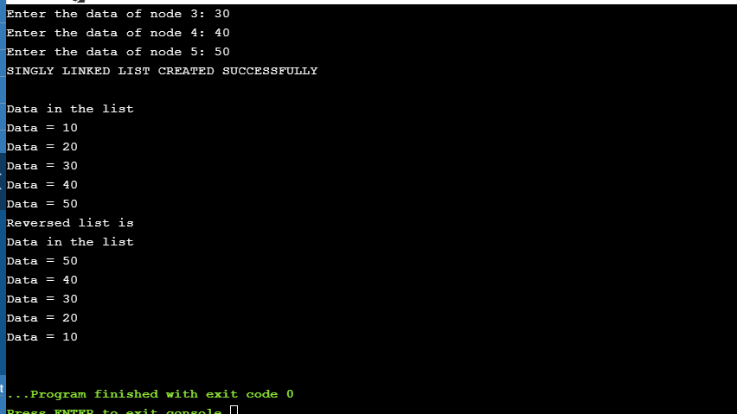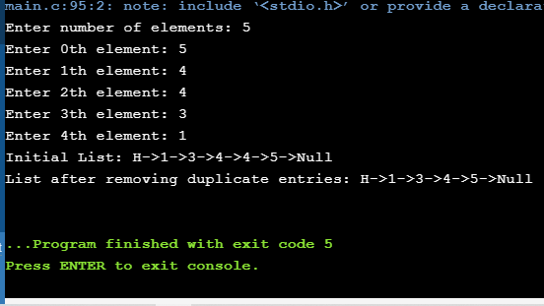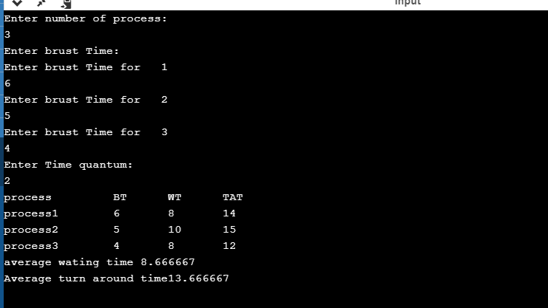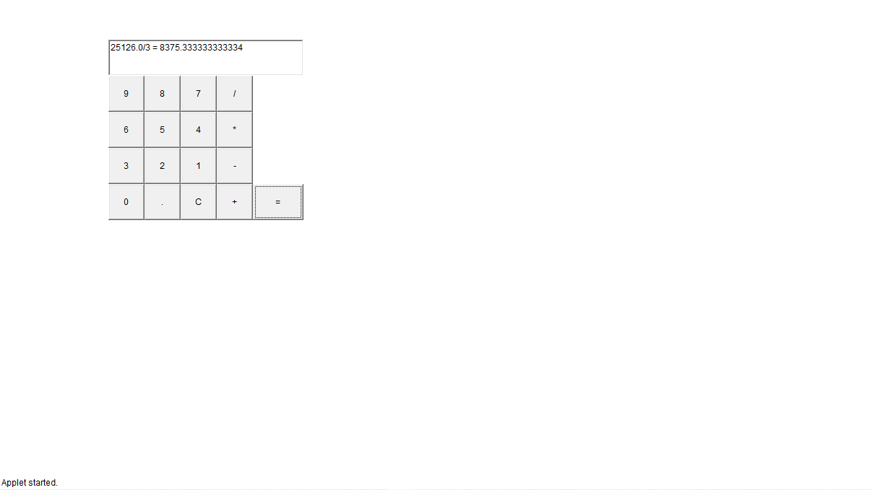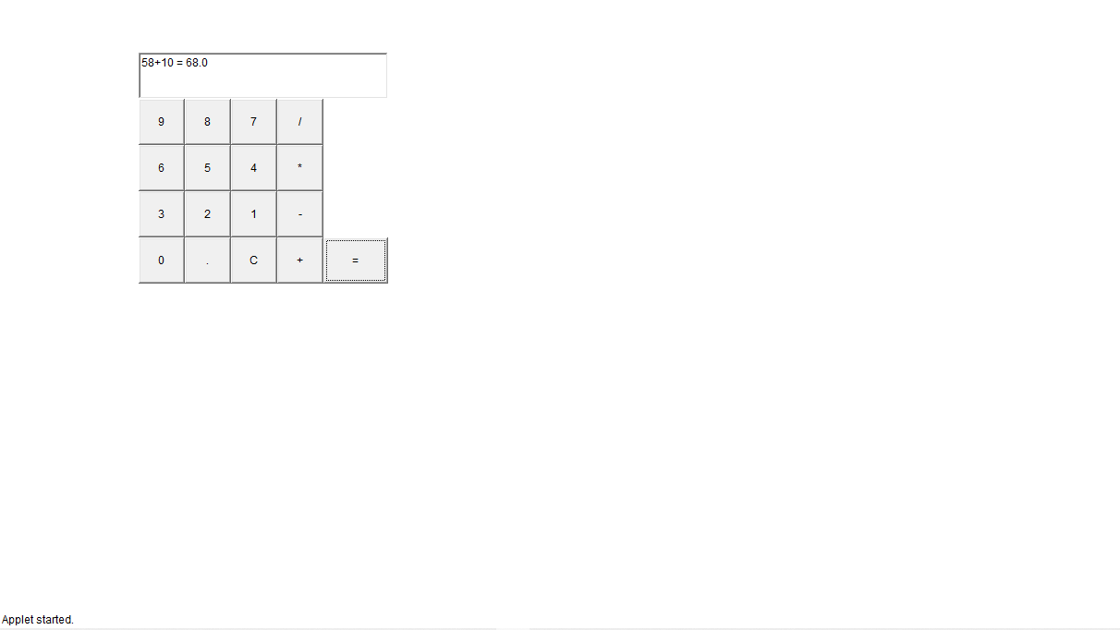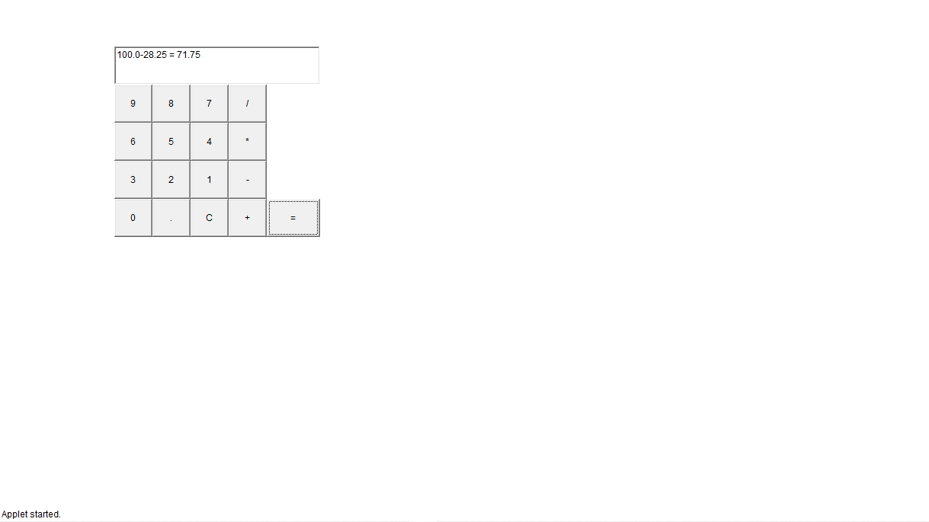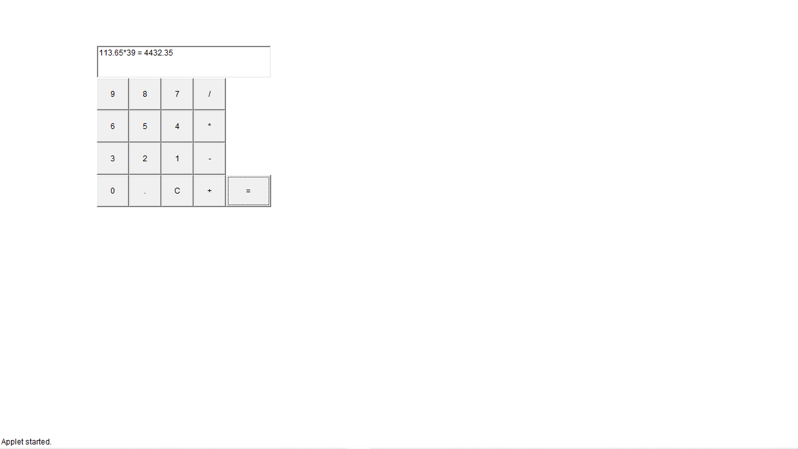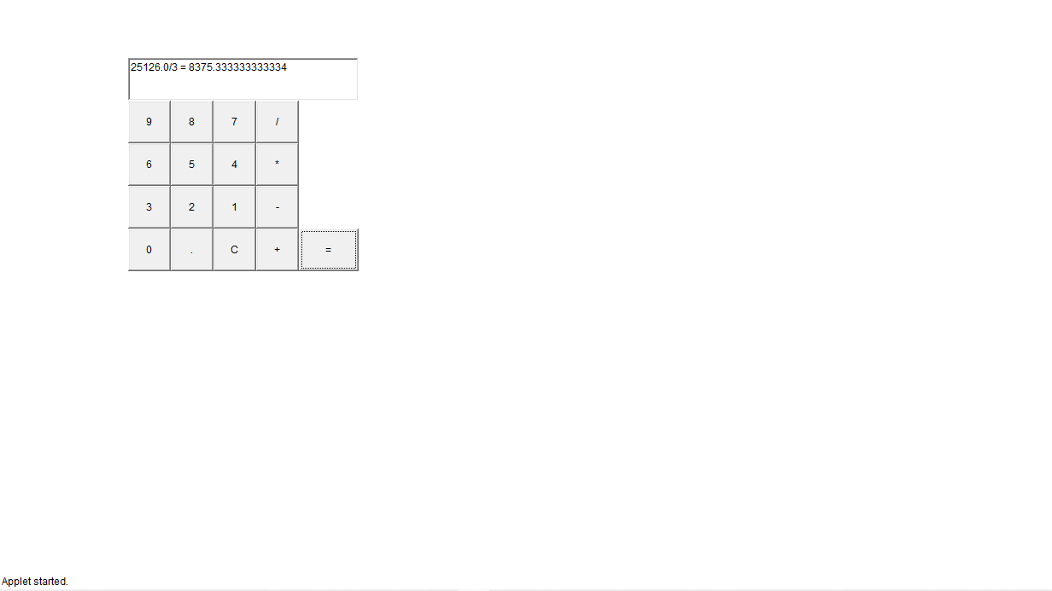

The above the programs were written and executed and the output of the same is displayed above. The code for the given 4 programs have been uploaded to the github repository and the link to the same is provided on the form.