## DAILY ONLINE ACTIVITIES SUMMARY

|  |  |  |  |  |  |  |
| --- | --- | --- | --- | --- | --- | --- |
| **Date:** | **11th July 2020** | | | | **Name:** | **Dsouza Elston Ronald** |
| **Sem & Sec** | **6th A section** | | | | **USN:** | **4AL17CS029** |
| **Assesment Test Summary** | | | | | | |
| **Subject** | | **Assessment test** | | | | |
| **Max. Marks** | |  | **Score** | | |  |
| **Coding Challenges** | | | | | | |
| 1. Java program to count frequency of characters in string. | | | | | | |
| **Status: Completed** | | | | | | |
| **Uploaded the report in Github** | | | | **Yes** | | |
| **If yes Repository name** | | | | <https://github.com/alvas-education-foundation/elston-dsouza> | | |
| **Uploaded the report in slack** | | | | **Yes** | | |

Certifiction course Details: (Attach the snapshot and briefly write the report for the same)

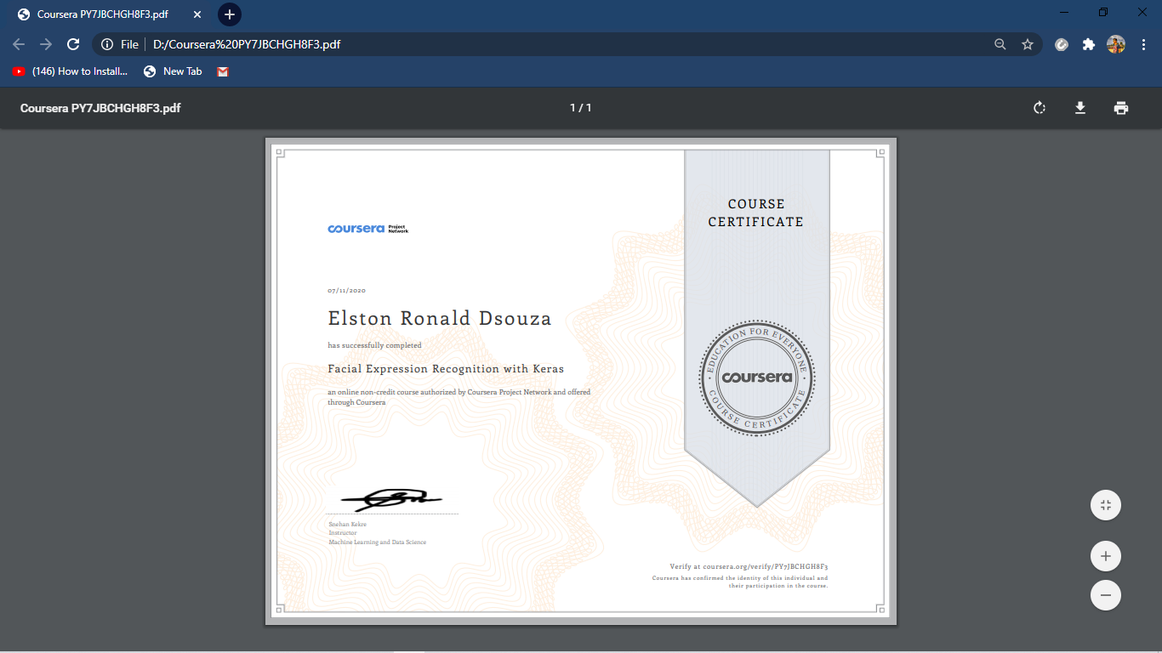

Completed course on “Facial expression recognition with Keras” .Certificate is as follows.

Assesment details:

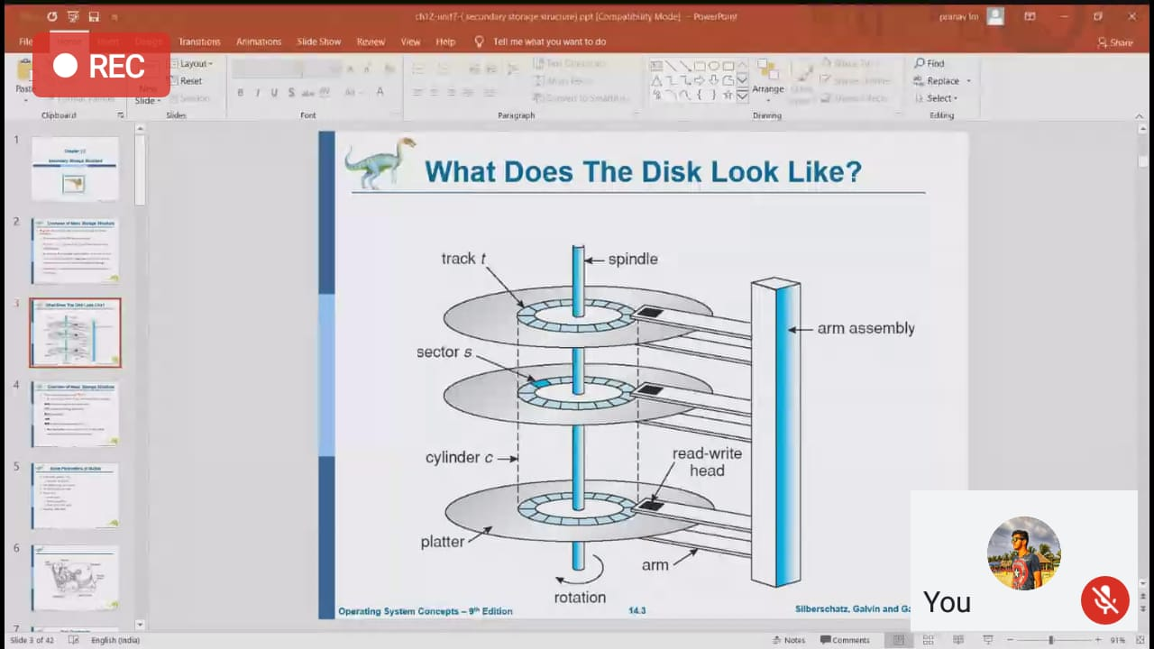

This session was on the topic “Operating Systems” and conducted by Mrs. Reena Lobo. Details are as follows.

Coding Challenges Details: (Attach the snapshot and briefly write the report for the same)

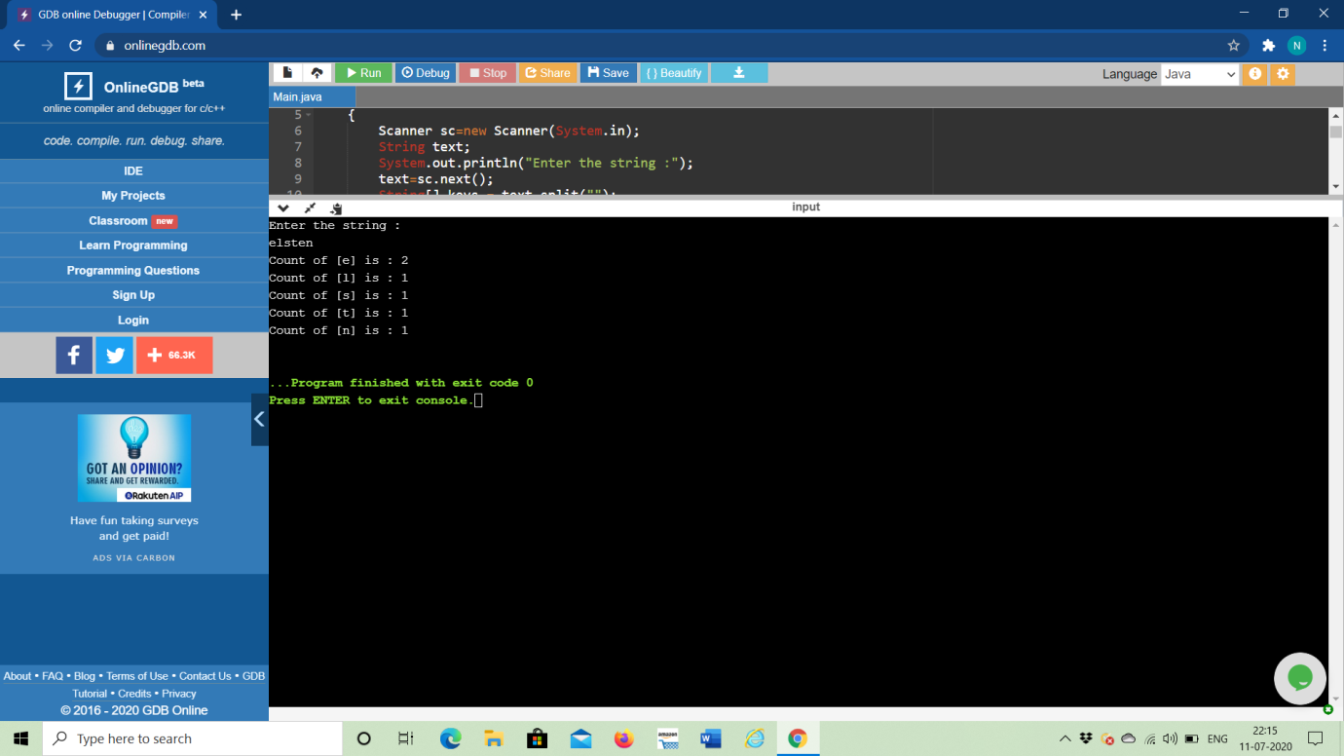

The above the programs were written and executed and the output of the same is displayed above. The code for the given 1 program have been uploaded to the github repository and the link to the same is provided on the form.