## DAILY ONLINE ACTIVITIES SUMMARY

|  |  |  |  |  |  |  |
| --- | --- | --- | --- | --- | --- | --- |
| **Date:** | **16th July 2020** | | | | **Name:** | **Dsouza Elston Ronald** |
| **Sem & Sec** | **6th A section** | | | | **USN:** | **4AL17CS029** |
| **Online Test Summary** | | | | | | |
| **Subject** | |  | | | | |
| **Max. Marks** | | **30** | **Score** | | |  |
| **Coding Challenges** | | | | | | |
| 1. Python program to print the invert numerical right angled triangle pattern. | | | | | | |
| **Status: Completed** | | | | | | |
| **Uploaded the report in Github** | | | | **Yes** | | |
| **If yes Repository name** | | | | <https://github.com/alvas-education-foundation/elston-dsouza> | | |
| **Uploaded the report in slack** | | | | **Yes** | | |

Certification course Details: (Attach the snapshot and briefly write the report for the same)

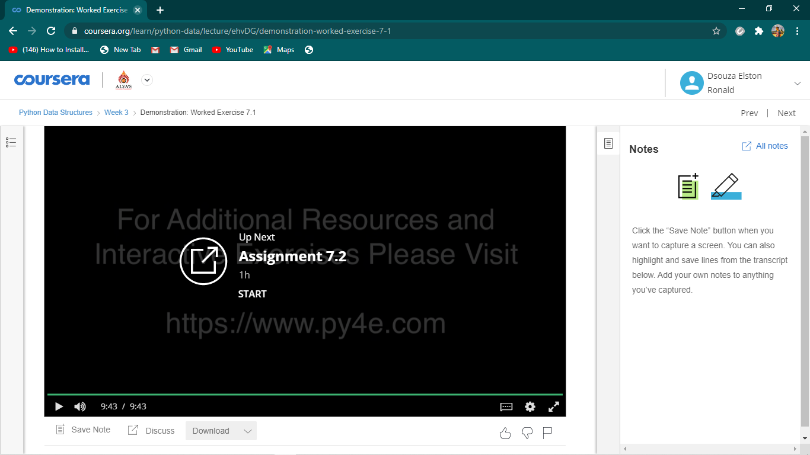

Python Data structures course by coursera.

Assesment details:

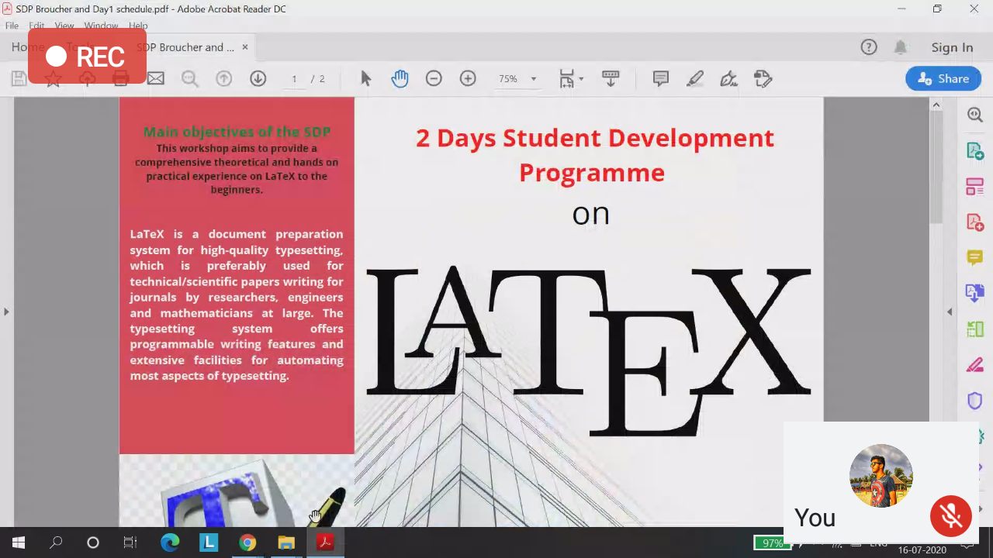

Session on LATEX by Prof.Sushanth M.

Coding Challenges Details: (Attach the snapshot and briefly write the report for the same)

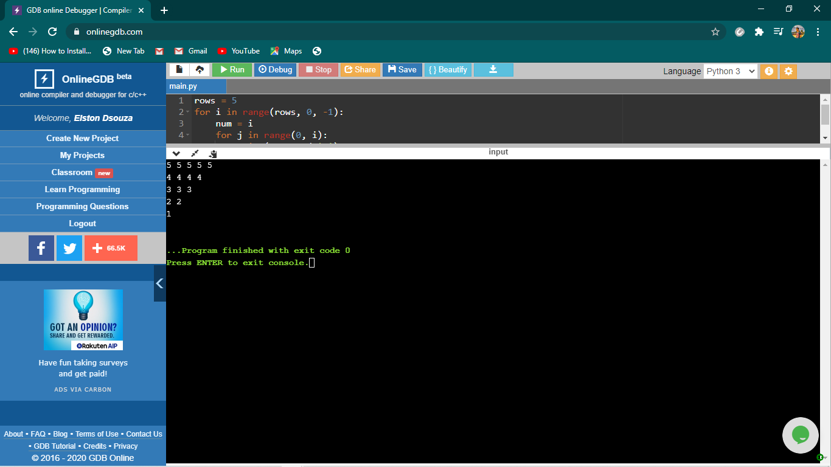

The above the programs were written and executed and the output of the same is displayed above. The code for the given 1 program have been uploaded to the github repository and the link to the same is provided on the form.