## DAILY ONLINE ACTIVITIES SUMMARY

|  |  |  |  |  |  |  |
| --- | --- | --- | --- | --- | --- | --- |
| **Date:** | **21th July 2020** | | | | **Name:** | **Dsouza Elston Ronald** |
| **Sem & Sec** | **6th A section** | | | | **USN:** | **4AL17CS029** |
| **Online Test Summary** | | | | | | |
| **Subject** | |  | | | | |
| **Max. Marks** | | **30** | **Score** | | |  |
| **Coding Challenges** | | | | | | |
| 1.C program to concatenate 2 strings . | | | | | | |
| **Status: Completed** | | | | | | |
| **Uploaded the report in Github** | | | | **Yes** | | |
| **If yes Repository name** | | | | <https://github.com/alvas-education-foundation/elston-dsouza> | | |
| **Uploaded the report in slack** | | | | **Yes** | | |

Certification course Details: (Attach the snapshot and briefly write the report for the same)

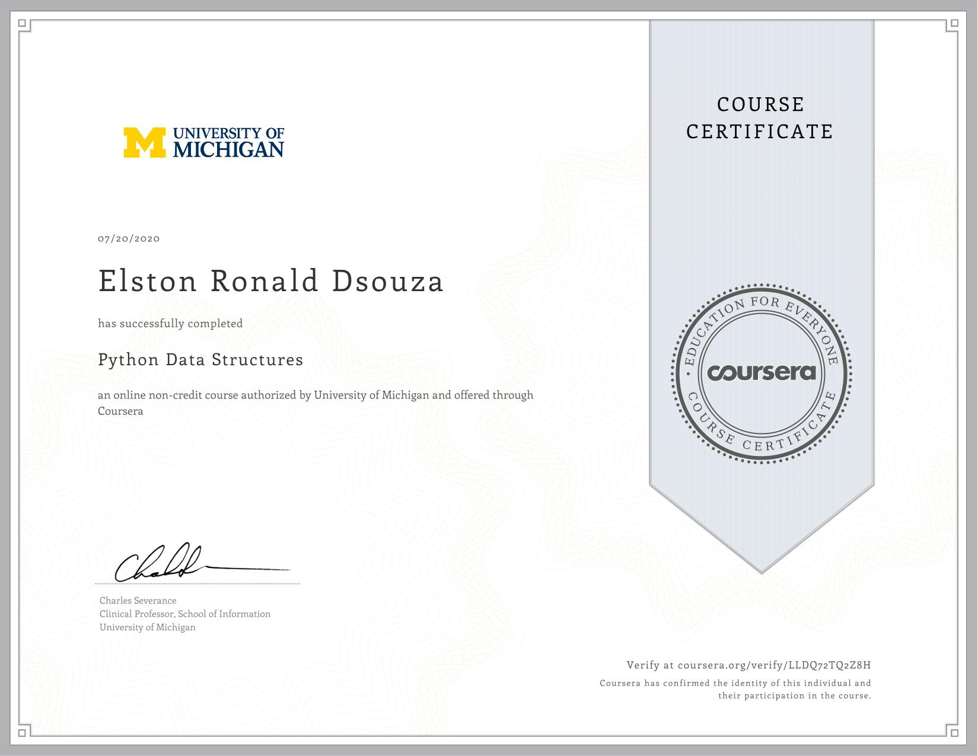

Python Data structures course by coursera.

Assesment details:

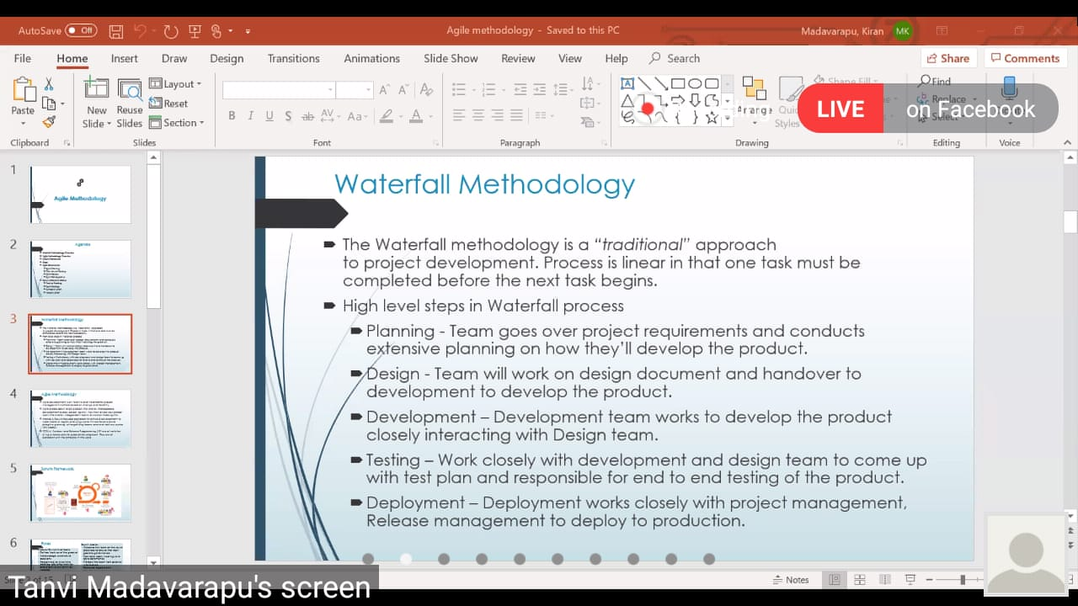

Session on Agile Technologies by Mr.Kiran M on 21st July from 11.00 am to 1.00pm

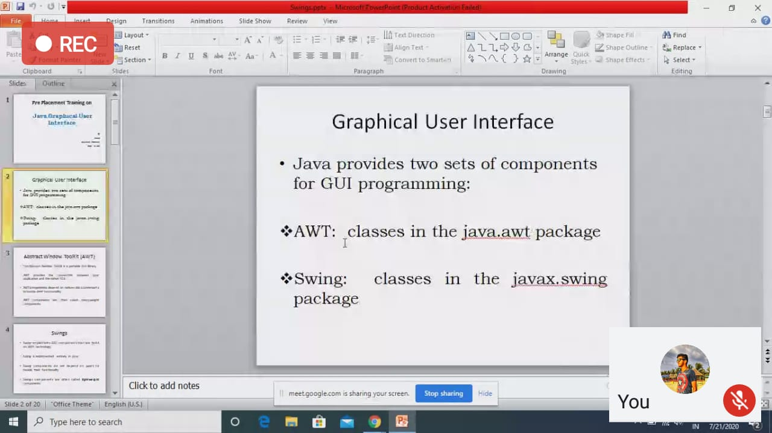

Session on Advanced JAVA by Ms.Shilpa on 21st July from 9.30 am to 10.30am.

Coding Challenges Details: (Attach the snapshot and briefly write the report for the same)

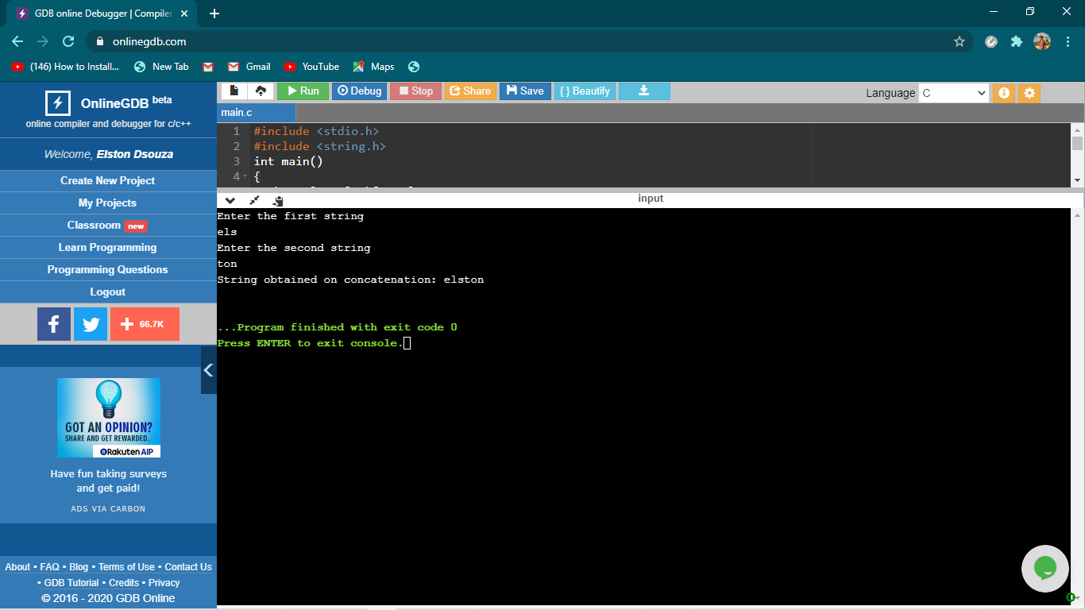

The above the programs were written and executed and the output of the same is displayed above. The code for the given 1 program have been uploaded to the github repository and the link to the same is provided on the form.