## DAILY ONLINE ACTIVITIES SUMMARY

|  |  |  |  |  |  |  |
| --- | --- | --- | --- | --- | --- | --- |
| **Date:** | **23th July 2020** | | | | **Name:** | **Dsouza Elston Ronald** |
| **Sem & Sec** | **6th A section** | | | | **USN:** | **4AL17CS029** |
| **Online Test Summary** | | | | | | |
| **Subject** | |  | | | | |
| **Max. Marks** | | **30** | **Score** | | |  |
| **Coding Challenges** | | | | | | |
| 1.Java program to check palindromic string using recursion. | | | | | | |
| **Status: Completed** | | | | | | |
| **Uploaded the report in Github** | | | | **Yes** | | |
| **If yes Repository name** | | | | <https://github.com/alvas-education-foundation/elston-dsouza> | | |
| **Uploaded the report in slack** | | | | **Yes** | | |

Certification course Details: (Attach the snapshot and briefly write the report for the same)

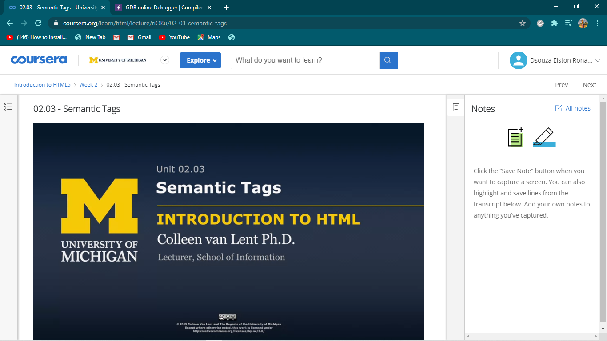

Introduction to HTML5 course by coursera.

Assesment details:

Coding Challenges Details: (Attach the snapshot and briefly write the report for the same)

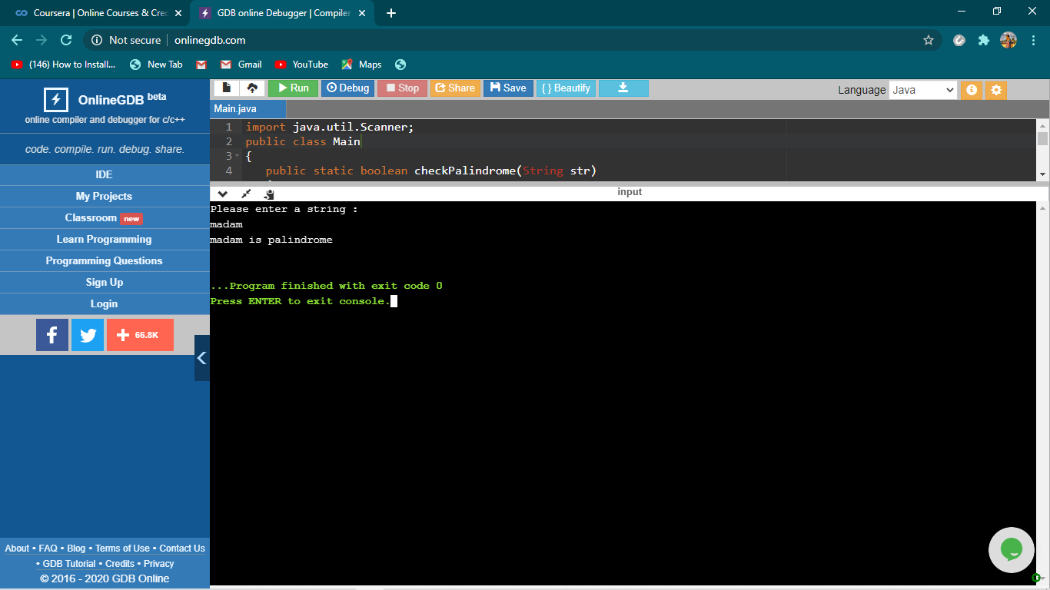

The above the programs were written and executed and the output of the same is displayed above. The code for the given 1 program have been uploaded to the github repository and the link to the same is provided on the form.