## DAILY ONLINE ACTIVITIES SUMMARY

|  |  |  |  |  |  |  |
| --- | --- | --- | --- | --- | --- | --- |
| **Date:** | **24th July 2020** | | | | **Name:** | **Dsouza Elston Ronald** |
| **Sem & Sec** | **6th A section** | | | | **USN:** | **4AL17CS029** |
| **Online Test Summary** | | | | | | |
| **Subject** | | **SSCD** | | | | |
| **Max. Marks** | | **30** | **Score** | | |  |
| **Coding Challenges** | | | | | | |
| 1Java program to find maximum and minimum ocuring character in string.. | | | | | | |
| **Status: Completed** | | | | | | |
| **Uploaded the report in Github** | | | | **Yes** | | |
| **If yes Repository name** | | | | <https://github.com/alvas-education-foundation/elston-dsouza> | | |
| **Uploaded the report in slack** | | | | **Yes** | | |

Online Test Details: (Attach the snapshot and briefly write the report for the same)

Certification course details:

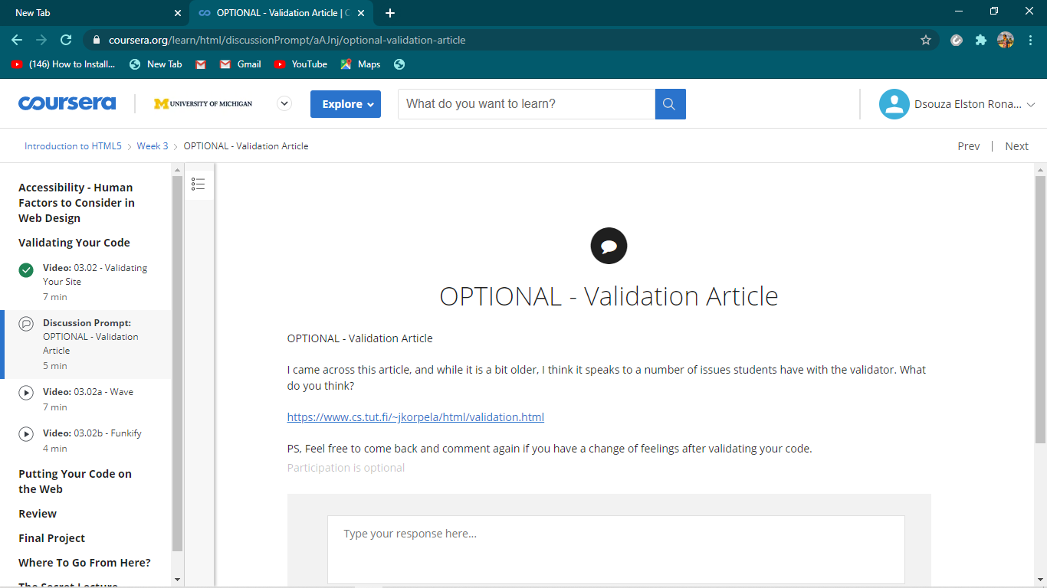

Coding Challenges Details: (Attach the snapshot and briefly write the report for the same)

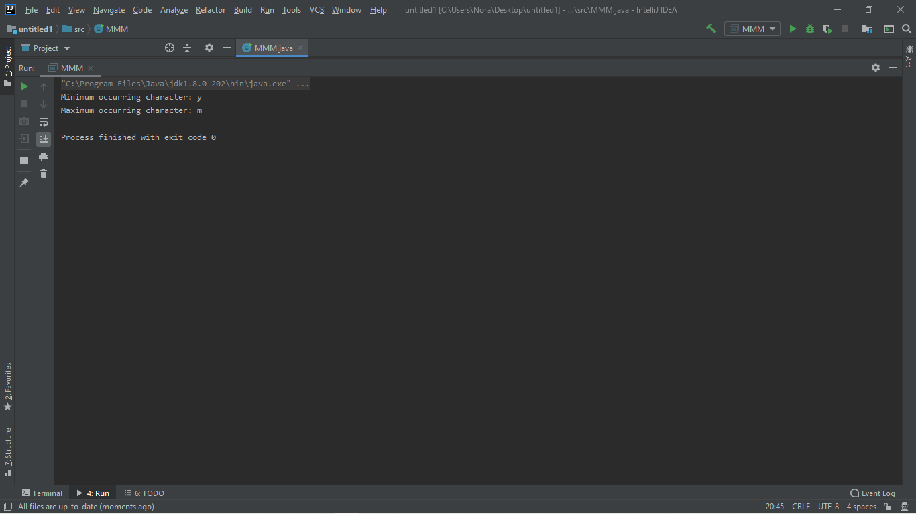

The above the programs were written and executed and the output of the same is displayed above. The code for the given 1 program have been uploaded to the github repository and the link to the same is provided on the form.