## DAILY ONLINE ACTIVITIES SUMMARY

|  |  |  |  |  |  |  |
| --- | --- | --- | --- | --- | --- | --- |
| **Date:** | **29th July 2020** | | | | **Name:** | **Dsouza Elston Ronald** |
| **Sem & Sec** | **6th A section** | | | | **USN:** | **4AL17CS029** |
| **Online Test Summary** | | | | | | |
| **Subject** | | **Operations Research(OR)** | | | | |
| **Max. Marks** | | **30** | **Score** | | |  |
| **Coding Challenges** | | | | | | |
| 1.C++ program to print all squares in the given range. | | | | | | |
| **Status: Completed** | | | | | | |
| **Uploaded the report in Github** | | | | **Yes** | | |
| **If yes Repository name** | | | | <https://github.com/alvas-education-foundation/elston-dsouza> | | |
| **Uploaded the report in slack** | | | | **Yes** | | |

Certification course Details: (Attach the snapshot and briefly write the report for the same)

Assesment details:

Coding Challenges Details: (Attach the snapshot and briefly write the report for the same)

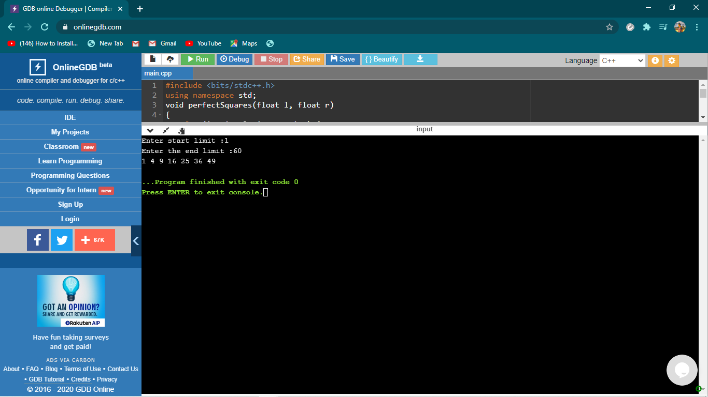

The above the programs were written and executed and the output of the same is displayed above. The code for the given 1 program have been uploaded to the github repository and the link to the same is provided on the form.