## DAILY ONLINE ACTIVITIES SUMMARY

|  |  |  |  |  |  |  |
| --- | --- | --- | --- | --- | --- | --- |
| **Date:** | **05th August 2020** | | | | **Name:** | **Dsouza Elston Ronald** |
| **Sem & Sec** | **6th A section** | | | | **USN:** | **4AL17CS029** |
| **Assesment Test Summary** | | | | | | |
| **Subject** | | **Assessment test** | | | | |
| **Max. Marks** | |  | **Score** | | |  |
| **Coding Challenges** | | | | | | |
| 1. Write a program that will read a sequence of positive real numbers entered by the user and will print the same numbers in sorted order from smallest to largest. The user will input a zero to mark the end of the input. Assume that at most 100 positive numbers will be entered.. | | | | | | |
| **Status: Completed** | | | | | | |
| **Uploaded the report in Github** | | | | **Yes** | | |
| **If yes Repository name** | | | | <https://github.com/alvas-education-foundation/elston-dsouza> | | |
| **Uploaded the report in slack** | | | | **Yes** | | |

Online Test Details: (Attach the snapshot and briefly write the report for the same)

Assesment details:

Coding Challenges Details: (Attach the snapshot and briefly write the report for the same)

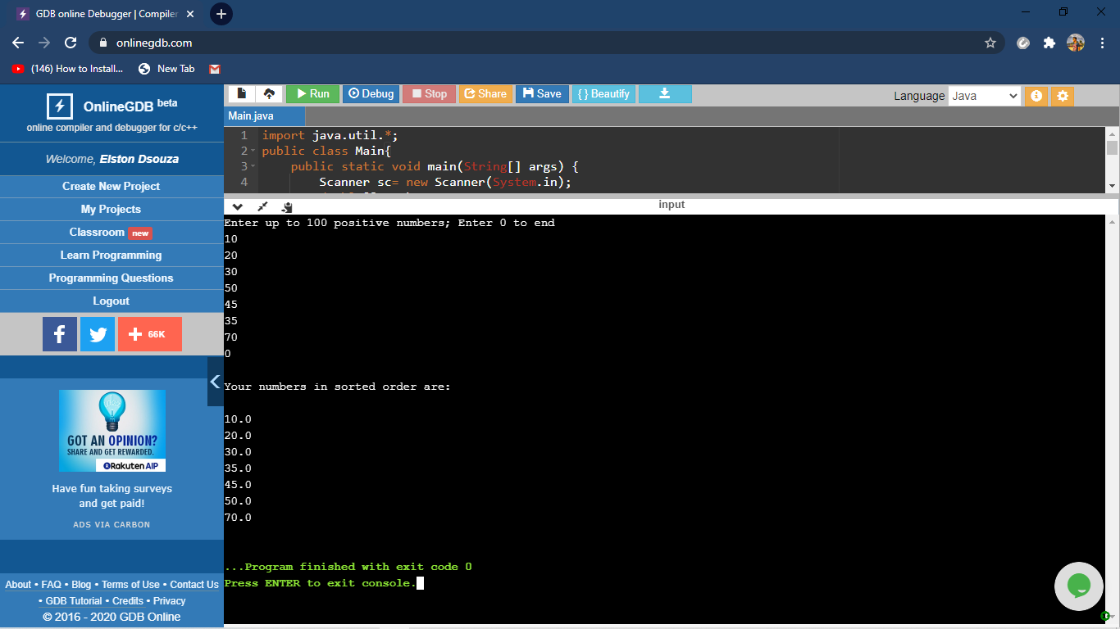

The above the programs were written and executed and the output of the same is displayed above. The code for the given 1 program have been uploaded to the github repository and the link to the same is provided on the form.