**DAILY ONLINE ACTIVITIES SUMMARY**

|  |  |  |  |  |  |  |  |  |
| --- | --- | --- | --- | --- | --- | --- | --- | --- |
| **Date:** | **25th May 2020** | | | | | **Name:** | **Dsouza Elston Ronald** | |
| **Sem & Sec** | **6th A section** | | | | | **USN:** | **4AL17CS029** | |
| **Online Test Summary** | | | | | | | | |
| **Subject** | |  | | | | | | |
| **Max. Marks** | |  | | **Score** | | |  | |
| **Certification Course Summary** | | | | | | | | |
| **Course** | **Full Stack Web Developer-Beginner to Advanced** | | | | | | | |
| **Certificate Provider** | | | **Udemy** | | **Duration** | | | **20 hours** |
| **Coding Challenges** | | | | | | | | |
|  | | | | | | | | |
| **Status: Completed** | | | | | | | | |
| **Uploaded the report in Github** | | | | | **Yes** | | | |
| **If yes Repository name** | | | | | <https://github.com/alvas-education-foundation/elston-dsouza> | | | |
| **Uploaded the report in slack** | | | | | **Yes** | | | |

Online Test Details: (Attach the snapshot and briefly write the report for the same)

Certification Course Details: (Attach the snapshot and briefly write the report for the same)

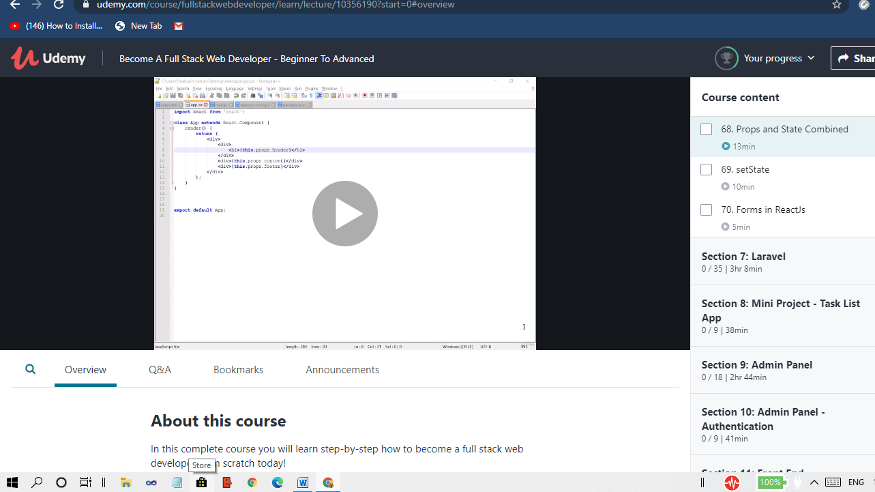

The above course is being taken up by me which is based on full stack web development. The course has started with the HTML basics as well as the various concepts in HTML. The details of the course and certificate provider is mentioned in the above form.

Coding Challenges Details: (Attach the snapshot and briefly write the report for the same)