**DAILY ONLINE ACTIVITIES SUMMARY**

|  |  |  |  |  |  |  |  |  |
| --- | --- | --- | --- | --- | --- | --- | --- | --- |
| **Date:** | **27th May 2020** | | | | | **Name:** | **Dsouza Elston Ronald** | |
| **Sem & Sec** | **6th A section** | | | | | **USN:** | **4AL17CS029** | |
| **Online Test Summary** | | | | | | | | |
| **Subject** | | **System Software and Compiler Design(SSCD)** | | | | | | |
| **Max. Marks** | | **30** | | **Score** | | | **19** | |
| **Certification Course Summary** | | | | | | | | |
| **Course** | **Full Stack Web Developer-Beginner to Advanced** | | | | | | | |
| **Certificate Provider** | | | **Udemy** | | **Duration** | | | **20 hours** |
| **Coding Challenges** | | | | | | | | |
| 1. Write a Java program to implement Binary Tree using the Linked List 2. Given an array arr[] of the positive integers of size N, the task is to find the largest element on the left side of each index which is smaller than the element present at that index. Note: If no such element is found then print -1. 3. Write a C Program to sort an array of integers in ascending order and display the sorted array and Number of passes performed for sorting.. | | | | | | | | |
| **Status: Completed** | | | | | | | | |
| **Uploaded the report in Github** | | | | | **Yes** | | | |
| **If yes Repository name** | | | | | <https://github.com/alvas-education-foundation/elston-dsouza> | | | |
| **Uploaded the report in slack** | | | | | **Yes** | | | |

Online Test Details: (Attach the snapshot and briefly write the report for the same)

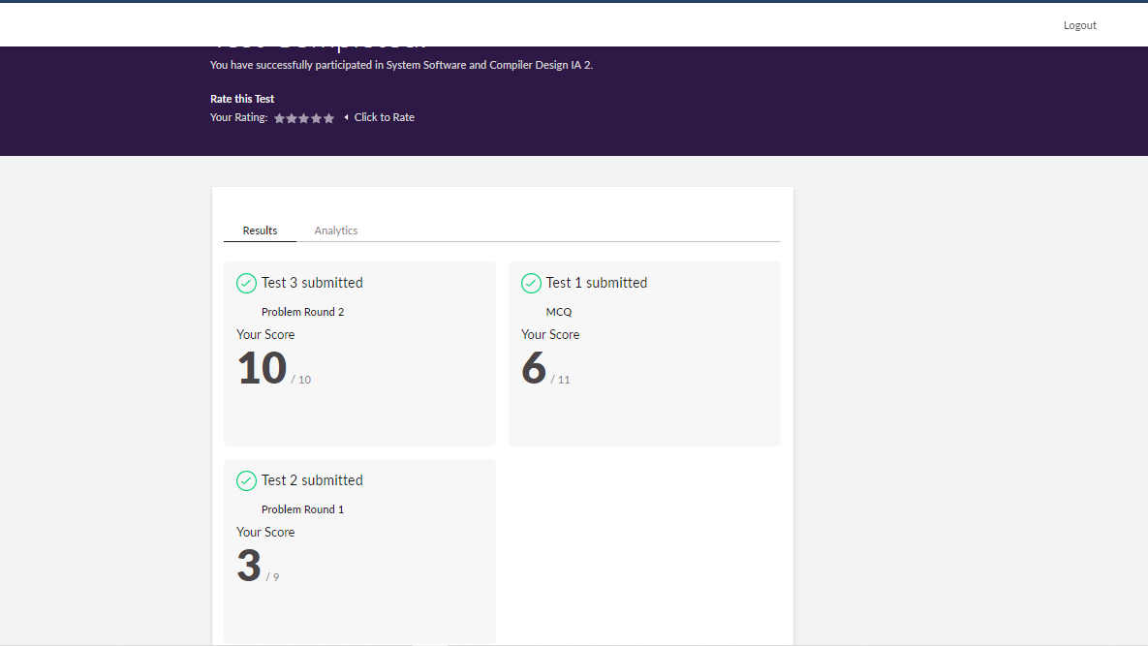

The above assessment was done by me on 27th May 2020 from 9.30 to 10.00 am and the details of assessment is as above.

Certification Course Details: (Attach the snapshot and briefly write the report for the same)

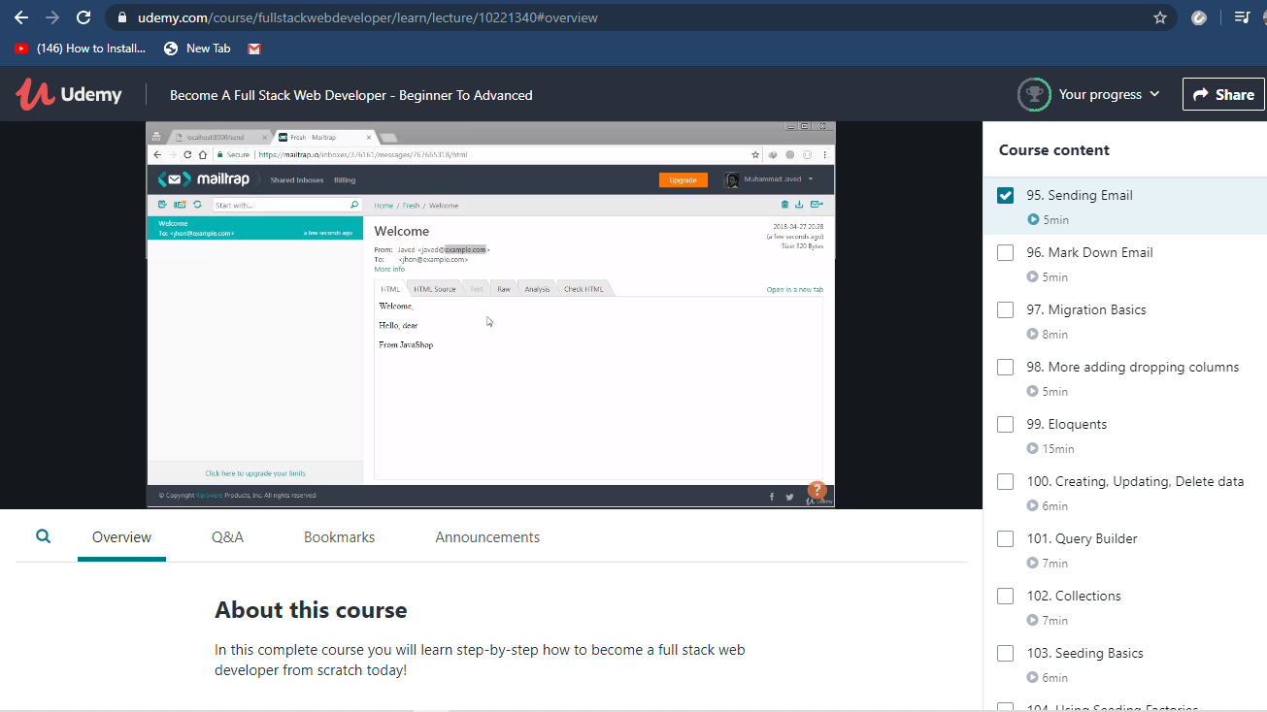

The above course is being taken up by me which is based on full stack web development. The course has started with the HTML basics as well as the various concepts in HTML. The details of the course and certificate provider is mentioned in the above form.

Coding Challenges Details: (Attach the snapshot and briefly write the report for the same)

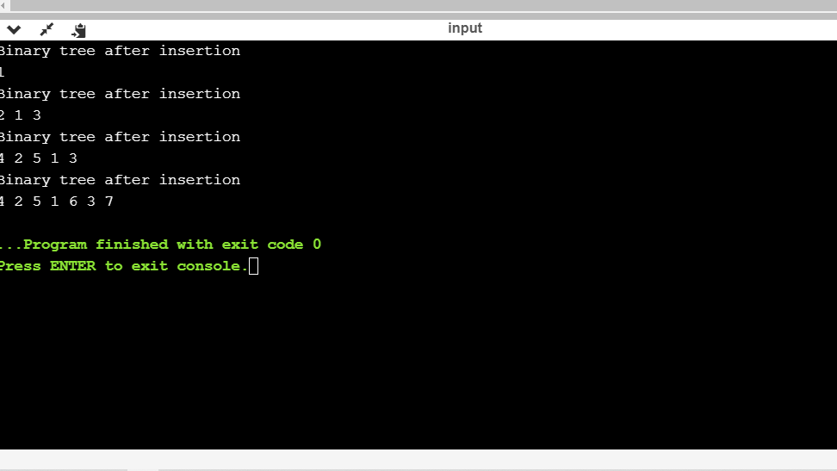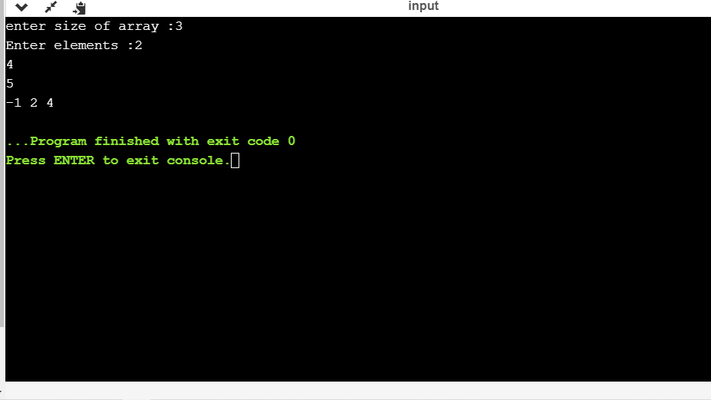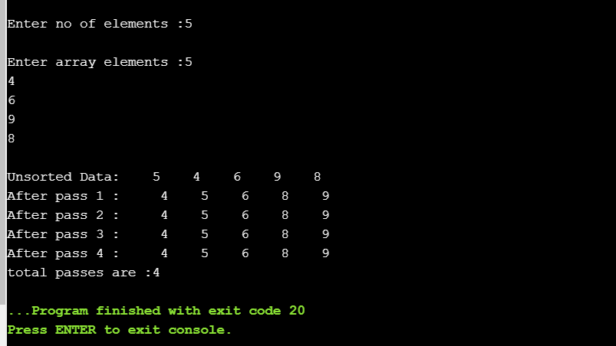

The above the programs were written and executed and the output of the same is displayed above. The code for the given 3 programs have been uploaded to the github repository and the link to the same is provided on the form.