**DAILY ONLINE ACTIVITIES SUMMARY**

|  |  |  |  |  |  |  |  |
| --- | --- | --- | --- | --- | --- | --- | --- |
| **Date:** | | **21/05/2020** | | | | | |
| **Name of the Faculty** | | **Harish Kunder** | | | | | |
| **No. of Students Allotted for monitoring** | | | | | **26** | | |
| **Progress** | | | | | **23 students have been active in the slack & github platform** | | |
| **Whether collected report from all the allotted students** | | | | | **23 students have been uploaded their reports in both slack & github** | | |
| **Online Test Summary** | | | | | | | |
| **Subject** | **System Modeling & Simulation** | | | | | | |
| **Semester** | **VIII** | | | **Duration** | | **1 Hour** | |
| **No. of students Taken** | | | **130** | **Passing %** | | **100%** | |
| **Certification Course Summary** | | | | | | | |
| **Course** | | **Deep Learning Onramp ( 30% completed)** | | | | | |
| **Attended webinar on Skycampus Digital Knowledge Series - Season 6 hosted by ICT Academy** | | | | | |
| **Certificate Provider** | | **MathWorks Training Services** | | | **Duration** | | **20 Hours** |
| **Uploaded the report in Github** | | | | | **Yes** | | |
| **If yes Repository name** | | | | | <https://github.com/alvas-education-foundation/harish_kunder> | | |
| **Uploaded the report in slack** | | | | | **Yes** | | |

Online Test Details:

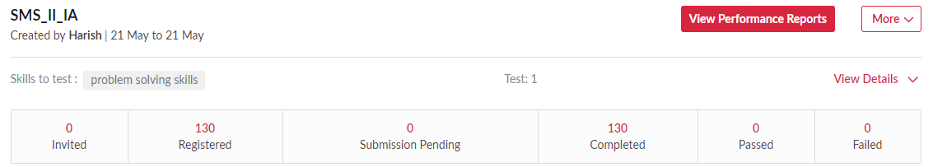

Certification Course Details:

