**DAILY ONLINE ACTIVITIES SUMMARY**

|  |  |  |  |  |  |  |  |
| --- | --- | --- | --- | --- | --- | --- | --- |
| **Date:** | **18/05/2020** | | | | **Name:** | **Huda Sultana** | |
| **Sem & Sec** | **8th A** | | | | **USN:** | **4AL16CS039** | |
| **Online Test Summary** | | | | | | | |
| **Subject** | | **SMS** | | | | | |
| **Max. Marks** | | **60** | | **Score** | | **58** | |
| **Certification Course Summary** | | | | | | | |
| **Course** | Introduction to Ethical Hacking | | | | | | |
| **Certificate Provider** | | | **Great learning** | **Duration** | | | **6 hours** |
| **Coding Challenges** | | | | | | | |
| **Problem Statement:** | | | | | | | |
| **Status: COMPLETED** | | | | | | | |
| **Uploaded the report in Github** | | | | **YES** | | | |
| **If yes Repository name** | | | | **Hudasulltana/online_certificate**  **Hudasulltana/online_coding** | | | |
| **Uploaded the report in slack** | | | | **YES** | | | |

Online Test Details:

Test on module 3 (Random number generation)

Snapshot of test

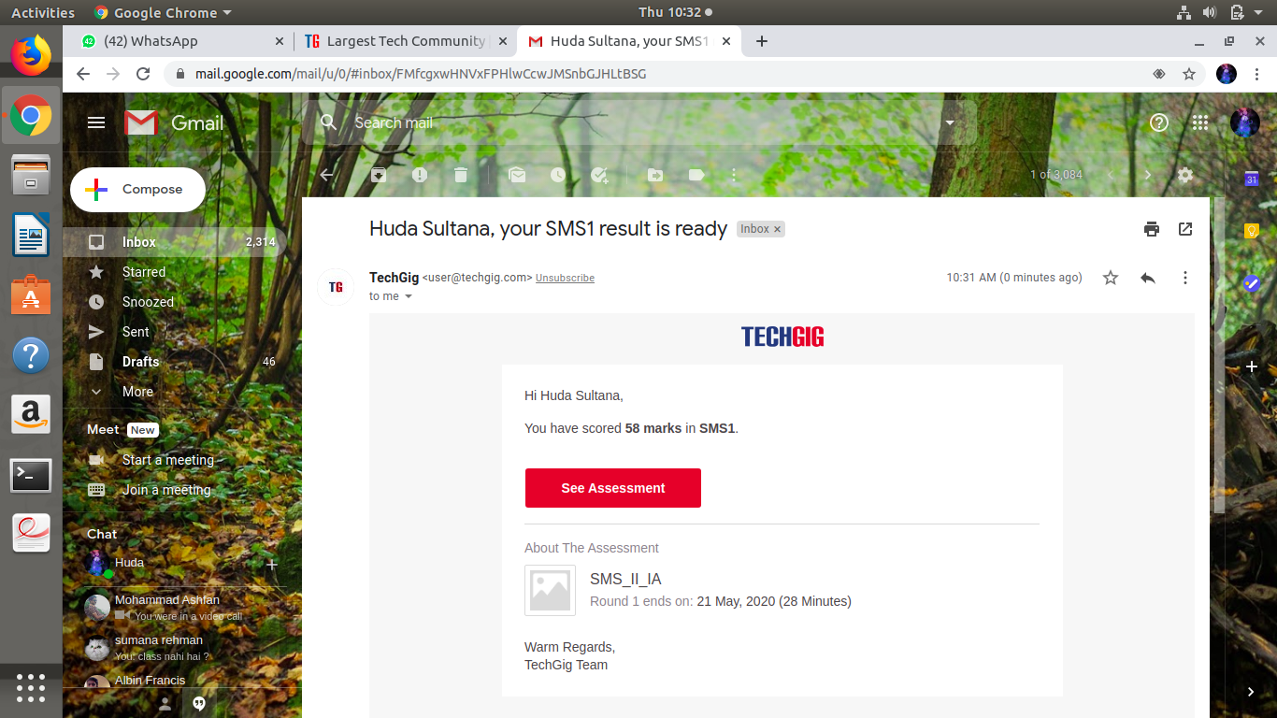

Certification Course Details:

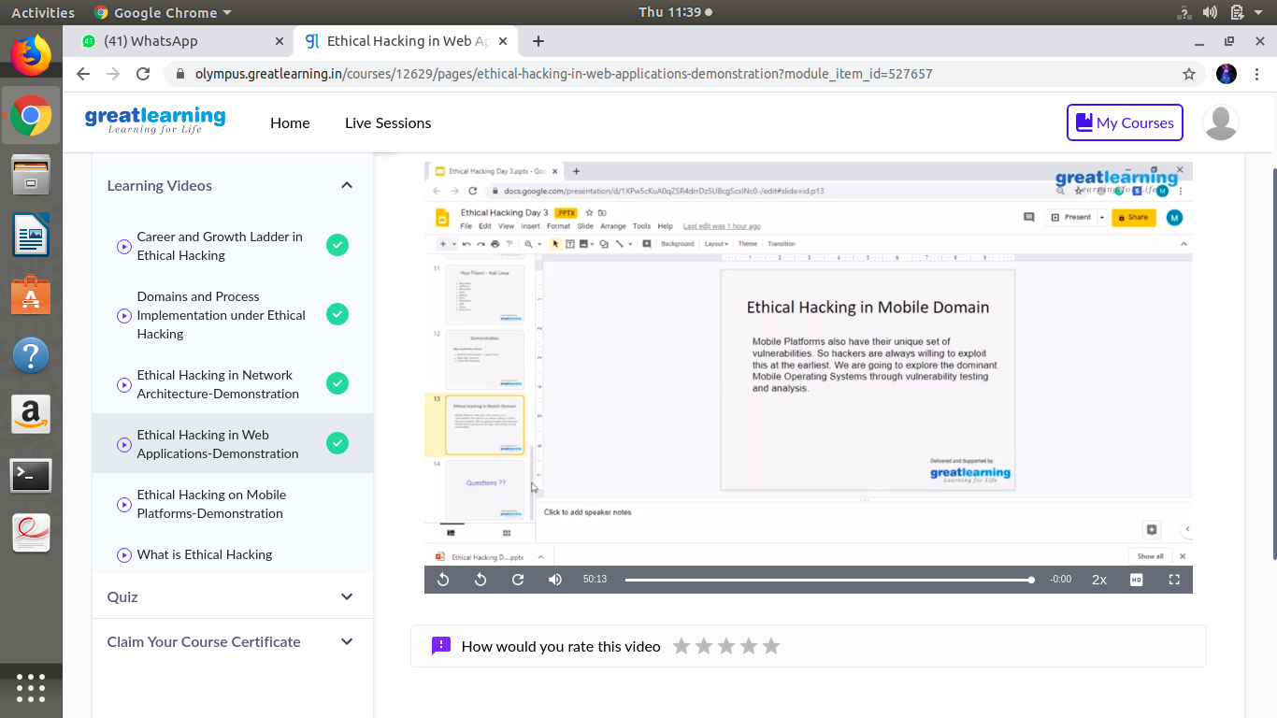

#### Introduction to Ethical Hacking

Coding Challenges Details

**Program no:1**

**Reverse a single linked list**

**#include<stdio.h>**

**#include<stdlib.h>**

**struct Node**

**{**

**int data;**

**struct Node* next;**

**};**

**static void reverse(struct Node** head_ref)**

**{**

**struct Node* prev = NULL;**

**struct Node* current = *head_ref;**

**struct Node* next;**

**while (current != NULL)**

**{**

**next = current->next;**

**current->next = prev;**

**prev = current;**

**current = next;**

**}**

**\*head_ref = prev;**

**}**

**void push(struct Node** head_ref, int new_data)**

**{**

**struct Node* new_node = (struct Node*) malloc(sizeof(struct Node));**

**new_node->data = new_data;**

**new_node->next = (*head_ref);**

**(*head_ref) = new_node;**

**}**

**void printList(struct Node *head)**

**{**

**struct Node *temp = head;**

**while(temp != NULL)**

**{**

**printf("%d ", temp->data);**

**temp = temp->next;**

**}**

**}**