DAILY ONLINE ACTIVITIES SUMMARY

|  |  |  |  |  |  |  |  |
| --- | --- | --- | --- | --- | --- | --- | --- |
| **Date:** | **01/6/2020** | | | | **Name:** | **Jyothi Lakshmi** | |
| **Sem & Sec** | **8th Sem** | | | | **USN:** | **4AL16CS129** | |
| Online Test Summary | | | | | | | |
| **Subject** | | **SMS** | | | | | |
| **Max. Marks** | | **60** | | **Score** | | **60** | |
| Certification Course Summary | | | | | | | |
| **Course** | **Step into Robotic Automation** | | | | | | |
| **Certificate Provider** | | | **Udemy** | **Duration** | | | **4hr** |
| Coding Challenges | | | | | | | |
| **Problem Statement:**  1: Write a c program to print right angled triangle number star pattern. | | | | | | | |
| **Status:COMPLETED** | | | | | | | |
| **Uploaded the report in Github** | | | | **Yes** | | | |
| **If yes Repository name** | | | | **Jyothi_129** | | | |
| **Uploaded the report in slack** | | | | **Yes** | | | |

Online Test Details: (Attach the snapshot and briefly write the report for the same)

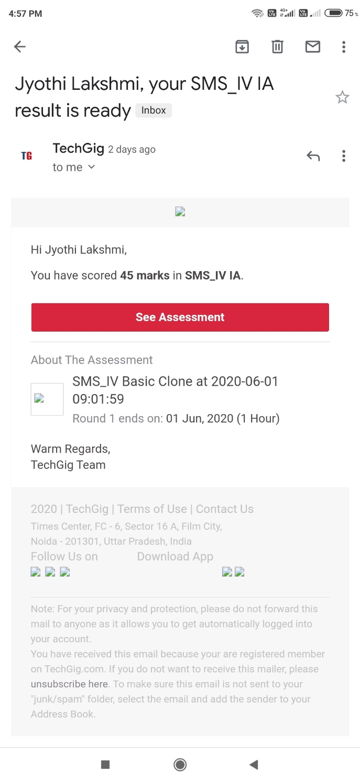

Certification Course Details: (Attach the snapshot and briefly write the report for the same)



Coding Challenges Details: (Attach the snapshot and briefly write the report for the same)

#include stdio.h int main()

{

int rows, i, j;

printf(“please enter the no. of rows”); scanf(“%d”,&rows);

printf(“printing pattern”);

{

for(j=1;j<i;j++)

{

printf(“*”);

}

printf(“\n”);

}

return 0;

}