**D AILY ONLINE ACTIVITIES SUMMARY**

|  |  |  |  |  |  |  |  |
| --- | --- | --- | --- | --- | --- | --- | --- |
| **Date:** | **04/6/2020** | | | | **Name:** | **Jyothi lakshmi** | |
| **Sem & Sec** | **8th Sem** | | | | **USN:** | **4AL16CS129** | |
| Online Test Summary | | | | | | | |
| **Subject** | | **SMS** | | | | | |
| **Max. Marks** | | **60** | | **Score** | | **60** | |
| Certification Course Summary | | | | | | | |
| **Course** | **AWS Fragate** | | | | | | |
| **Certificate Provider** | | | **AWS** | **Duration** | | | **15mins** |
| Coding Challenges | | | | | | | |
| **Problem Statement:**  1: Python Program to Find the Size (Resolution) of a Image. | | | | | | | |
| **Status:COMPLETED** | | | | | | | |
| **Uploaded the report in Github** | | | | **Yes** | | | |
| **If yes Repository name** | | | | **Jyothi_129** | | | |
| **Uploaded the report in slack** | | | | **Yes** | | | |

Online Test Details: (Attach the snapshot and briefly write the report for the same)

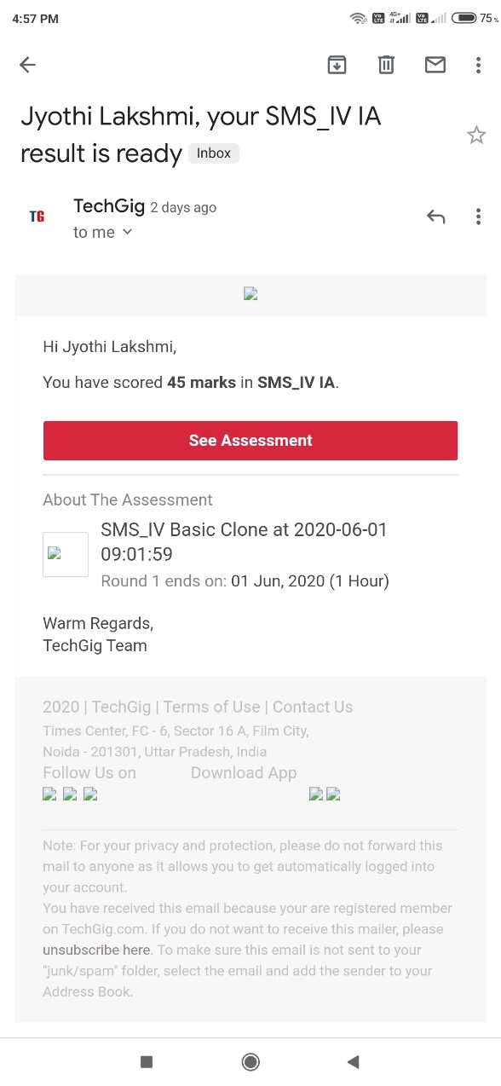

Certification Course Details: (Attach the snapshot and briefly write the report for the same)

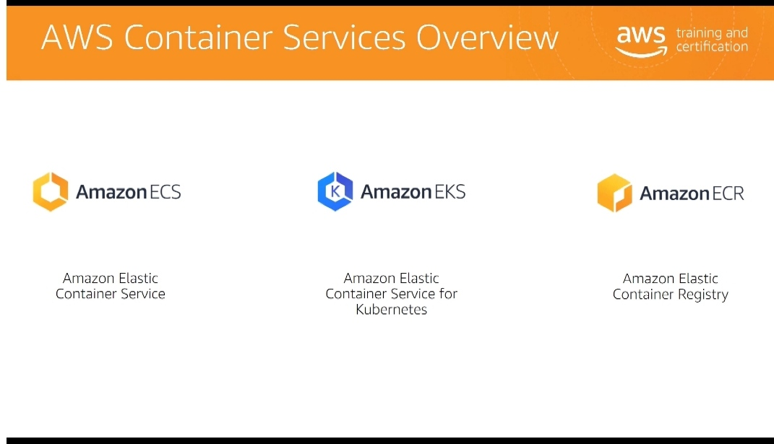

Coding Challenges Details: (Attach the snapshot and briefly write the report for the same)

def jpeg_res(filename):

#open image for reading in binary mode with open(filename,'rb')as img_file:

#height of image (in 2 bytes) is at 164th position img_file. seek(163)

#read the 2 bytes a=img_file. read(2)

#calculate height height=(a[0]<<8)+a[1]

#next 2 bytes is width a=img_file. read(2)

#calculate width width=(a[0]<<8)+a[1]

print("The resolution of the image is", width, "x", height) jpeg_res("img1.jpg")