**D AILY ONLINE ACTIVITIES SUMMARY**

|  |  |  |  |  |  |  |  |
| --- | --- | --- | --- | --- | --- | --- | --- |
| **Date:** | **06/6/2020** | | | | **Name:** | **Jyothi Lakshmi** | |
| **Sem & Sec** | **8th Sem** | | | | **USN:** | **4AL16CS129** | |
| Online Test Summary | | | | | | | |
| **Subject** | | **IOT** | | | | | |
| **Max. Marks** | | **30** | | **Score** | | **30** | |
| Certification Course Summary | | | | | | | |
| **Course** | **Intoduction to Amazon VPC** | | | | | | |
| **Certificate Provider** | | | **AWS** | **Duration** | | | **15mins** |
| Coding Challenges | | | | | | | |
| **Problem Statement:**  1: Python program for given a two list. Create a third list by picking an odd-index element from the first list and even index elements from second. | | | | | | | |
| **Status:COMPLETED** | | | | | | | |
| **Uploaded the report in Github** | | | | **Yes** | | | |
| **If yes Repository name** | | | | **Jyothi_129** | | | |
| **Uploaded the report in slack** | | | | **Yes** | | | |

Online Test Details: (Attach the snapshot and briefly write the report for the same)

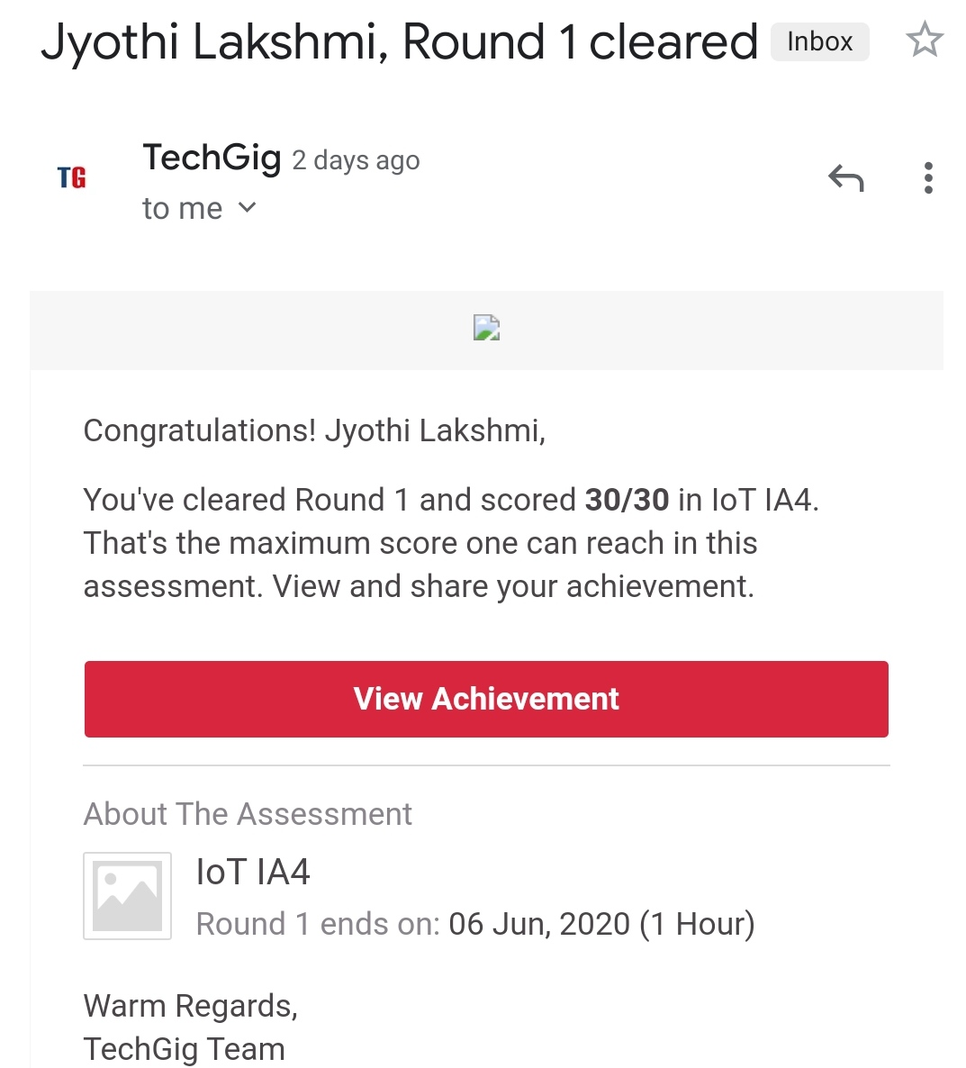

Certification Course Details: (Attach the snapshot and briefly write the report for the same)

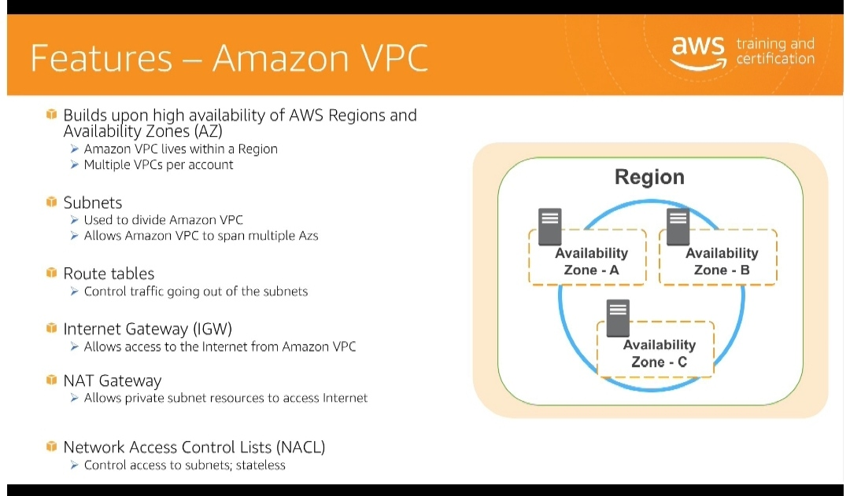

Coding Challenges Details: (Attach the snapshot and briefly write the report for the same)

listOne=[3,6,9,12,15,18,21] listTwo=[4,8,12,16,20,24,28]

listThree=list() oddElements=listOne[1::2]

print("Element at odd-index positions from list one") print(oddElements)

EvenElement=listTwo[0::2]

print("Element at even-index positions from list two") print(EvenElement)

print("Printing Final third list") listThree.extend(oddElements) listThree.extend(EvenElement) print(listThree)