DAILY ONLINE ACTIVITIES SUMMARY

|  |  |  |  |  |  |  |  |
| --- | --- | --- | --- | --- | --- | --- | --- |
| **Date:** | **07/6/2020** | | | | **Name:** | **Jyothi Lakshmi** | |
| **Sem & Sec** | **8th Sem** | | | | **USN:** | **4AL16CS129** | |
| Online Test Summary | | | | | | | |
| **Subject** | | NIL | | | | | |
| **Max. Marks** | | NIL | | **Score** | | NIL | |
| Certification Course Summary | | | | | | | |
| **Course** | **Introduction to Amazon VPC** | | | | | | |
| **Certificate Provider** | | | **Udemy** | **Duration** | | | **15mins** |
| Coding Challenges | | | | | | | |
| **Problem Statement:**  1: Program to multiply two floating point numbers. | | | | | | | |
| **Status: COMPLETED** | | | | | | | |
| **Uploaded the report in Github** | | | | **Yes** | | | |
| **If yes Repository name** | | | | **Jyothi_129** | | | |
| **Uploaded the report in slack** | | | | **Yes** | | | |

Online Test Details: (Attach the snapshot and briefly write the report for the same)

Certification Course Details: (Attach the snapshot and briefly write the report for the same)

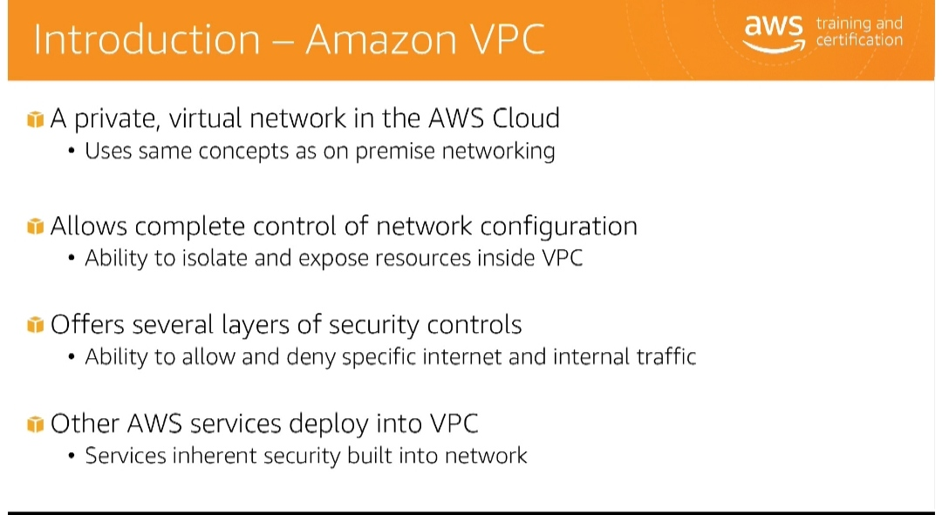

Coding Challenges Details: (Attach the snapshot and briefly write the report for the same)

# #include<stdio.h> int main(){ doublea,b,product;

printf("Enter two numbers:"); scanf("%lf%lf",&a,&b); product=a*b; printf("Product=%.2lf",product); return0;

}