**DAILY ONLINE ACTIVITIES SUMMARY**

|  |  |  |  |  |  |  |  |
| --- | --- | --- | --- | --- | --- | --- | --- |
| **Date:** | **08-06-2020** | | | | **Name:** | **Jyothi Lakshmi** | |
| **Sem & Sec** | **8th,B** | | | | **USN:** | **4AL16CS129** | |
| Online Test Summary | | | | | | | |
| **Subject** | | **SMS** | | | | | |
| **Max. Marks** | | **60** | | **Score** | | **60** | |
| Certification Course Summary | | | | | | | |
| **Course** | **INTRODUCTION TO AMAZON VPC** | | | | | | |
| **Certificate Provider** | | | **AWS** | **Duration** | | | **15 Mins** |
| Coding Challenges | | | | | | | |
| **Problem Statement:** C program to print character without using format specifiers | | | | | | | |
| **Status: Solved** | | | | | | | |
| **Uploaded the report in Github** | | | | **Yes** | | | |
| **If yes Repository name** | | | | **Jyothi_129** | | | |
| **Uploaded the report in slack** | | | | **Yes** | | | |

Online Test Details: (Attach the snapshot and briefly write the report for the same)

Certification Course Details: (Attach the snapshot and briefly write the report for the same) Coding Challenges Details: (Attach the snapshot and briefly write the report for the same)

# Online Test Details:

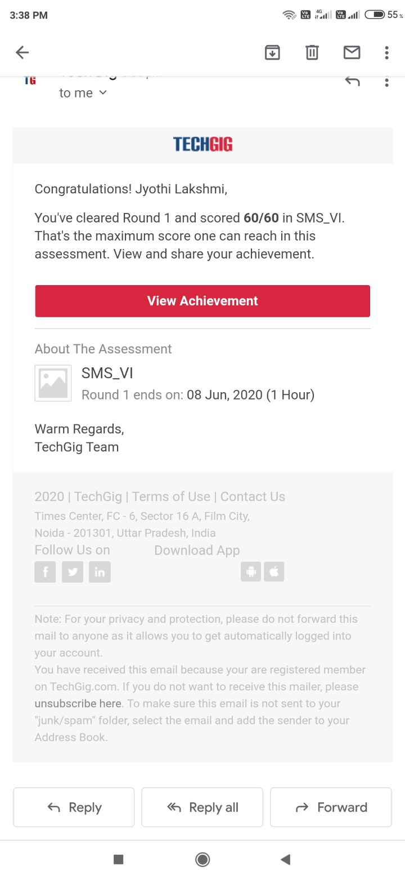

1. **Certification Course Details:**

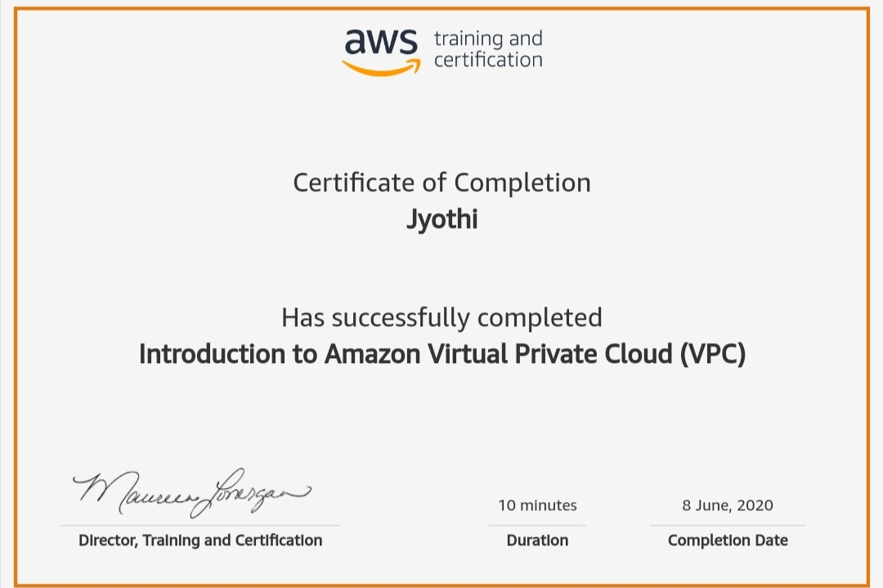

1. **Coding Challenges:**

/*C program to print character without using format specifiers.*/

#include <stdio.h> int main()

{

printf("\x41"); printf("\n");

printf("\x42"); printf("\n");

printf("\x43"); printf("\n");

printf("\x44"); printf("\n"); return 0;

}