**D AILY ONLINE ACTIVITIES SUMMARY**

|  |  |  |  |  |  |  |  |
| --- | --- | --- | --- | --- | --- | --- | --- |
| **Date:** | **09/6/2020** | | | | **Name:** | **Jyothi Lakshmi** | |
| **Sem & Sec** | **8th ,B** | | | | **USN:** | **4AL16CS129** | |
| Online Test Summary | | | | | | | |
| **Subject** | | **BDA** | | | | | |
| **Max. Marks** | | **30** | | **Score** | | **28** | |
| Certification Course Summary | | | | | | | |
| **Course** | **AWS** | | | | | | |
| **Certificate Provider** | | | **Aws** | **Duration** | | | **15 mins** |
| Coding Challenges | | | | | | | |
| **Problem Statement:**  1: Python program to rotate a matrix right by k times M=3  N=3 matrix=[[12,23,34],[45,56,67],[78,89,91]]. | | | | | | | |
| **Status: COMPLETED** | | | | | | | |
| **Uploaded the report in Github** | | | | **yes** | | | |
| **If yes Repository name** | | | | **Jyothi_129** | | | |
| **Uploaded the report in slack** | | | | **yes** | | | |

Online Test Details: (Attach the snapshot and briefly write the report for the same)

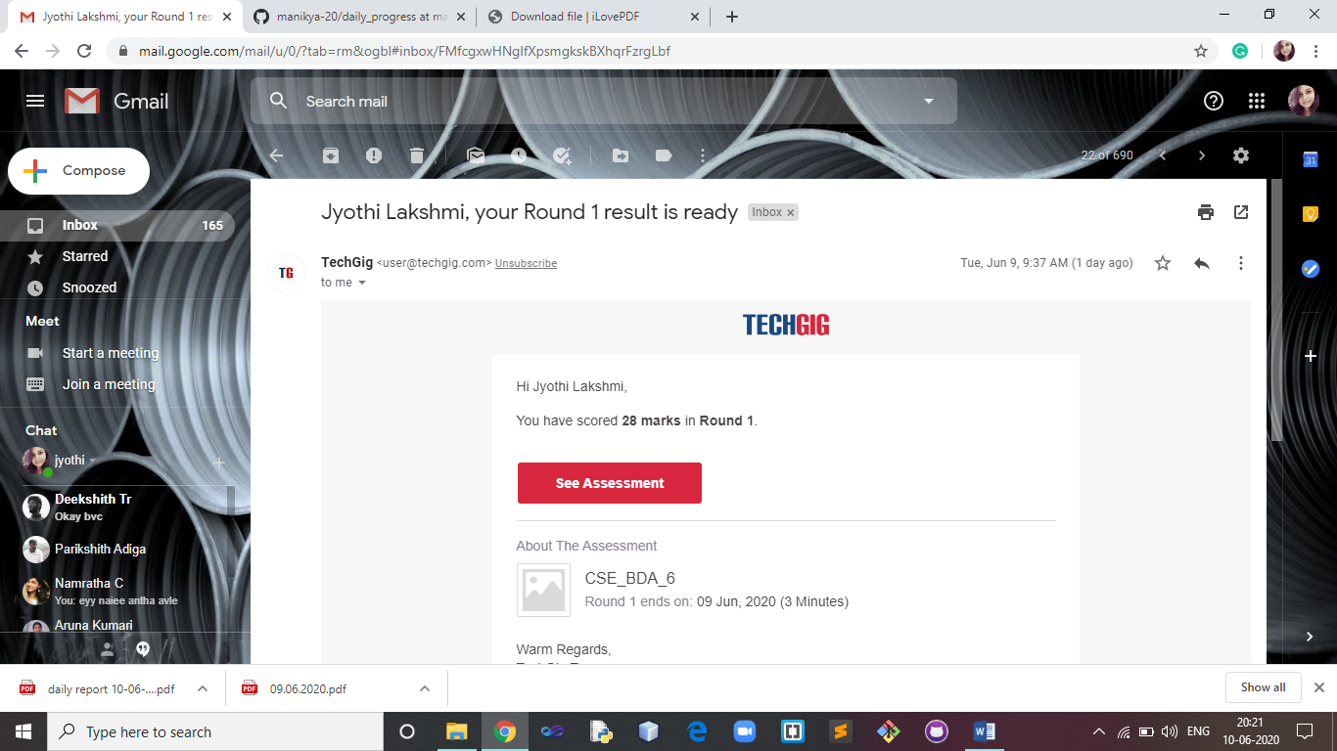

Certification Course Details: (Attach the snapshot and briefly write the report for the same)

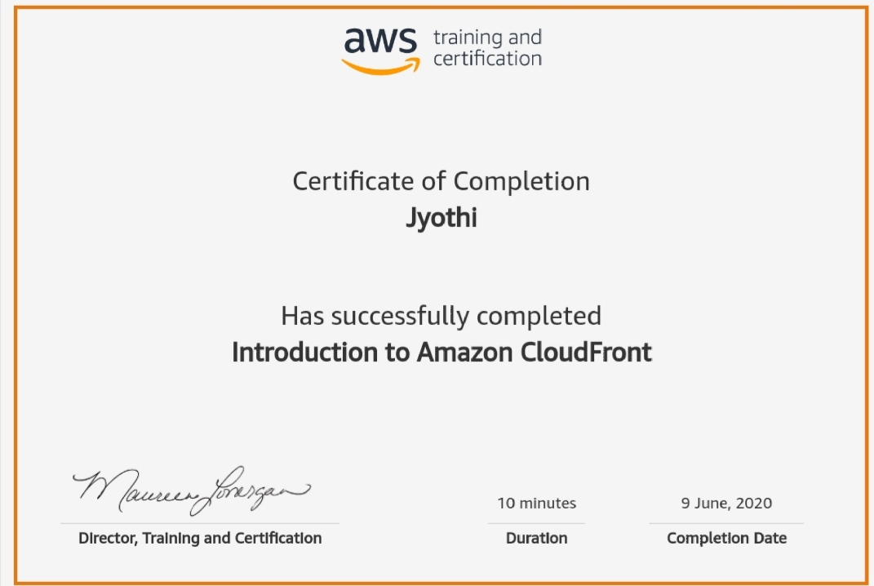

Coding Challenges Details: (Attach the snapshot and briefly write the report for the same)

def rotateMatrix(k):

global M, N, matrix temp=[0]*

k=k%M

for i in range(0,N):

for t in range(0,M-k):

temp[t]=matrix[i][t] for j in range(M-k,M):

matrix[i][j-M+k]=matrix[i][j] for j in range(k,M):

matrix[i][j]=temp[j-k] def displayMatrix():

global M, N, matrix for i in range(0,N):

for j in range(0,M):

print("{}".format(matrix[i][j]),end="") print()

k=2 rotateMatrix(k) displayMatrix()