**DAILY ONLINE ACTIVITIES SUMMARY**

|  |  |  |  |  |  |  |  |
| --- | --- | --- | --- | --- | --- | --- | --- |
| **Date:** | **10-06-2020** | | | | **Name:** | **Jyothi lakshmi** | |
| **Sem & Sec** | **8th,B** | | | | **USN:** | **4AL16CS0129** | |
| Online Test Summary | | | | | | | |
| **Subject** | | **Not Conducted** | | | | | |
| **Max. Marks** | | **-** | | **Score** | | **-** | |
| Certification Course Summary | | | | | | | |
| **Course** | **AWS** | | | | | | |
| **Certificate Provider** | | | **AWS** | **Duration** | | | **10MINS** |
| Coding Challenges | | | | | | | |
| Problem Statement: C++ implementation to print the half diamond star pattern | | | | | | | |
| **Status: Solved** | | | | | | | |
| **Uploaded the report in Github** | | | | **Yes** | | | |
| **If yes Repository name** | | | | **Jyothi_129** | | | |
| **Uploaded the report in slack** | | | | **Yes** | | | |

Online Test Details: (Attach the snapshot and briefly write the report for the same)

Certification Course Details: (Attach the snapshot and briefly write the report for the same) Coding Challenges Details: (Attach the snapshot and briefly write the report for the same)

# Certification Course Details:

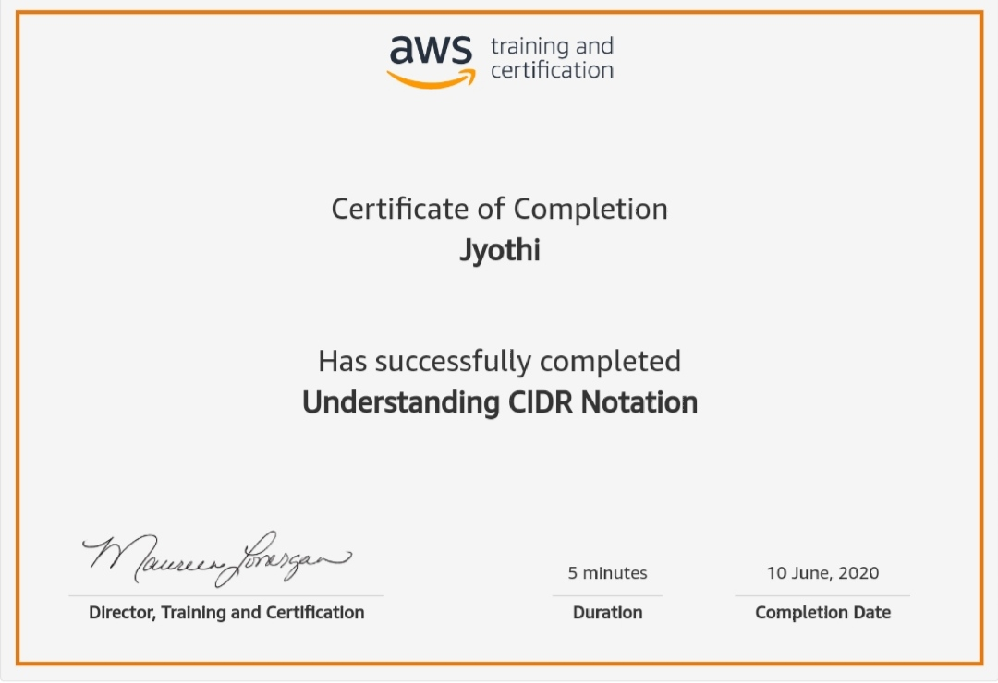

# Coding Challenges:

#include <iostream> using namespace std;

void halfDiamondStar(int N)

{

int i, j;

for (i = 0; i < N; i++) { for (j = 0; j < i + 1; j++)

cout << "*"; cout << "\n";

}

for (i = 1; i < N; i++) { for (j = i; j < N; j++)

cout << "*"; cout << "\n";

}

}

int main()

{

int N = 5; halfDiamondStar(N);

}