**DAILY ONLINE ACTIVITIES SUMMARY**

|  |  |  |  |  |  |  |  |
| --- | --- | --- | --- | --- | --- | --- | --- |
| **Date:** | **11/06/2020** | | | | **Name:** | **Jyothi Lakshmi** | |
| **Sem & Sec** | **8th- B** | | | | **USN:** | **4AL16CS129** | |
| Online Test Summary | | | | | | | |
| **Subject** | | **SMS** | | | | | |
| **Max. Marks** | | **60** | | **Score** | | **60** | |
| Certification Course Summary | | | | | | | |
| **Course** | **AWS Development tools overview** | | | | | | |
| **Certificate Provider** | | | **AWS** | **Duration** | | | **15Mins** |
| Coding Challenges | | | | | | | |
| **Problem Statement:**  **Python program to rotate an array by d elements** | | | | | | | |
| **Status: Executed** | | | | | | | |
| **Uploaded the report in Github** | | | | **Yes** | | | |
| **If yes Repository name** | | | | **Jyothi_129** | | | |
| **Uploaded the report in slack** | | | | **Yes** | | | |

Online Test Details:

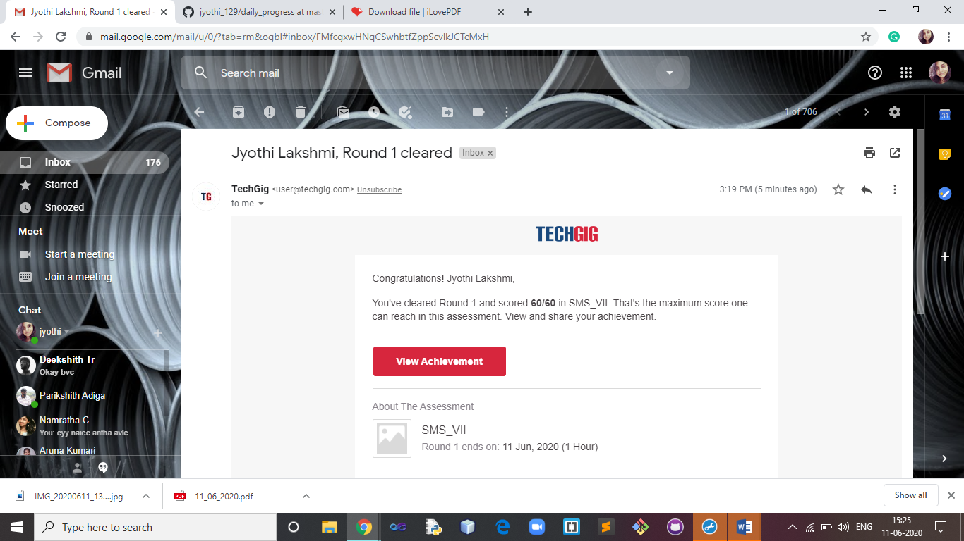

Certification Course Details:

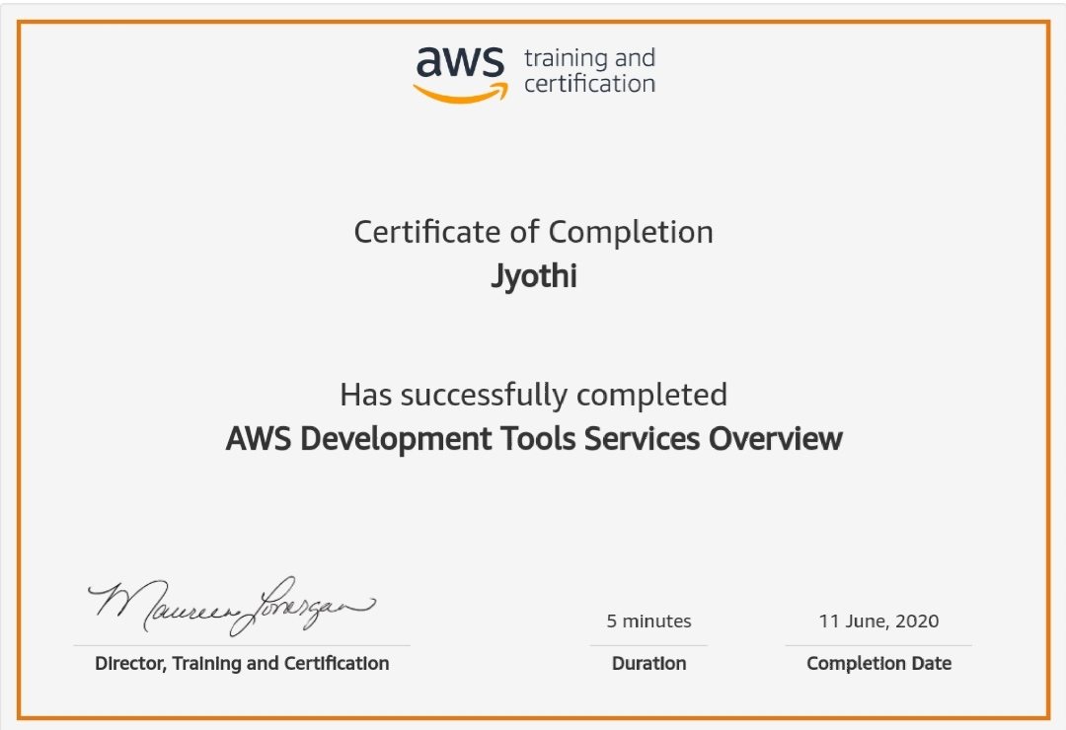

Coding Challenges Details:

