**DAILY ONLINE ACTIVITIES SUMMARY**

|  |  |  |  |  |  |  |  |
| --- | --- | --- | --- | --- | --- | --- | --- |
| **Date:** | **12-06-2020** | | | | **Name:** | **Jyothi Lakshmi** | |
| **Sem & Sec** | **8th,B** | | | | **USN:** | **4AL16CS129** | |
| Online Test Summary | | | | | | | |
| **Subject** | | **BDA** | | | | | |
| **Max. Marks** | | **30** | | **Score** | | **28** | |
| Certification Course Summary | | | | | | | |
| **Course** | **AWS** | | | | | | |
| **Certificate Provider** | | | **AWS** | **Duration** | | | **15 mins** |
| Coding Challenges | | | | | | | |
| **Problem Statement:** Removing last element from ArrayList in Java. | | | | | | | |
| **Status: Solved** | | | | | | | |
| **Uploaded the report in Github** | | | | **Yes** | | | |
| **If yes Repository name** | | | | **Jyothi_129** | | | |
| **Uploaded the report in slack** | | | | **Yes** | | | |

Online Test Details: (Attach the snapshot and briefly write the report for the same)

Certification Course Details: (Attach the snapshot and briefly write the report for the same) Coding Challenges Details: (Attach the snapshot and briefly write the report for the same)

# Online Test Details:

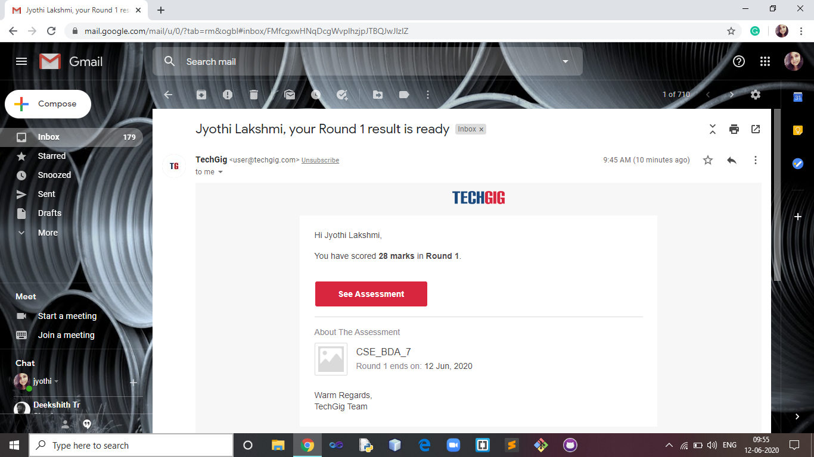

**2) Certification Course**

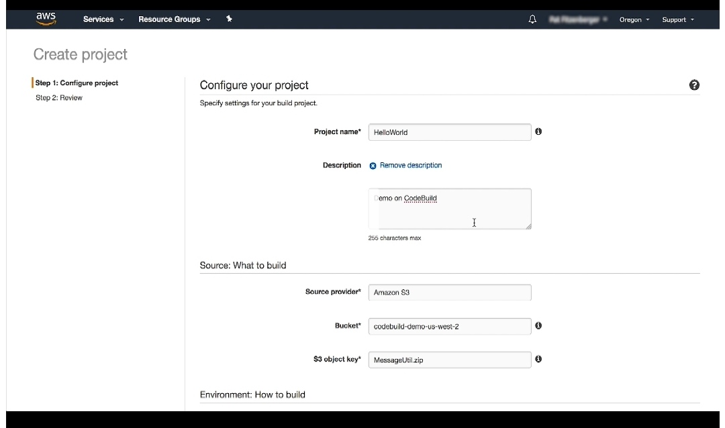

**3)Coding Challenges:**

import java.util.List; import java.util.ArrayList; public class GFG {

public static void main(String[] args)

{

List<Integer> al = new ArrayList<>(); al.add(10);

al.add(20);

al.add(30);

al.add(1);

al.add(2);

// Calculate index of last element int index = al.size() - 1;

// Delete last element by passing index al.remove(index);

System.out.println("Modified ArrayList : " + al);

}

}