**DAILY ONLINE ACTIVITIES SUMMARY**

|  |  |  |  |  |  |  |  |
| --- | --- | --- | --- | --- | --- | --- | --- |
| **Date:** | **13-06-2020** | | | | **Name:** | **Jyothi Lakshmi** | |
| **Sem & Sec** | **8th, B** | | | | **USN:** | **4AL16CS129** | |
| Online Test Summary | | | | | | | |
| **Subject** | | **IOT** | | | | | |
| **Max. Marks** | | **30** | | **Score** | | **29** | |
| Certification Course Summary | | | | | | | |
| **Course** | **AWS** | | | | | | |
| **Certificate Provider** | | | **AWS** | **Duration** | | | **15Mins** |
| Coding Challenges | | | | | | | |
| **Problem Statement:** Java prog tocalculate log base 2 of an Integer. | | | | | | | |
| **Status: Solved** | | | | | | | |
| **Uploaded the report in Github** | | | | **Yes** | | | |
| **If yes Repository name** | | | | **Jyothi_129** | | | |
| **Uploaded the report in slack** | | | | **Yes** | | | |

Online Test Details: (Attach the snapshot and briefly write the report for the same)

Certification Course Details: (Attach the snapshot and briefly write the report for the same) Coding Challenges Details: (Attach the snapshot and briefly write the report for the same)

# Online Test Details:

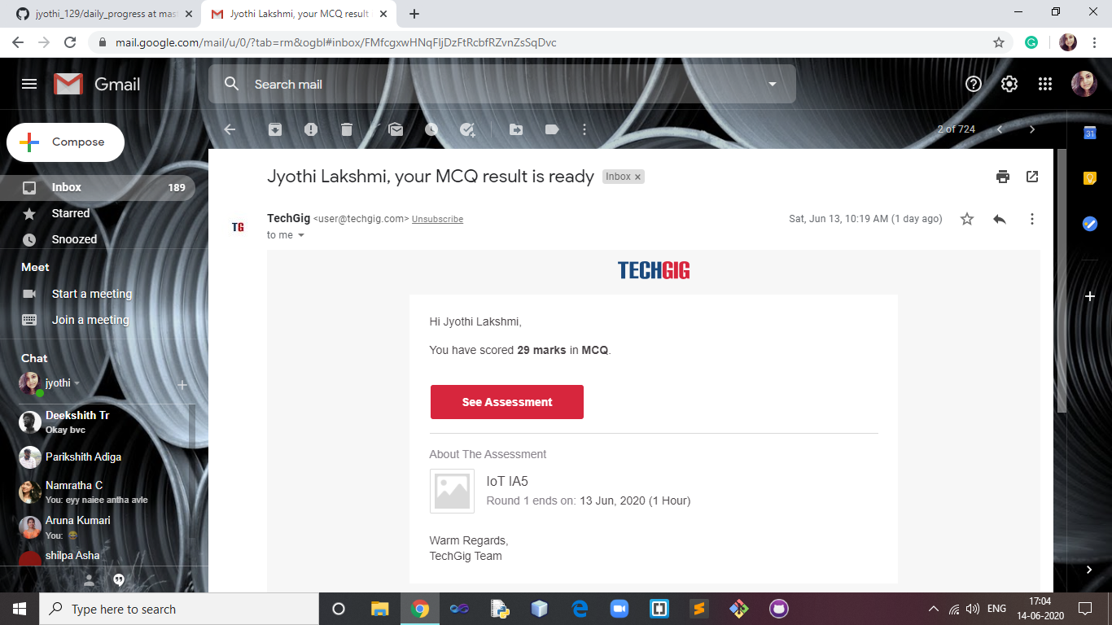

1. **Certification Course Details:**

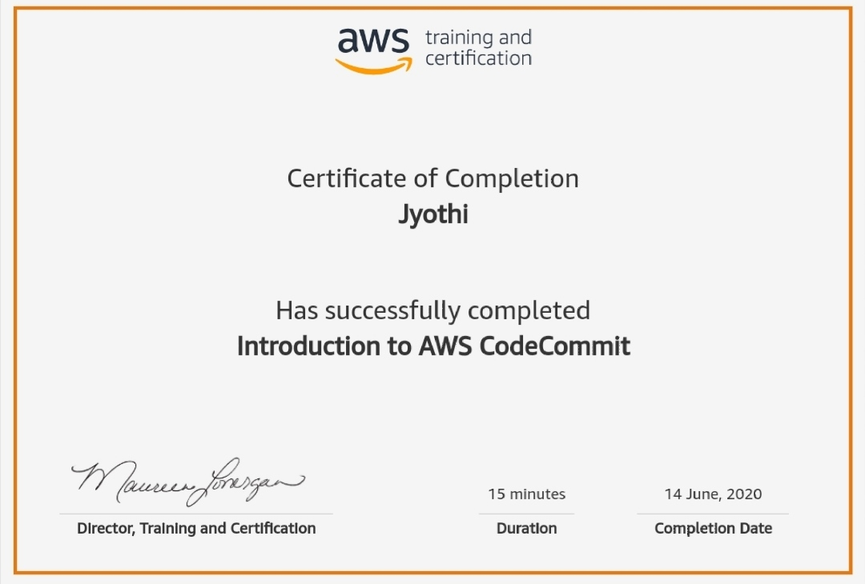

# Coding Challenges:

import java.io.*; import java.lang.*;

class GFG {

// Function to calculate the

// log base 2 of an integer public static int log2(int N)

{

// calculate log2 N indirectly

// using log() method

int result = (int)(Math.log(N) / Math.log(2));

return result;

}

// Driver code

public static void main(String[] args)

{

int N = 1024;

System.out.println("Log " + N

+ " to the base 2 = "

+ log2(N));

}

}