**DAILY ONLINE ACTIVITIES SUMMARY**

|  |  |  |  |  |  |  |  |
| --- | --- | --- | --- | --- | --- | --- | --- |
| **Date:** | **23/05/2020** | | | | **Name:** | **JYOTHI LAKSHMI** | |
| **Sem & Sec** | **8th sem, B sec** | | | | **USN:** | **4AL16CS129** | |
| **Online Test Summary** | | | | | | | |
| **Subject** | | **NO TEST TODAY** | | | | | |
| **Max. Marks** | | **00** | | **Score** | | **00** | |
| **Certification Course Summary** | | | | | | | |
| **Course** | **JAVA PROGRAMMING(240 mins)** | | | | | | |
| **Certificate Provider** | | | **Great Learning** | **Duration** | | | **30 mins** |
| **Coding Challenges** | | | | | | | |
| **Problem Statement: 1) Write a program to display fisrt N Triangular Numbers.** | | | | | | | |
| **Status: Completed** | | | | | | | |
| **Uploaded the report in Github** | | | | **Yes** | | | |
| **If yes Repository name** | | | |  | | | |
| **Uploaded the report in slack** | | | | **Yes** | | | |

ONLINE CERTIFICATION COURSE:

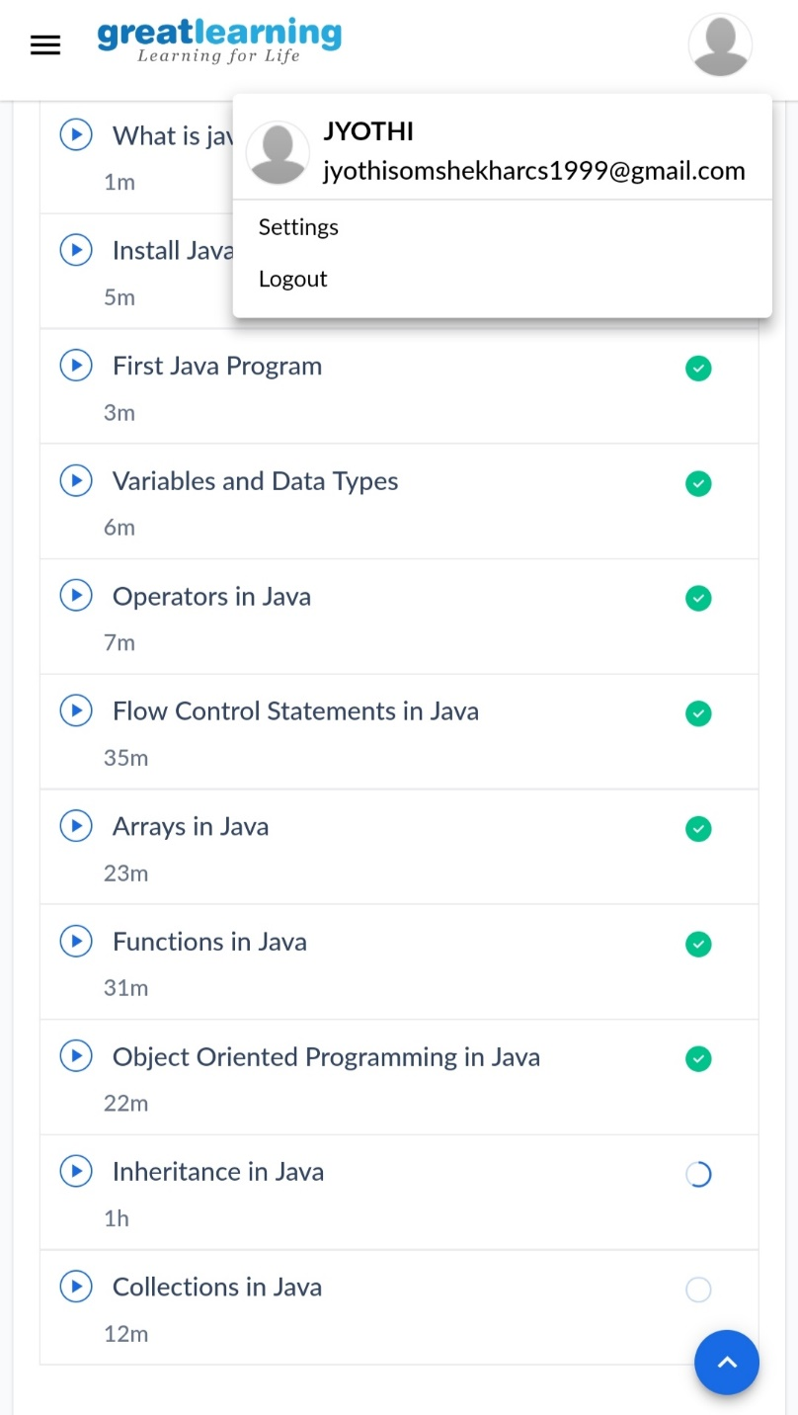

Coding Challenges Details:

1)Write a C Program to Display first N Triangular Numbers –where N is read from the Keyboard.

#include<stdio.h>

void triangular_series(int n)

{

for(int i=1;i<=n;i++)

printf(“%d”,i*(i+1)/2);

}

int main()

{

int n;

printf(“enter the value for n”);

scanf(“%d”,&n);

return 0;

}