DAILY ONLINE ACTIVITIES SUMMARY

|  |  |  |  |  |  |  |  |
| --- | --- | --- | --- | --- | --- | --- | --- |
| **Date:** | **26/5/2020** | | | | **Name:** | **Jyothi lakshmii** | |
| **Sem & Sec** | **8th Sem** | | | | **USN:** | **4AL16CS129** | |
| Online Test Summary | | | | | | | |
| **Subject** | | **Big Data Analysis** | | | | | |
| **Max. Marks** | | **Test 1: 20**  **Test 2: 20** | | **Score** | | **Test 1: 16**  **Test 2: 14** | |
| Certification Course Summary | | | | | | | |
| **Course** | **Java programming** | | | | | | |
| **Certificate Provider** | | | **Great learning** | **Duration** | | | **33min** |
| Coding Challenges | | | | | | | |
| **Problem Statement:**  1: Python program print al numbers which aren't divisible by 2 or 3 and lie between 1-50. 2: Python Program to Count the Number of Digits in a Number. | | | | | | | |
| **Status:COMPLETED** | | | | | | | |
| **Uploaded the report in Github** | | | | **Yes** | | | |
| **If yes Repository name** | | | |  | | | |
| **Uploaded the report in slack** | | | | **Yes** | | | |

Online Test Details: (Attach the snapshot and briefly write the report for the same)

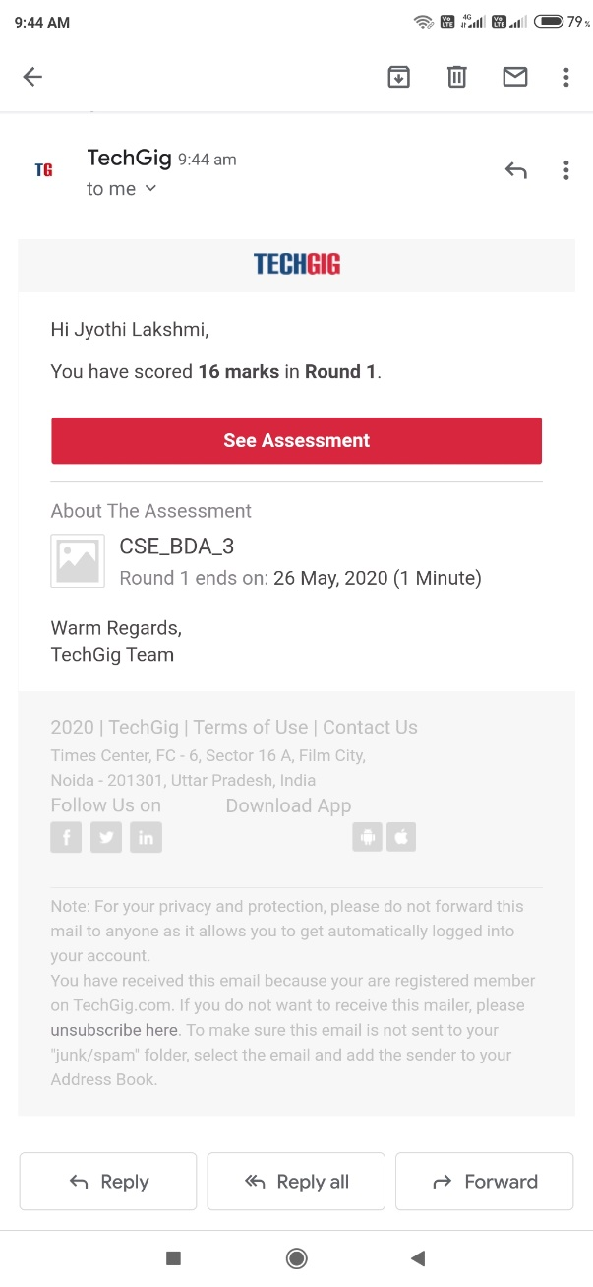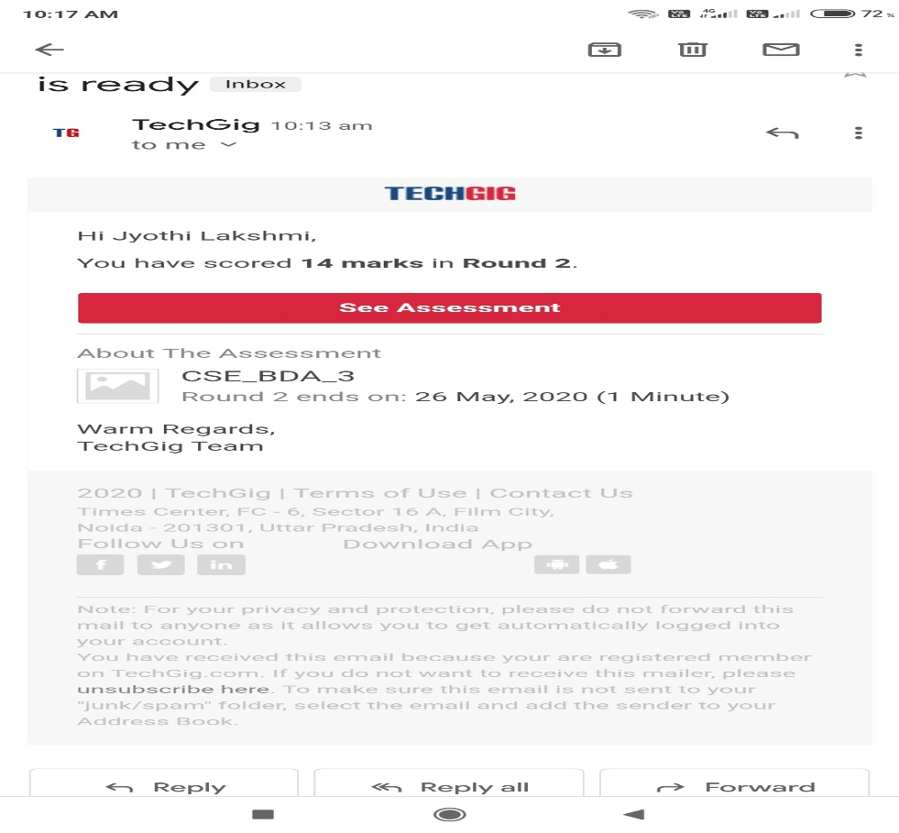

Certification Course Details: (Attach the snapshot and briefly write the report for the same)

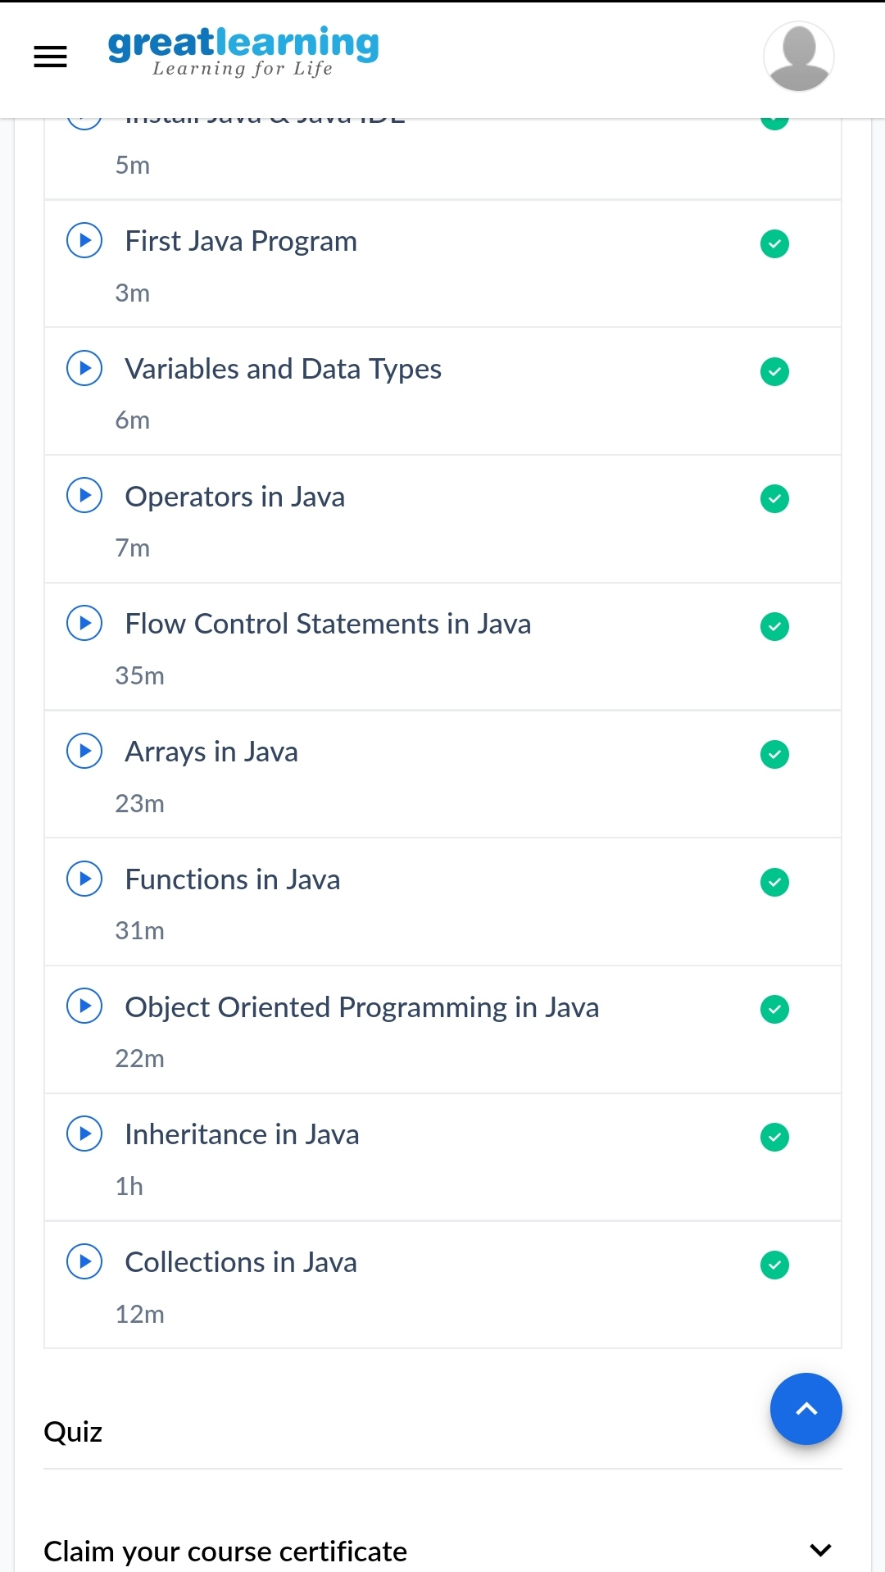

Coding Challenges Details: (Attach the snapshot and briefly write the report for the same)

