**D AILY ONLINE ACTIVITIES SUMMARY**

|  |  |  |  |  |  |  |  |
| --- | --- | --- | --- | --- | --- | --- | --- |
| **Date:** | **27/5/2020** | | | | **Name:** | **Jyothi Lakshmi** | |
| **Sem & Sec** | **8th Sem** | | | | **USN:** | **4AL16CS129** | |
| Online Test Summary | | | | | | | |
| **Subject** | | **Internet Of Things** | | | | | |
| **Max. Marks** | | **30** | | **Score** | | **28** | |
| Certification Course Summary | | | | | | | |
| **Course** | **Java programming** | | | | | | |
| **Certificate Provider** | | | **Great learning** | **Duration** | | | **30min** |
| Coding Challenges | | | | | | | |
| **Problem Statement:**  1: In bubble sort, each pass consists of comparison each element in the file with its successor and interchange two elements if they are not in the proper order. The array may be sorted in any pass. If the array is sorted, then remaining passes should be skipped off. Write a C program to | | | | | | | |
| **Status:COMPLETED** | | | | | | | |
| **Uploaded the report in Github** | | | | **Yes** | | | |
| **If yes Repository name** | | | |  | | | |
| **Uploaded the report in slack** | | | | **Yes** | | | |

Online Test Details: (Attach the snapshot and briefly write the report for the same)

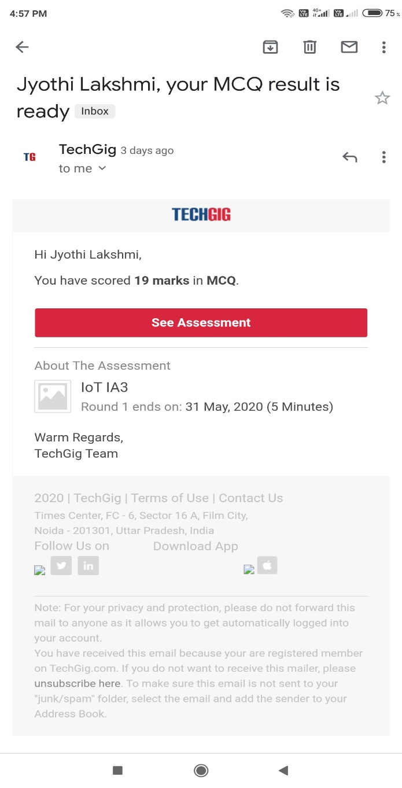

Certification Course Details: (Attach the snapshot and briefly write the report for the same)

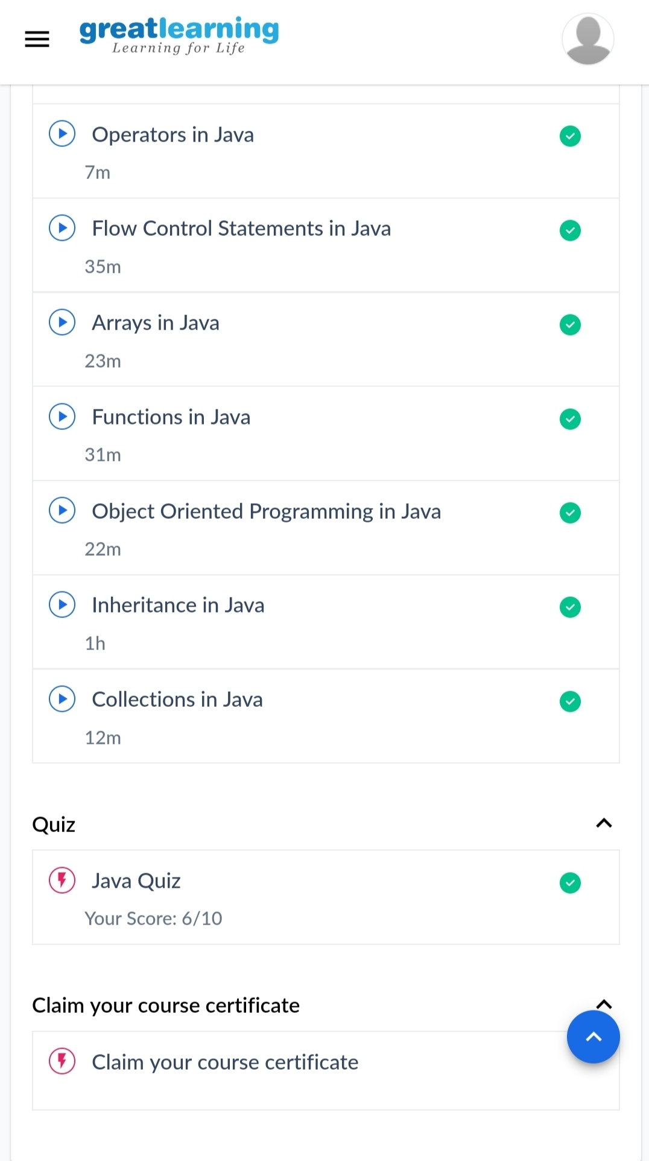

Coding Challenges Details: (Attach the snapshot and briefly write the report for the same)

