**D AILY ONLINE ACTIVITIES SUMMARY**

|  |  |  |  |  |  |  |  |
| --- | --- | --- | --- | --- | --- | --- | --- |
| **Date:** | **28/5/2020** | | | | **Name:** | **Jyothi Lakshmi** | |
| **Sem & Sec** | **8th Sem** | | | | **USN:** | **4AL16CS129** | |
| Online Test Summary | | | | | | | |
| **Subject** | | **SMS** | | | | | |
| **Max. Marks** | | **60** | | **Score** | | **45** | |
| Certification Course Summary | | | | | | | |
| **Course** | **Java Programming** | | | | | | |
| **Certificate Provider** | | | **Great Learning** | **Duration** | | | **38min** |
| Coding Challenges | | | | | | | |
| **Problem Statement:**  1: Python program to convert Celsius to Fahrenheit. | | | | | | | |
| **Status:COMPLETED** | | | | | | | |
| **Uploaded the report in Github** | | | | **yes** | | | |
| **If yes Repository name** | | | |  | | | |
| **Uploaded the report in slack** | | | | **yes** | | | |

Online Test Details: (Attach the snapshot and briefly write the report for the same)

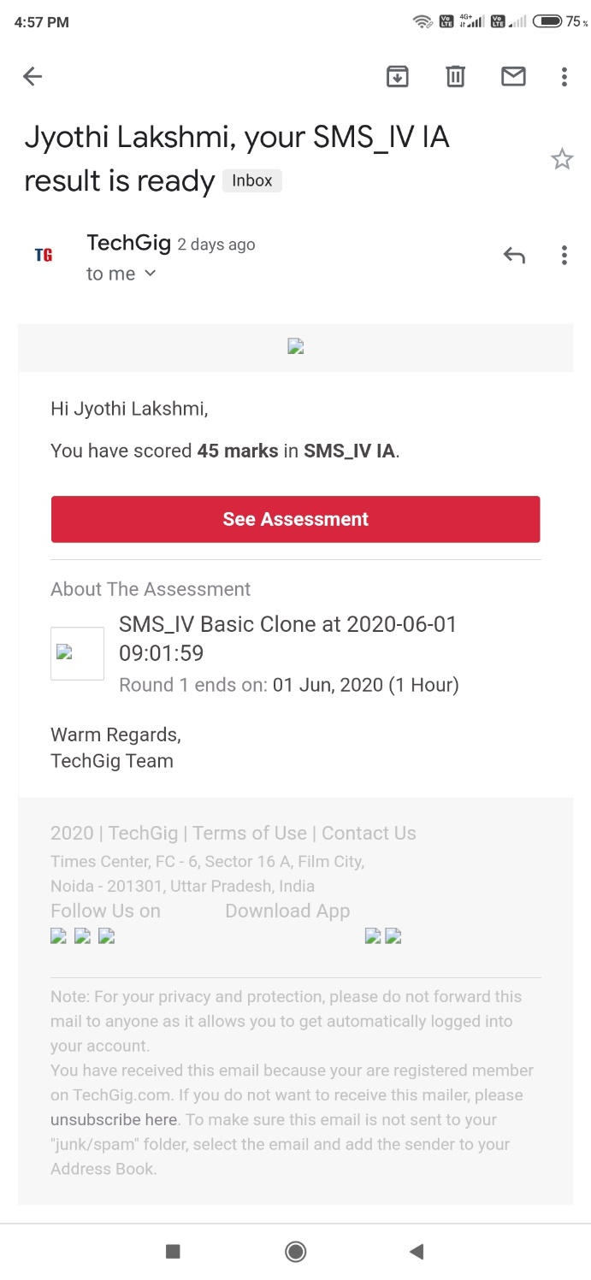

Certification Course Details: (Attach the snapshot and briefly write the report for the same)

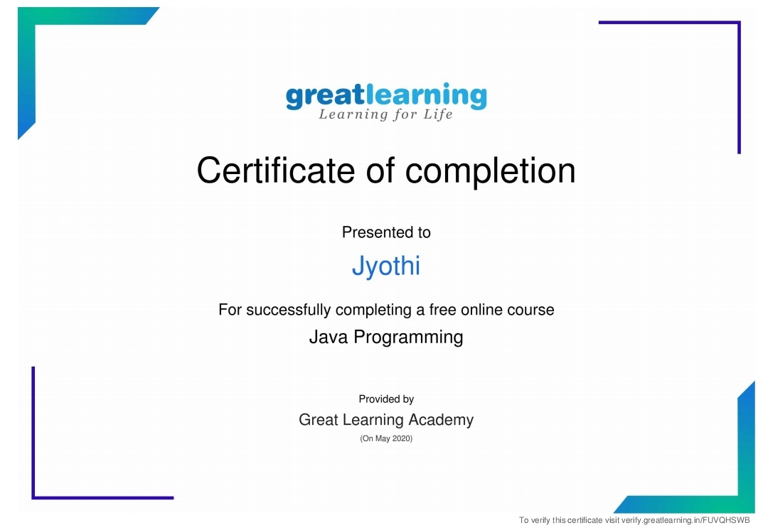

Coding Challenges Details: (Attach the snapshot and briefly write the report for the same)

Celsius=37.5 Fahreheit=(celsius*1.8)+32

Print(‘%0.IfdegreeCelsiusisequalto%0.IfdegreeFahrenheit’%(Celsius,Fahrenheit))