**D AILY ONLINE ACTIVITIES SUMMARY**

|  |  |  |  |  |  |  |  |
| --- | --- | --- | --- | --- | --- | --- | --- |
| **Date:** | **30/5/2020** | | | | **Name:** | **Jyothi Lakshmi** | |
| **Sem & Sec** | **8th Sem** | | | | **USN:** | **4AL16CS129** | |
| Online Test Summary | | | | | | | |
| **Subject** | | **NO TEST TAKEN** | | | | | |
| **Max. Marks** | | **NIL** | | **Score** | | **NIL** | |
| Certification Course Summary | | | | | | | |
| **Course** | **The Introduction to Amazon Elastic Compute Cloud** | | | | | | |
| **Certificate Provider** | | | **AWS** | **Duration** | | | **10mins** |
| Coding Challenges | | | | | | | |
| **Problem Statement:**  1: Find the nuber that is missing from the array containing n distinct number taken from 0,1,2,…n | | | | | | | |
| **Status:COMPLETED** | | | | | | | |
| **Uploaded the report in Github** | | | | **Yes** | | | |
| **If yes Repository name** | | | | **Jyothi_129** | | | |
| **Uploaded the report in slack** | | | | **Yes** | | | |

Online Test Details: (Attach the snapshot and briefly write the report for the same)

Certification Course Details: (Attach the snapshot and briefly write the report for the same)

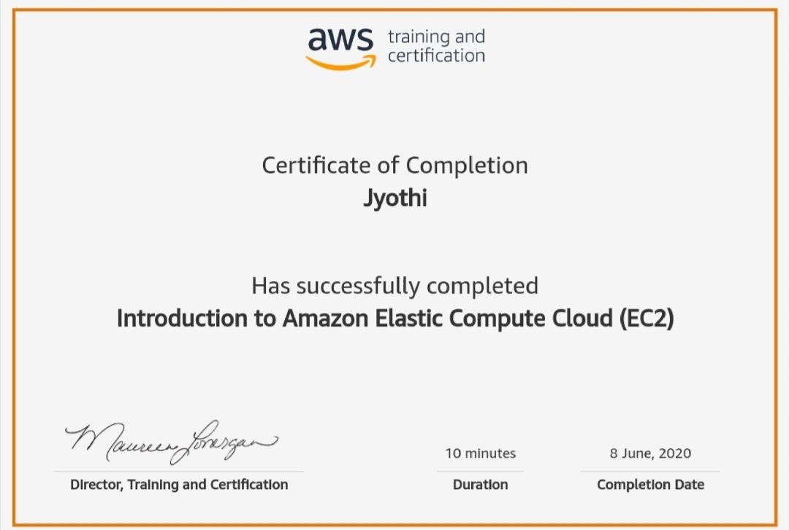

Coding Challenges Details: (Attach the snapshot and briefly write the report for the same)

#include<stdio.h>

int getMissingNo(inta[],intn)

{

int i, total;

total=(n+1)*(n+2)/2; for(i=0;i<n;i++) total-=a[i];

return total;

}

intmain()

{

int a[]={1,2,4,5,6};

int miss=getMissingNo(a,5); printf("%d",miss); getchar();

}