**D AILY ONLINE ACTIVITIES SUMMARY**

|  |  |  |  |  |  |  |  |
| --- | --- | --- | --- | --- | --- | --- | --- |
| **Date:** | **31/5/2020** | | | | **Name:** | **Jyothi lakshmi** | |
| **Sem & Sec** | **8th Sem** | | | | **USN:** | **4AL16CS129** | |
| Online Test Summary | | | | | | | |
| **Subject** | | **IOT** | | | | | |
| **Max. Marks** | | **20** | | **Score** | | **19** | |
| Certification Course Summary | | | | | | | |
| **Course** | **Learn to create AI Assistant with python** | | | | | | |
| **Certificate Provider** | | | **Udemy** | **Duration** | | | **5hr** |
| Coding Challenges | | | | | | | |
| **Problem Statement:**  1: Write a c program to sort an array of integers in ascending or descending order and display the sorted array and number of passes performed for sorting. | | | | | | | |
| **Status:COMPLETED** | | | | | | | |
| **Uploaded the report in Github** | | | | **Yes** | | | |
| **If yes Repository name** | | | | **Jyothi Lakshmi** | | | |
| **Uploaded the report in slack** | | | | **Yes** | | | |

Online Test Details: (Attach the snapshot and briefly write the report for the same)



Certification Course Details: (Attach the snapshot and briefly write the report for the same)

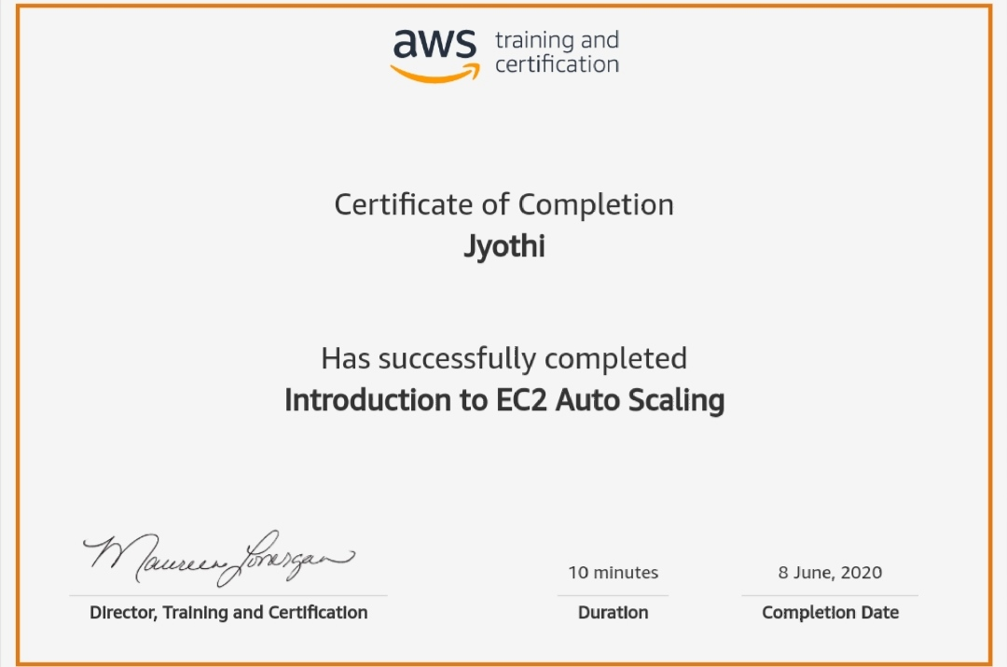

Coding Challenges Details: (Attach the snapshot and briefly write the report for the same)

#include stdio.h

void swap(int*xp,int*yp)

{

int temp=*xp;

*xp=*yp;

*yp=temp;

}

int bubbleSort(int arr[], int n)

{

int i, j, count=0; int swapped; for(i=0;i<n-1;i++)

{

swapped=0; for(j=0;j<n-i-1;j++)

{

if(arr[j]>arr[j+1])

{

swap(&arr[j],&arr[j+1]); swapped=1;

count++;

}

}

if(swapped==0) break;

}

return count;

}

void printArray(int arr[], int size)

{

inti; for(i=0;i<size;i++) printf("%d",arr[i])

printf("\n");

}

int main()

{

int arr[50], num;

printf("enter the number of elements"); scanf("%d",&num);

printf("enter the elements"); for(inti=0;i=n;i++)

}