**DAILY ONLINE ACTIVITIES SUMMARY**

|  |  |  |  |  |  |  |  |  |
| --- | --- | --- | --- | --- | --- | --- | --- | --- |
| **Date:** | 06-07-2020 | | | | | **Name:** | JYOTHI B R | |
| **Sem & Sec** | Fourth sem section A | | | | | **USN:** | 4AL18CS030 | |
| **Descriptive Test Summary** | | | | | | | | |
| **Subject** | | Engineering Mathematics - 4 | | | | | | |
| **Time Limit** | | 45 min | | **Score** | | | - | |
| **Certification Course Summary** | | | | | | | | |
| **Course** | 1. **HTML,CSS AND JAVASCRIPT** | | | | | | | |
| **Certificate Provider** | | | Udemy | | **Duration** | | | 3 hr |
| **Coding Challenges** | | | | | | | | |
| **Problem Statement:**  1: [Given an array of integer arr[] and an integer k, the task is to find the median of each window of size k starting from the left and moving towards the right by one position each time.](https://github.com/orgs/alvas-education-foundation/teams/2nd-year/discussions/145) | | | | | | | | |
| **Status:** completed | | | | | | | | |
| **Uploaded the report in Github** | | | | | yes | | | |
| **If yes Repository name** | | | | | <https://github.com/alvas-education-foundation/jyothi_b_r> | | | |
| **Uploaded the report in slack** | | | | | yes | | | |

**Descriptive Test Details:**

The test was from module 1 and there were 3 questions to solve. The time limit was 45 minutes. We had to write the test in A4 sheet and had to upload in Google classroom.

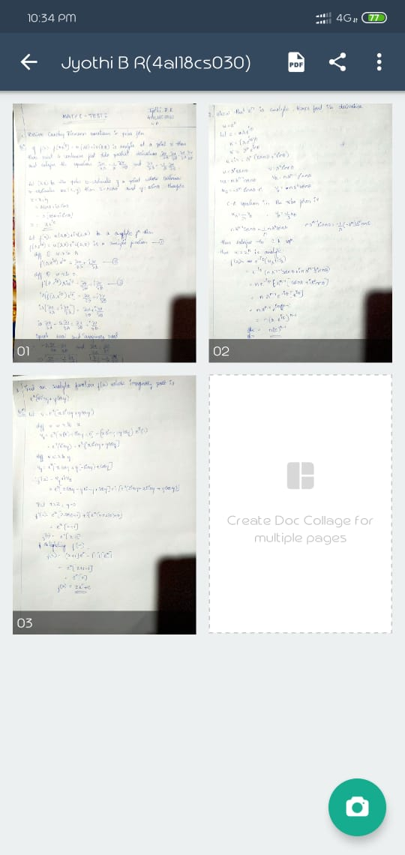

**Online Course Details:**

1. Name of course: **HTML,CSS AND JAVASCRIPT**

Certificate provider: Udemy

The total course is about getting familiar with **web development** and how web development can be implemented in it. Today I went through html basics, the difference between web development and web design.

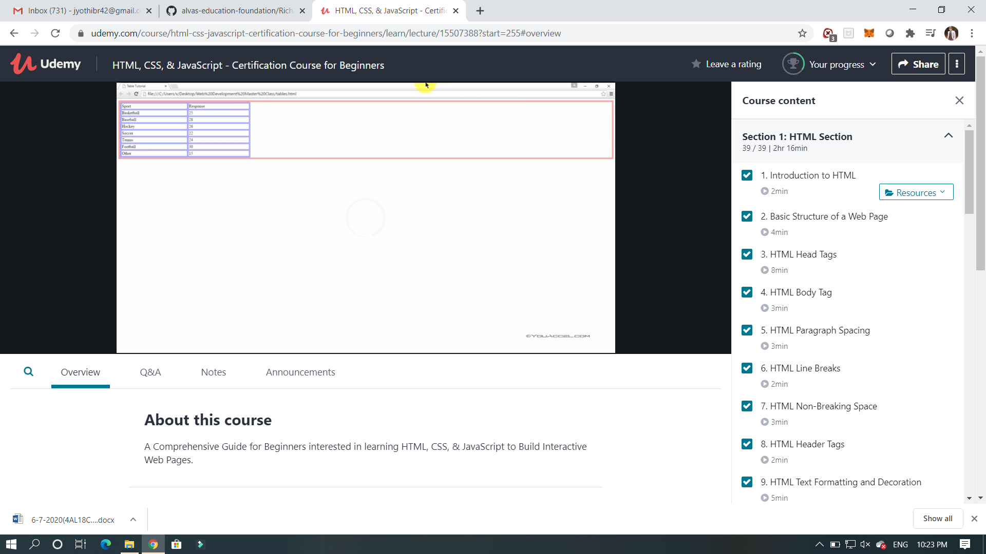

**Online coding:**

Problem 1: (using JAVA) [Given an array of integer arr[] and an integer k, the task is to find the median of each window of size k starting from the left and moving towards the right by one position each time.](https://github.com/orgs/alvas-education-foundation/teams/2nd-year/discussions/145)

