**DAILY ONLINE ACTIVITIES SUMMARY**

|  |  |  |  |  |  |  |  |  |
| --- | --- | --- | --- | --- | --- | --- | --- | --- |
| Date: | 19/05/2000 | | | | | Name: | Jyothi B R | |
| Sem & Sec | IV-A | | | | | USN: | 4AL18CS030 | |
| Online Test Summary | | | | | | | | |
| Subject | | Design and Analysis of Algorithms | | | | | | |
| Max. Marks | | 30 | | Score | | | 20 | |
| Certification Course Summary | | | | | | | | |
| Course | Programming Essentials in Python | | | | | | | |
| Certificate Provider | | | Cisco Virtual Academy | | Duration | | | 2hrs |
| Coding Challenges | | | | | | | | |
| Problem Statement:Using methods charAt() & length() of String class, write a program to print thefrequency of each character in a string.  “Hello friend”  Output should be  -: 1  d: 1  e: 2  f: 1 | | | | | | | | |
| Status:Completed | | | | | | | | |
| Uploaded the report in Github | | | | | Yes | | | |
| If yes Repository name | | | | | https://github.com/alvas-education-foundation/jyothi_b_r | | | |
| Uploaded the report in slack | | | | | Yes | | | |

Online Test Details: (Attach the snapshot and briefly write the report for the same)

Certification Course Details: (Attach the snapshot and briefly write the report for the same)

Coding Challenges Details: (Attach the snapshot and briefly write the report for the same)

ONLINE TEST DETAILS:

The online test was from module 1 which was about Introduction to the subject and asymptotic notations. There were 25 questions and the duration were 30 minutes. The questions were optimal and were easy. The score that I received was 20/30.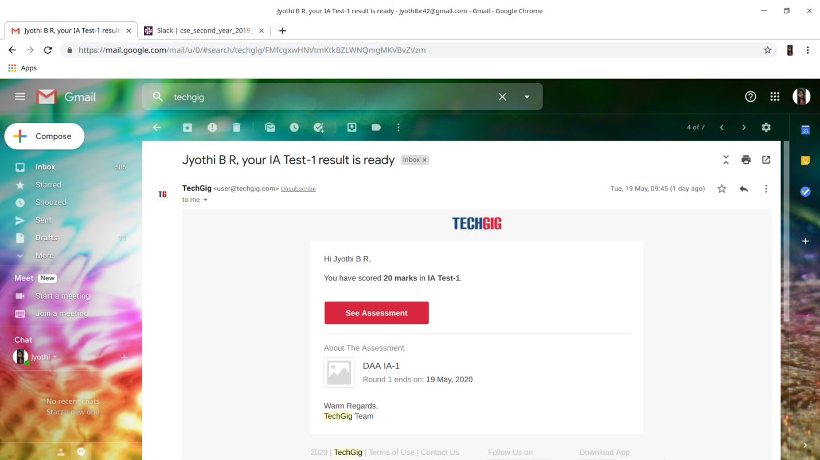

CERTIFICATION COURSE DETAILS:

Programming Essentials in Python :

* data types and the basic methods of formatting, converting, inputting and outputting data;
* operators;
* variables.

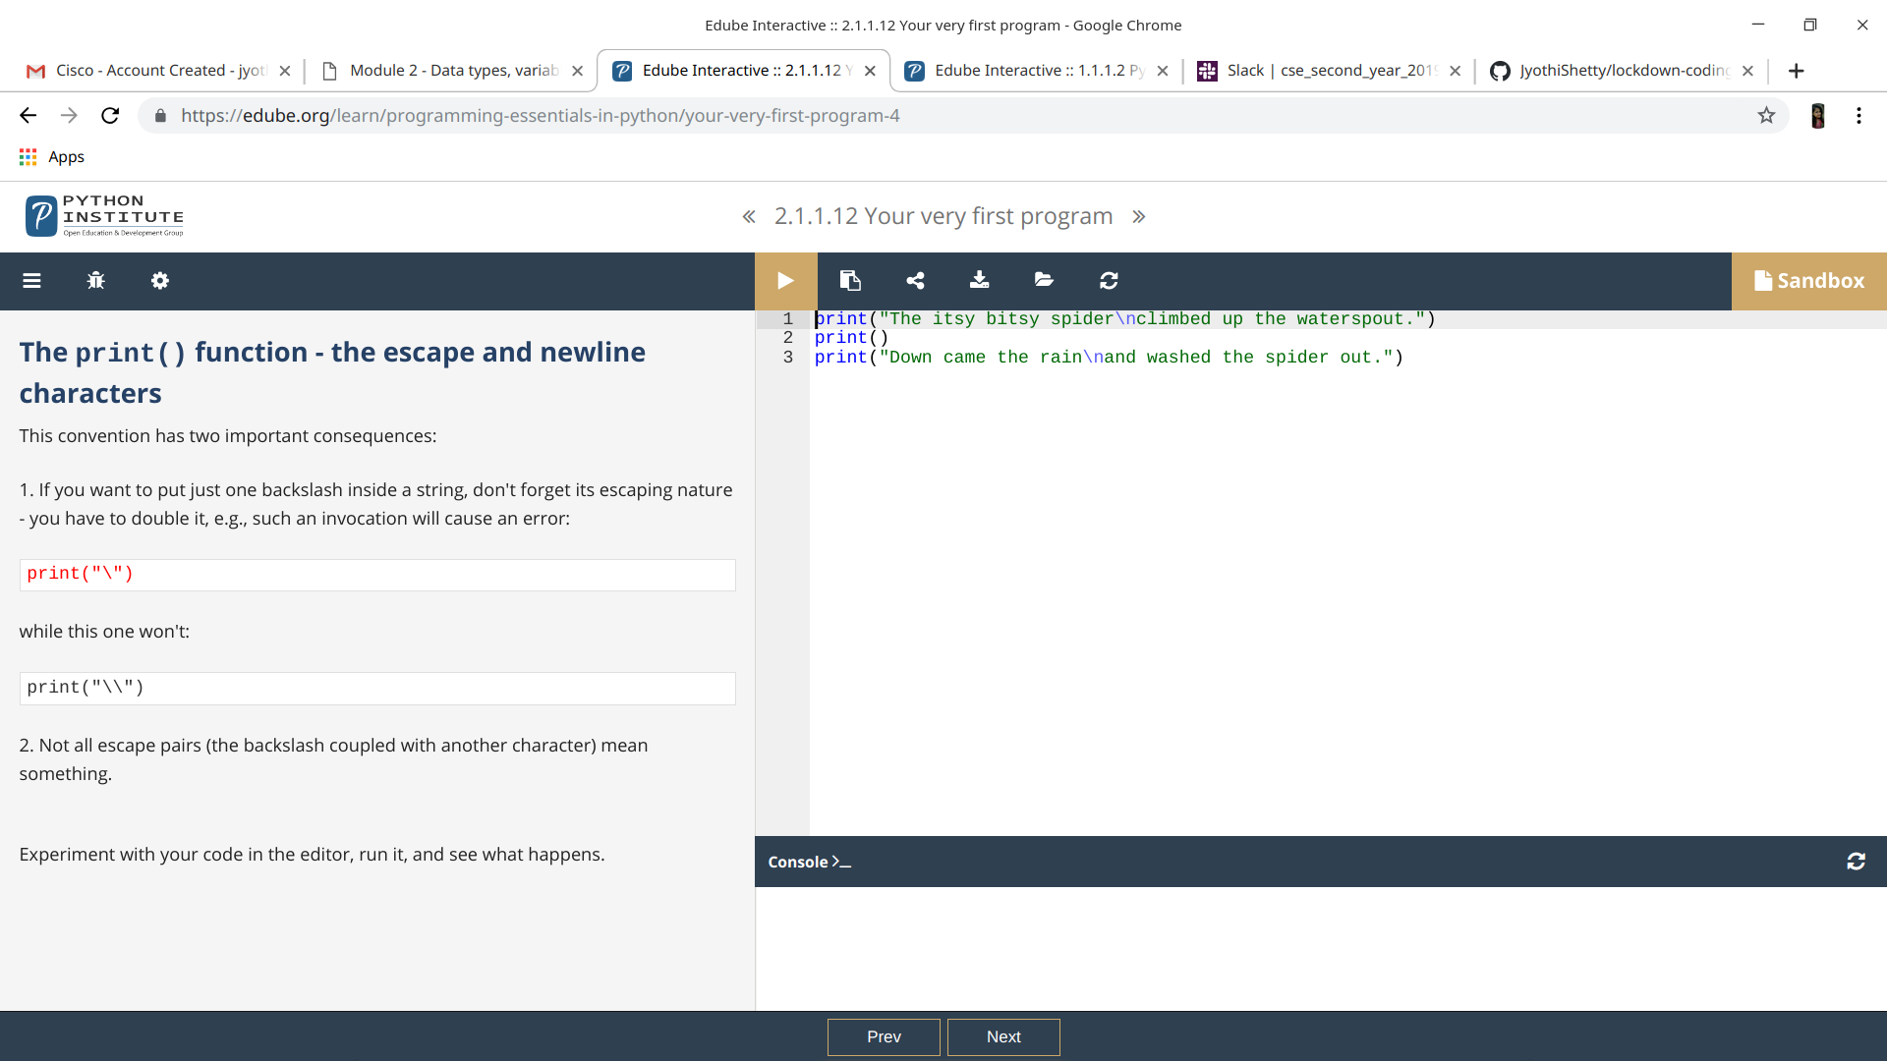

ONLINE CODING:

Using methods charAt() & length() of String class, write a program to print thefrequency of each character in a string.

“Hello friend”

Output should be

-: 1

d: 1

e: 2

f: 1

