**DAILY ONLINE ACTIVITIES SUMMARY**

|  |  |  |  |  |  |  |  |  |
| --- | --- | --- | --- | --- | --- | --- | --- | --- |
| Date: | 20/05/2000 | | | | | Name: | Jyothi B R | |
| Sem & Sec | IV-A | | | | | USN: | 4AL18CS030 | |
| Online Test Summary | | | | | | | | |
| Subject | | Object Oriented Concepts | | | | | | |
| Max. Marks | | 30 | | Score | | | 16 | |
| Certification Course Summary | | | | | | | | |
| Course | Programming Essentials in Python | | | | | | | |
| Certificate Provider | | | Cisco Virtual Academy | | Duration | | | 2hrs |
| Coding Challenges | | | | | | | | |
| Problem Statement:Using Write a simple code to identify given linked list is palindrome or not by using stack. | | | | | | | | |
| Status:Completed | | | | | | | | |
| Uploaded the report in Github | | | | | Yes | | | |
| If yes Repository name | | | | | https://github.com/alvas-education-foundation/jyothi_b_r | | | |
| Uploaded the report in slack | | | | | Yes | | | |

Online Test Details: (Attach the snapshot and briefly write the report for the same)

Certification Course Details: (Attach the snapshot and briefly write the report for the same)

Coding Challenges Details: (Attach the snapshot and briefly write the report for the same)

ONLINE TEST DETAILS:

The online test was from module 1 which was about c++ programming. There were 30 questions which contains 20 mcq and 10 programing question and the duration were 40 minutes. The questions were optimal. The score that I received was 16/30.

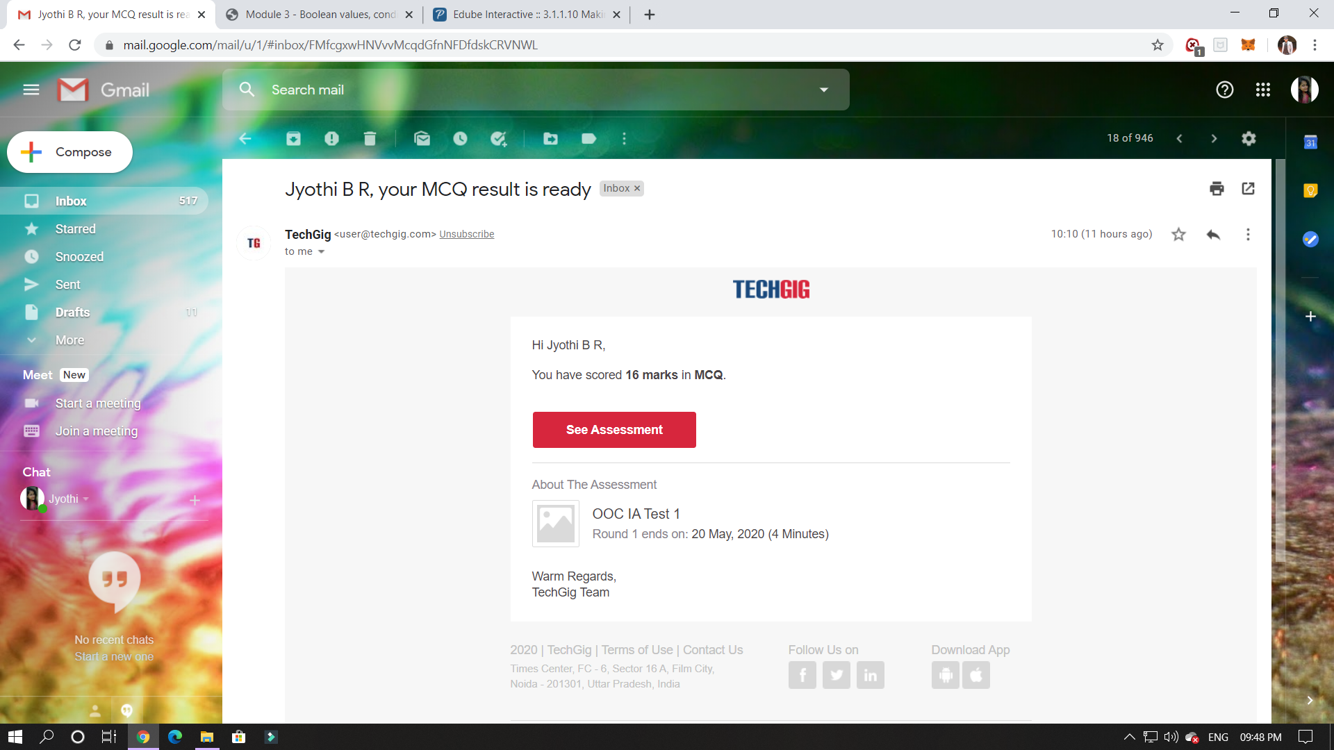

CERTIFICATION COURSE DETAILS:

Programming Essentials in Python :

* Boolean values;
* if-elif-else instructions;
* the while and for loops;
* flow control;
* logical and bitwise operations;
* lists and arrays.

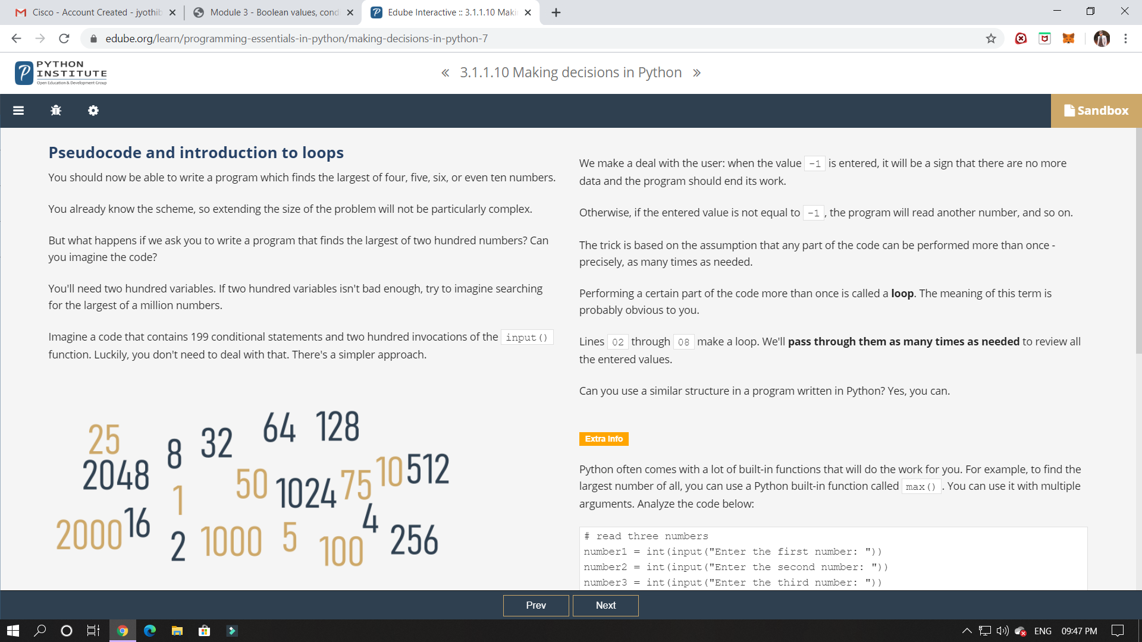

ONLINE CODING:

Write a simple code to identify given linked list is palindrome or not by using stack.  
First take a Stack. Traverse through each node of the linked list and push each node value to Stack.  
Once the traversal & copying is done, iterate through linked list from head node again.  
In each iteration, pop one stack element and compare with node value in respective iteration. It is expected to match stack popped value with node value.  
In case of all matches, its a palindrome. Any one element mismatch makes it not a palindrome.