**DAILY ONLINE ACTIVITIES SUMMARY**

|  |  |  |  |  |  |  |  |  |
| --- | --- | --- | --- | --- | --- | --- | --- | --- |
| Date: | 21/05/2000 | | | | | Name: | Jyothi B R | |
| Sem & Sec | IV-A | | | | | USN: | 4AL18CS030 | |
| Online Test Summary | | | | | | | | |
| Subject | | Micro-controller and Embedded Systems | | | | | | |
| Max. Marks | | 30 | | Score | | | 19 | |
| Certification Course Summary | | | | | | | | |
| Course | Programming Essentials in Python | | | | | | | |
| Certificate Provider | | | Cisco Virtual Academy | | Duration | | | 2hrs |
| Coding Challenges | | | | | | | | |
| Problem Statement:1.Reverse number using python ,2.right angle using python | | | | | | | | |
| Status:Completed | | | | | | | | |
| Uploaded the report in Github | | | | | Yes | | | |
| If yes Repository name | | | | | https://github.com/alvas-education-foundation/jyothi_b_r | | | |
| Uploaded the report in slack | | | | | Yes | | | |

Online Test Details: (Attach the snapshot and briefly write the report for the same)

Certification Course Details: (Attach the snapshot and briefly write the report for the same)

Coding Challenges Details: (Attach the snapshot and briefly write the report for the same)

ONLINE TEST DETAILS:

The online test was from module 1 which was about ARM embedded system. There were 30 questions which contains 30 mcq questions and the duration were 30 minutes. The questions were optimal. The score that I received was 19/30.

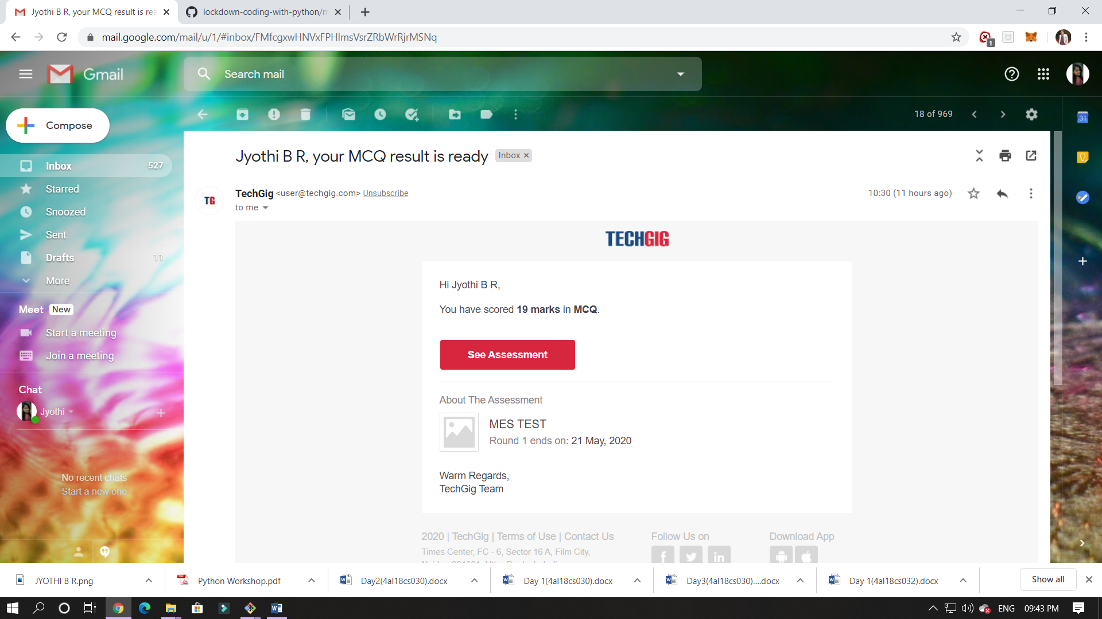

CERTIFICATION COURSE DETAILS:

Programming Essentials in Python :

**LISTS**:

The **list is a type of data** in Python used to **store multiple objects**. It is an **ordered and mutable collection** of comma-separated items between square brackets, e.g.:

myList = [1, None, True, "I am a string", 256, 0]

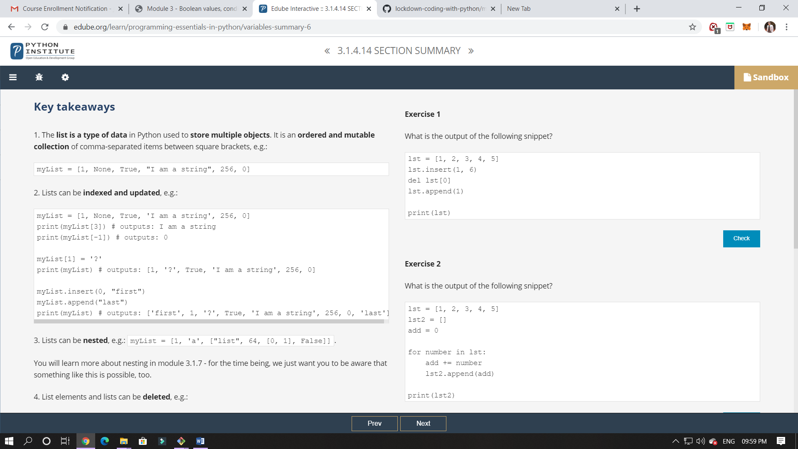

In this class I have learned about list and different ways of lists.

ie., Collection of Data, function method, list method, list and loops.

ONLINE CODING:

1. Write Python Program to Reverse a Given Number  
This is a Python Program to reverse a given number.  
Problem Description  
The program takes a number and reverses it and store it in another variable and show it.

2.Write a python program for

Enter number 5  
5 4 3 2 1  
4 3 2 1  
3 2 1  
2 1

1.reverse.py

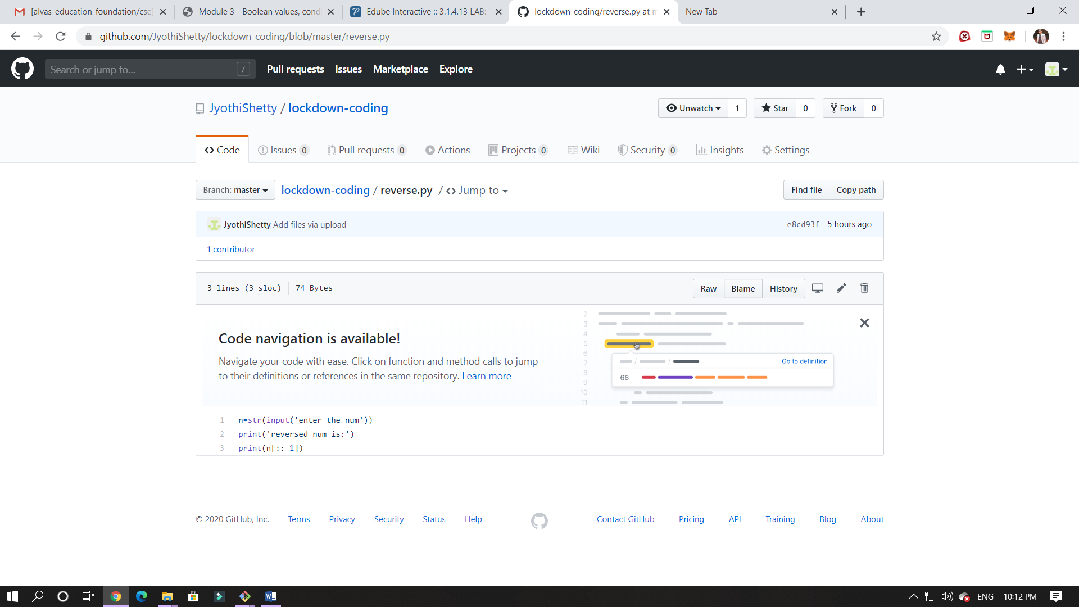

2.delete.py

