**DAILY ONLINE ACTIVITIES SUMMARY**

|  |  |  |  |  |  |  |  |  |
| --- | --- | --- | --- | --- | --- | --- | --- | --- |
| Date: | 22/05/2000 | | | | | Name: | Jyothi B R | |
| Sem & Sec | IV-A | | | | | USN: | 4AL18CS030 | |
| Online Test Summary | | | | | | | | |
| Subject | | Operating System | | | | | | |
| Max. Marks | | 30 | | Score | | | 18 | |
| Certification Course Summary | | | | | | | | |
| Course | Programming Essentials in Python | | | | | | | |
| Certificate Provider | | | Cisco Virtual Academy | | Duration | | | 2hrs |
| Coding Challenges | | | | | | | | |
| Problem Statement:1. Create a Singly Linked List Stack with the node corresponding to First Element is the base of the stack 2. Write a C or Java program to implement round robin type of process scheduling. | | | | | | | | |
| Status:Completed | | | | | | | | |
| Uploaded the report in Github | | | | | Yes | | | |
| If yes Repository name | | | | | https://github.com/JyothiShetty/lockdown-coding | | | |
| Uploaded the report in slack | | | | | Yes | | | |

Online Test Details: (Attach the snapshot and briefly write the report for the same)

Certification Course Details: (Attach the snapshot and briefly write the report for the same)

Coding Challenges Details: (Attach the snapshot and briefly write the report for the same)

ONLINE TEST DETAILS:

The online test was from module 1 which was about Introduction to OS. There were 30 questions which contains 30 mcq questions and the duration were 40 minutes. The questions were optimal. The score that I received was 18/30.

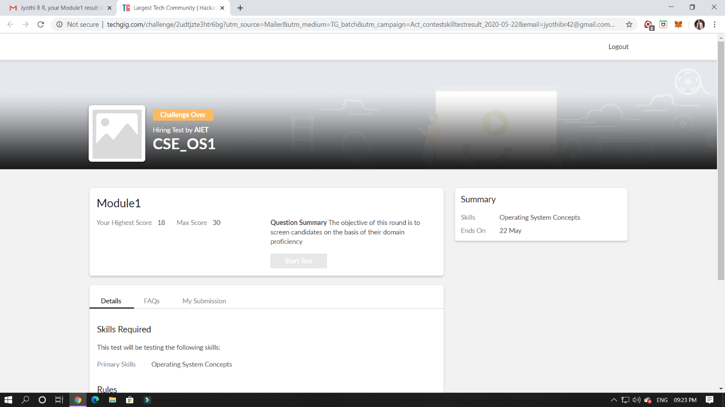

CERTIFICATION COURSE DETAILS:

Programming Essentials in Python :

Bubble Sortting:

List can be sorted in two ways:

* increasing (or more precisely - non-decreasing) - if in every pair of adjacent elements, the former element is not greater than the latter;
* decreasing (or more precisely - non-increasing) - if in every pair of adjacent elements, the former element is not less than the latter.

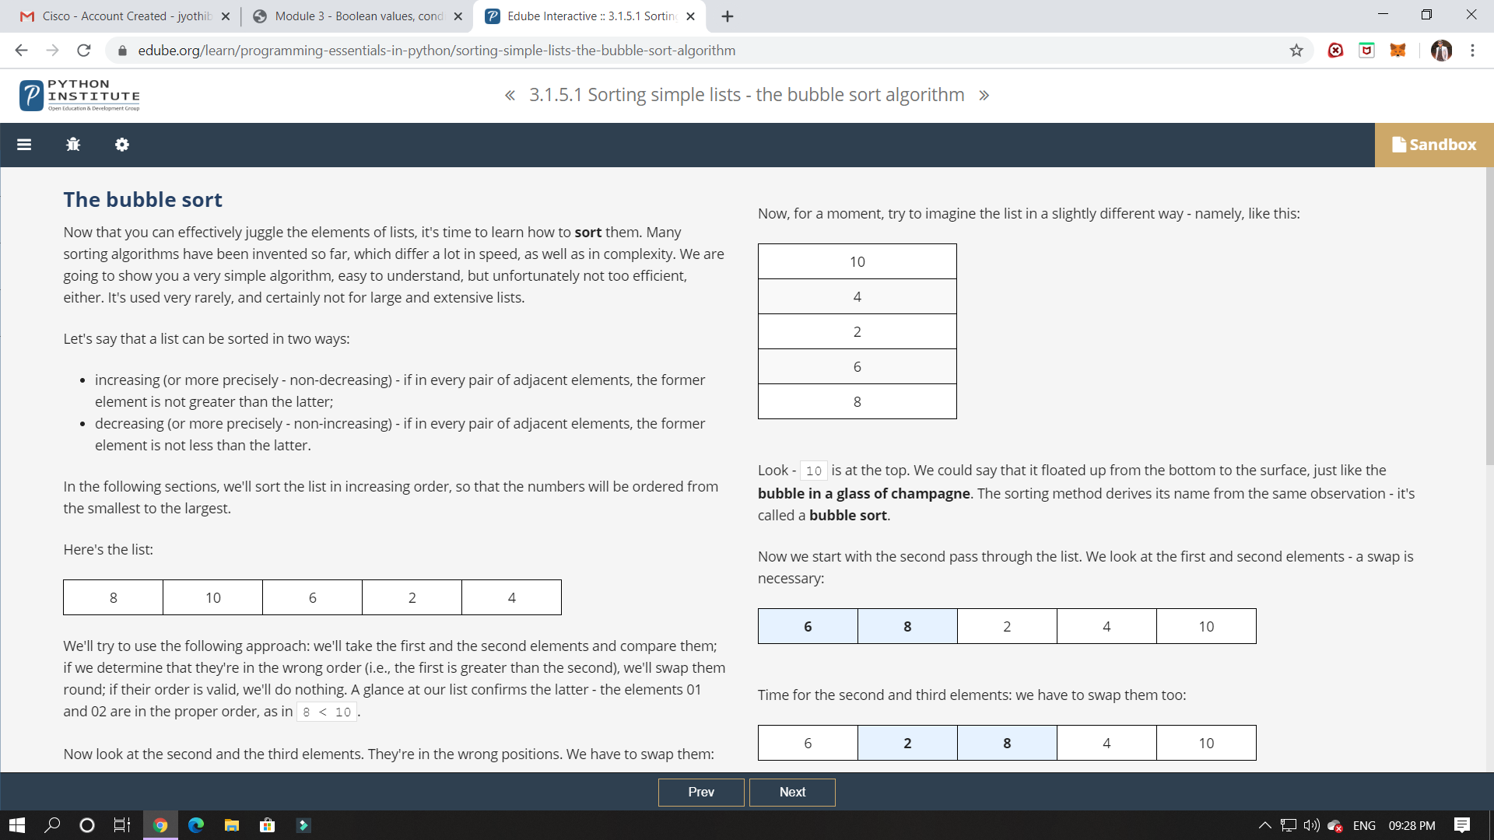

In this class I have learned about the bubble sort and its algorithm.

ONLINE CODING:

1.hint: First Create a Singly Linked List Stack with the node corresponding to First Element is the base of the stack; and its link field must be always Null.  
When you push First Element, It is the First and it is Base of the stack. Its Link must be Null. top pointer pointing to First. (top = First)  
When you push any element, (No need of checking Stack full case because SLL is dynamic) Create a new node called temp using malloc function and insert the a number into Data field, and Link field must be pointing to top; and move the pointer top to point to temp.  
When you pop, First check for stack Empty. if First == NULL, then Stack Empty. If it is not empty, The pointer temp must be pointing to top. Move the pointer top to top->link. delete temp.  
When you display the stack element, First Check for Stack Empty as in pop operation. If it is not empty, Display all the elements of current stack starting from top to First.

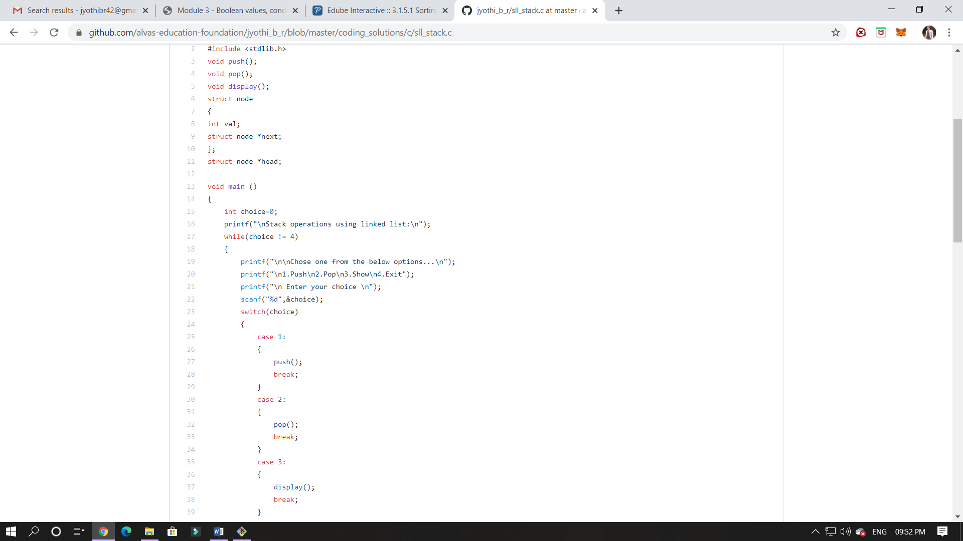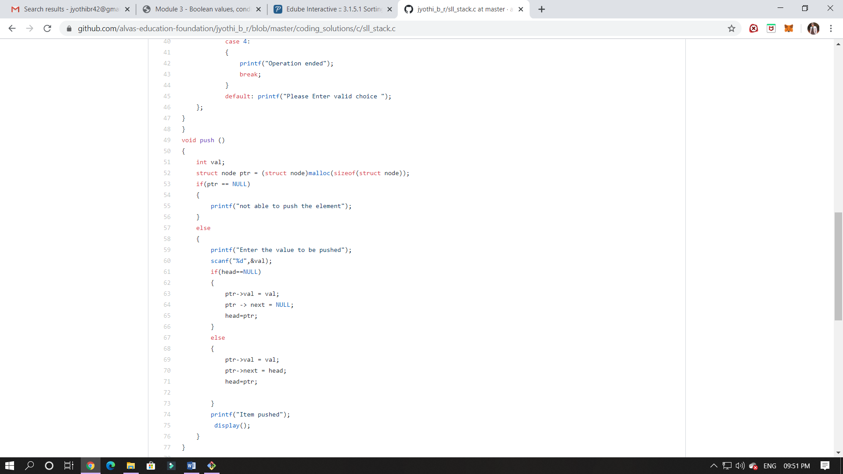

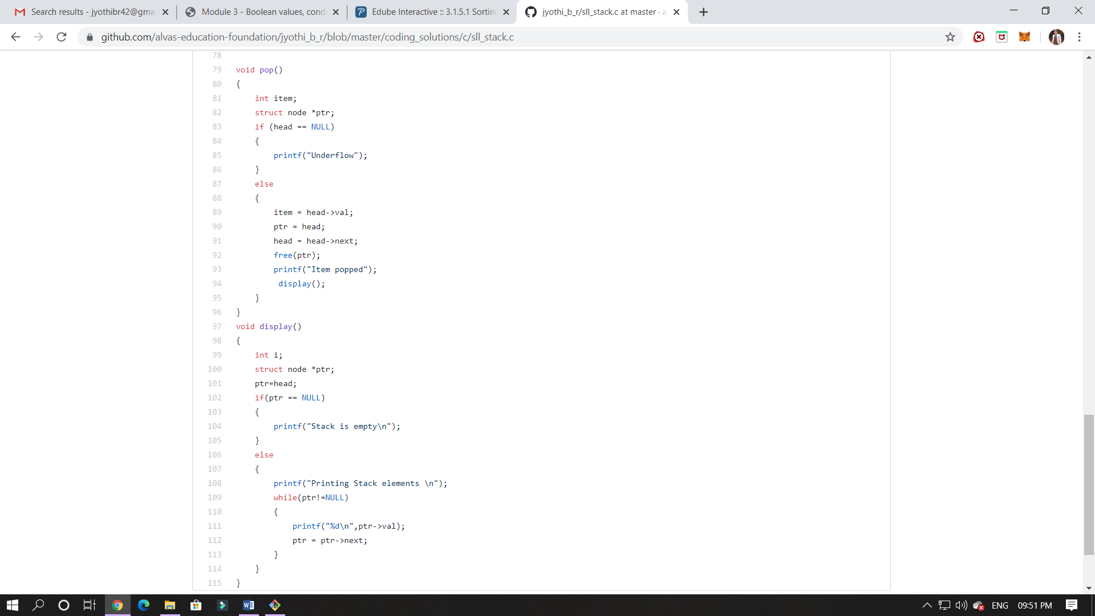

2. Write a C or Java program to implement round robin type of process scheduling.  
Input: Process with burst time, arrival time and specify the time quantum  
Output: Processes scheduled based on the round robin type of scheduling, with its average waiting time.

