**DAILY ONLINE ACTIVITIES SUMMARY**

|  |  |  |  |  |  |  |  |  |
| --- | --- | --- | --- | --- | --- | --- | --- | --- |
| **Date:** | 25-05-2020 | | | | | **Name:** | Jyothi B R | |
| **Sem & Sec** | Vi A sec | | | | | **USN:** | 4AL18CS030 | |
| **Online Test Summary** | | | | | | | | |
| **Subject** | | ----------------- | | | | | | |
| **Max. Marks** | | --- | | **Score** | | | --- | |
| **Certification Course Summary** | | | | | | | | |
| **Course** | Programming Essentials in Python | | | | | | | |
| **Certificate Provider** | | | Cisco Virtual Academy | | **Duration** | | | **1.5 hr** |
| **Coding Challenges** | | | | | | | | |
| **Problem Statement:** 1. Check whether two strings are identical  2. To check whether it’s possible to reach 1 by performing two operations on a number | | | | | | | | |
| **Status:** completed | | | | | | | | |
| **Uploaded the report in Github** | | | | | yes | | | |
| **If yes Repository name** | | | | | https://github.com/alvas-education-foundation/jyothi_b_r | | | |
| **Uploaded the report in slack** | | | | | yes | | | |

Online Test Details: (Attach the snapshot and briefly write the report for the same)

Certification Course Details: (Attach the snapshot and briefly write the report for the same)

Coding Challenges Details: (Attach the snapshot and briefly write the report for the same)

ONLINE TEST: it was not conducted

Snapshot of certification course:

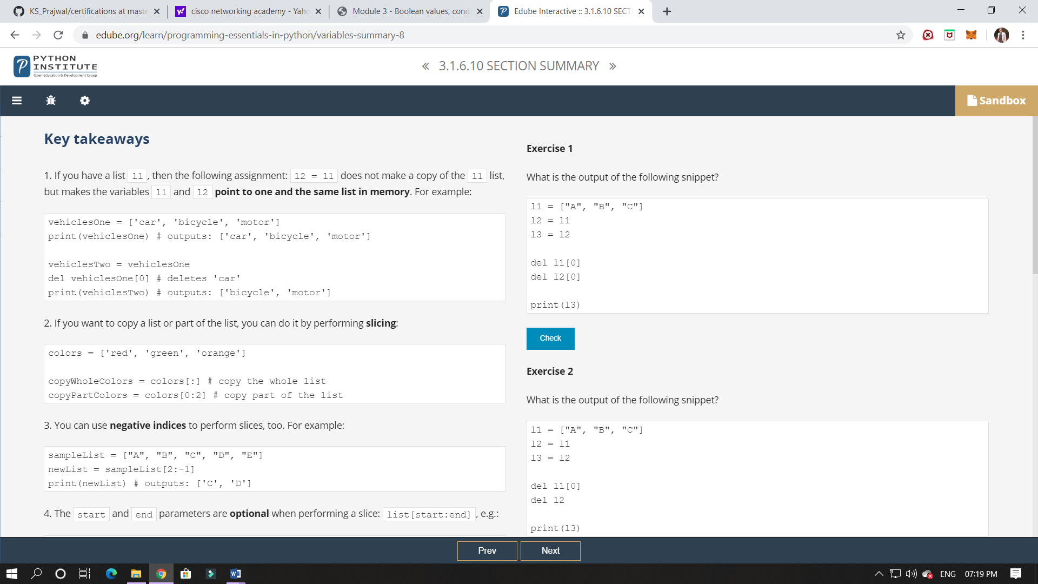

It was about summary of lists.

**Online coding:**

Problem 1: (Using C) You are given a number ***N***. You can perform the following operations on N any number of times:

> If N is***even***, divide N by **2**.

> If N is ***odd***, replace N with **3N+1**.

 Your task is to find out, for a given N, ***if it is possible to reach the number 1*** after performing the above two valid operations on N any number of times.

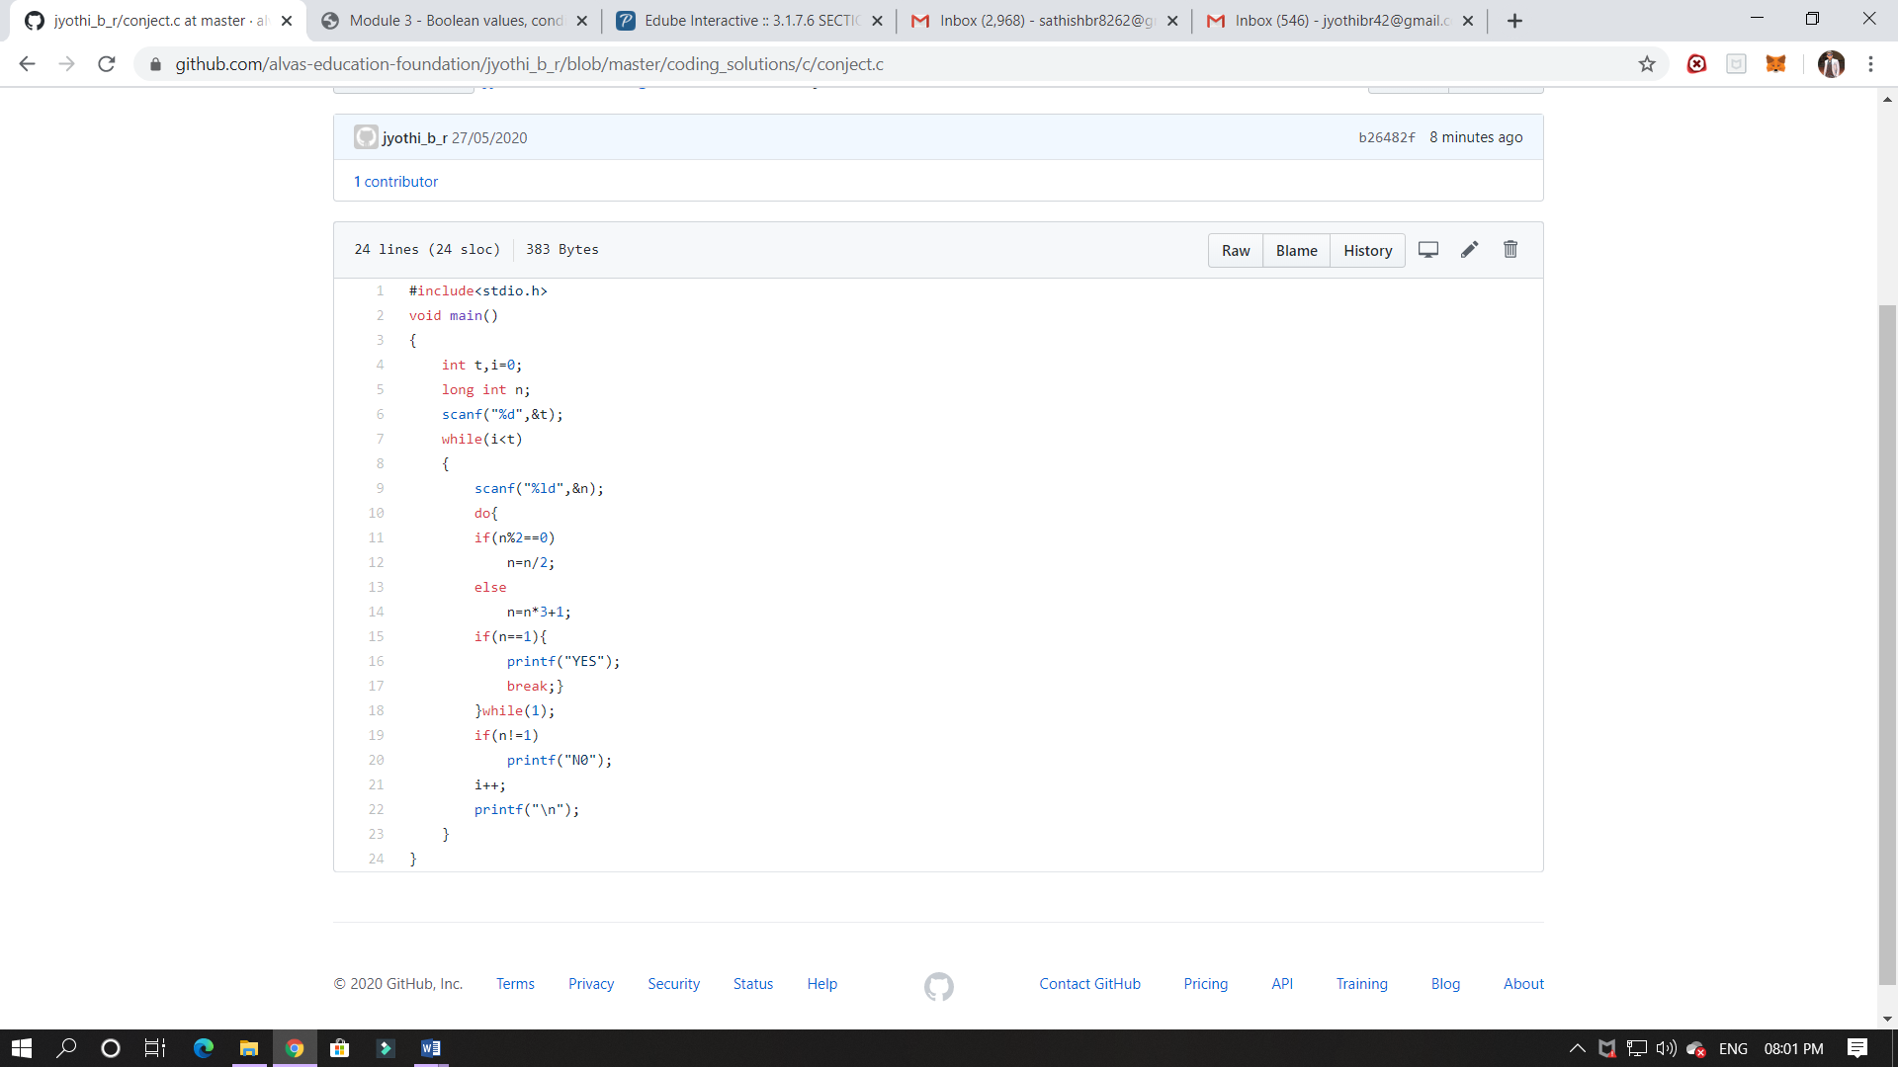

Problem 2: (using Python) Given two strings of equal length, you have to tell whether they both strings are identical. Two strings S1 and S2 are said to be identical, if any of the permutation of string S1 is equal to the string S2.

