**DAILY ASSESSMENT FORMAT**

|  |  |  |  |
| --- | --- | --- | --- |
| **Date:** | **22.05.2020** | **Name:** | **K.Naga hemanth** |
| **Course:** | **TCS ION CAREER EDGE** | **USN:** | **4AL18EC027** |
| **Topic:** | **1.Understand Artificial Intelligence (AI) Part-1.**  **2.Understand Artificial Intelligence (AI) part-2.** | **Semester & Section:** | **4TH SEM**  **& A SEC** |
| **Github Repository:** | **nagahemanth** |  |  |

|  |
| --- |
| **FORENOON SESSION DETAILS** |
| **Image of session** |
| **Report – Report can be typed or hand written for up to two pages.**  **Understand Artificial Intelligence (AI):**   * Artificial Intelligence is concerned with the design of intelligencr in an artificial device. * The turing test is the test in which if the interrogator cannot reliably distinguish the human fron the computer then the computer does possess (artificial) intelligence. * Intelligent entities need to be able to do both "mundane" and "expert" tasks., * Immediate translation between people speaking different languages would be a remarkable acheivement of AI. * AI components are embedded in numerous devices, ex: copy machines. * Should AI aims to huild manchines that can truely reason and solve complex problems. * Weak AI deals with the creation of some of computer based AI that cannot truely reason and solve problem. * Agent operate in an environment and then preceives its environment through sensors. * Then acts upto the environment through actuators or effectors. * Fundemental of AI are Acting, Sensing. Understanding reasoning and learning. * Performance measure is a subjective measures to charectreize how successful an agent is. * Rationak action is the action that maximum the expected value of the performance measures given the percrnt sequence to data   **Techinical Competency:**   * This module explain about the Techinical competency. * Interviewees seem to have knowledge on various technologies. * Warehouse is new database, primarily for reporting and analysis of data.  |  |  |  |  | | --- | --- | --- | --- | | **DATE:** | **22.05.2020** | **NAME:** | **K.Naga hemanth** | | **COURSE:** | **PYTHON** | **USN:** | **4AL18EC027** | | **TOPIC:** | **Numpy and Applications.** | **SEMESTER & SECTION:** | **4TH SEM & A SEC** | |

**Afternoon session details**

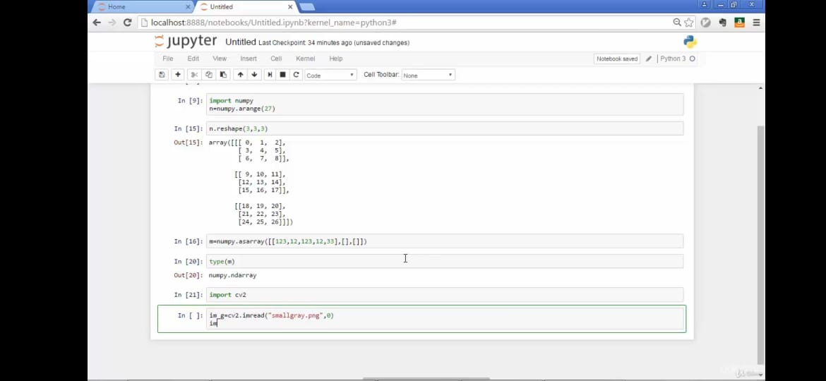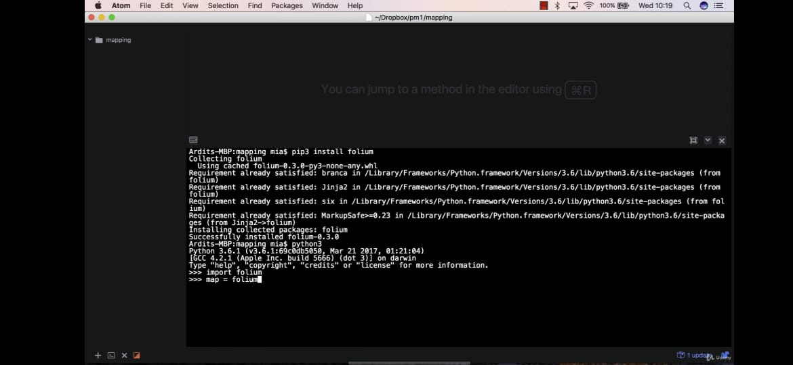

**Numpy and the applicatioms :**

>In this section we have learnt about what are numpy and the use of numpyin thepratical world.

>Stacking and splitting numpy array.

>Indexing,iterating of numpy array.

>converting image to numpy array.

>Implementing the numpy in applications like web map.

>adding files from different files and popup windows from files.

>color pointer on maps.