**DAILY ONLINE ACTIVITIES SUMMARY**

|  |  |  |  |  |  |  |  |  |
| --- | --- | --- | --- | --- | --- | --- | --- | --- |
| **Date:** | **01-07-2020** | | | | | **Name:** | **P Vighnesh Pejathaya** | |
| **Sem & Sec** | **8 sem , A sec** | | | | | **USN:** | **4al16cs060** | |
| **Online Test Summary** | | | | | | | | |
| **Subject** | | **--** | | | | | | |
| **Max. Marks** | |  | | **Score** | | |  | |
| **Certification Course Summary** | | | | | | | | |
| **Course** | **Cloud Computing** | | | | | | | |
| **Certificate Provider** | | | **Microsoft** | | **Duration** | | | **120 min** |
| **Coding Challenges** | | | | | | | | |
| **Problem Statement: Java program to print pattern.** | | | | | | | | |
| **Status: Completed** | | | | | | | | |
| **Uploaded the report in Github** | | | | | **yes** | | | |
| **If yes Repository name** | | | | | **Alvas-education-foundation/p_vighnesh** | | | |
| **Uploaded the report in slack** | | | | | **yes** | | | |

Online Test Details: (Attach the snapshot and briefly write the report for the same)

Not conducted

Certification Course Details: (Attach the snapshot and briefly write the report for the same)

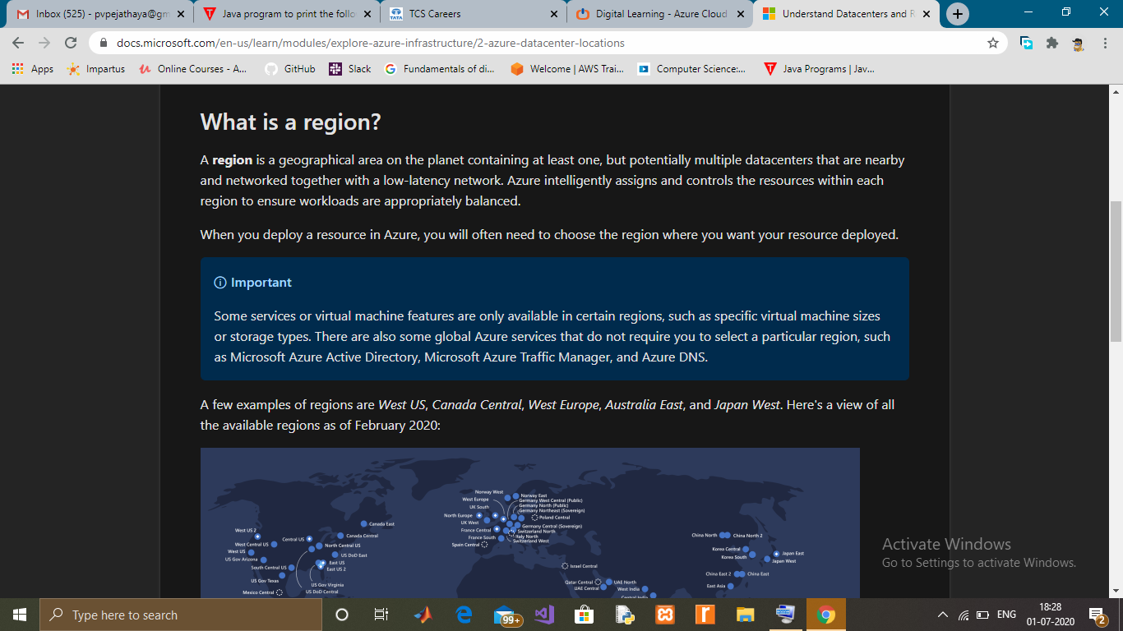

Coding Challenges Details: (Attach the snapshot and briefly write the report for the same)

## **Java program to print the following pattern**

1  
2 4  
3 6 9  
4 8 12 16  
5 10 15 20 25  
6 12 18 24 30 36  
7 14 21 28 35 42 49  
8 16 24 32 40 48 56 64  
9 18 27 36 45 54 63 72 81  
10 20 30 40 50 60 70 80 90 100