**DAILY ONLINE ACTIVITIES SUMMARY**

|  |  |  |  |  |  |  |  |  |
| --- | --- | --- | --- | --- | --- | --- | --- | --- |
| **Date:** | **05-07-2020** | | | | | **Name:** | **P Vighnesh Pejathaya** | |
| **Sem & Sec** | **8 sem , A sec** | | | | | **USN:** | **4al16cs060** | |
| **Online Test Summary** | | | | | | | | |
| **Subject** | | **--** | | | | | | |
| **Max. Marks** | |  | | **Score** | | |  | |
| **Certification Course Summary** | | | | | | | | |
| **Course** | **Machine Learning** | | | | | | | |
| **Certificate Provider** | | | **Linkedin** | | **Duration** | | | **120 min** |
| **Coding Challenges** | | | | | | | | |
| **Problem Statement: Java program to create linkedlist.** | | | | | | | | |
| **Status: Completed** | | | | | | | | |
| **Uploaded the report in Github** | | | | | **yes** | | | |
| **If yes Repository name** | | | | | **Alvas-education-foundation/p_vighnesh** | | | |
| **Uploaded the report in slack** | | | | | **yes** | | | |

Online Test Details: (Attach the snapshot and briefly write the report for the same)

Not conducted

Certification Course Details: (Attach the snapshot and briefly write the report for the same)



Coding Challenges Details: (Attach the snapshot and briefly write the report for the same)

## **Java Program to create and display a singly linked list.**

The singly linked list is a linear data structure in which each element of the list contains a pointer which points to the next element in the list. Each element in the singly linked list is called a node. Each node has two components: data and a pointer next which points to the next node in the list. The first node of the list is called as head, and the last node of the list is called a tail. The last node of the list contains a pointer to the null. Each node in the list can be accessed linearly by traversing through the list from head to tail.

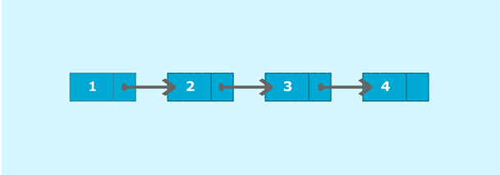

Consider the above example; node 1 is the head of the list and node 4 is the tail of the list. Each node is connected in such a way that node 1 is pointing to node 2 which in turn pointing to node 3. Node 3 is again pointing to node 4. Node 4 is pointing to null as it is the last node of the list.