**DAILY ONLINE ACTIVITIES SUMMARY**

|  |  |  |  |  |  |  |  |  |
| --- | --- | --- | --- | --- | --- | --- | --- | --- |
| **Date:** | **06-07-2020** | | | | | **Name:** | **P Vighnesh Pejathaya** | |
| **Sem & Sec** | **8 sem , A sec** | | | | | **USN:** | **4al16cs060** | |
| **Online Test Summary** | | | | | | | | |
| **Subject** | | **--** | | | | | | |
| **Max. Marks** | |  | | **Score** | | |  | |
| **Certification Course Summary** | | | | | | | | |
| **Course** | **Machine Learning** | | | | | | | |
| **Certificate Provider** | | | **Linkedin** | | **Duration** | | | **120 min** |
| **Coding Challenges** | | | | | | | | |
| **Problem Statement: Java program to find Caesar cipher.** | | | | | | | | |
| **Status: Completed** | | | | | | | | |
| **Uploaded the report in Github** | | | | | **yes** | | | |
| **If yes Repository name** | | | | | **Alvas-education-foundation/p_vighnesh** | | | |
| **Uploaded the report in slack** | | | | | **yes** | | | |

Online Test Details: (Attach the snapshot and briefly write the report for the same)

Not conducted

Certification Course Details: (Attach the snapshot and briefly write the report for the same)

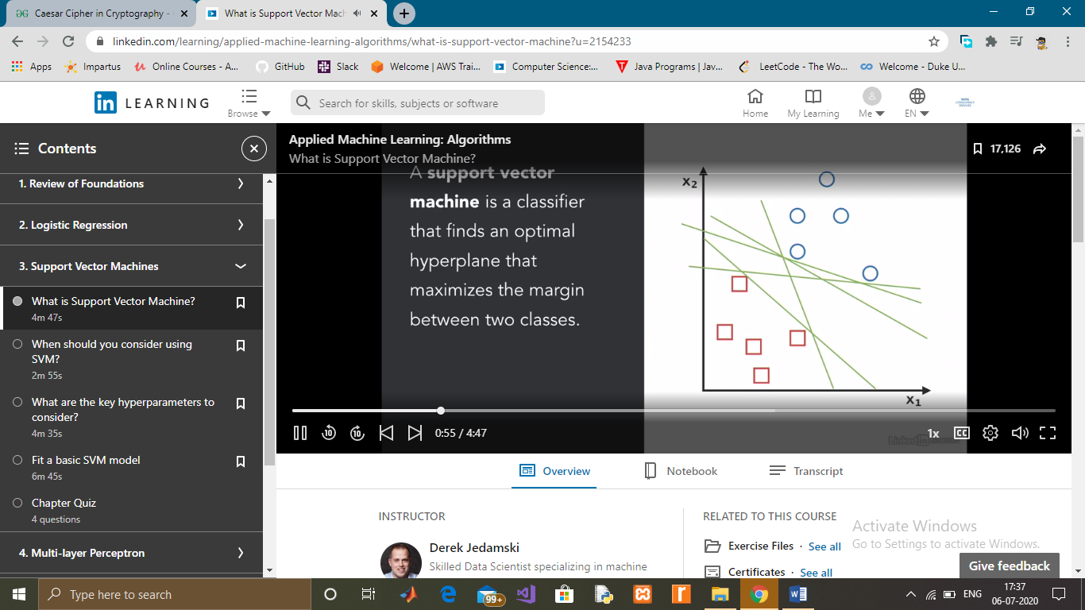

Coding Challenges Details: (Attach the snapshot and briefly write the report for the same)

# Caesar Cipher in Cryptography

The Caesar Cipher technique is one of the earliest and simplest method of encryption technique. It’s simply a type of substitution cipher, i.e., each letter of a given text is replaced by a letter some fixed number of positions down the alphabet. For example with a shift of 1, A would be replaced by B, B would become C, and so on. The method is apparently named after Julius Caesar, who apparently used it to communicate with his officials.  
Thus to cipher a given text we need an integer value, known as shift which indicates the number of position each letter of the text has been moved down.  
The encryption can be represented using modular arithmetic by first transforming the letters into numbers, according to the scheme, A = 0, B = 1,…, Z = 25. Encryption of a letter by a shift n can be described mathematically as.

(Encryption Phase with shift n)

(Decryption Phase with shift n)

