**DAILY ONLINE ACTIVITIES SUMMARY**

|  |  |  |  |  |  |  |  |  |
| --- | --- | --- | --- | --- | --- | --- | --- | --- |
| **Date:** | **07-07-2020** | | | | | **Name:** | **P Vighnesh Pejathaya** | |
| **Sem & Sec** | **8 sem , A sec** | | | | | **USN:** | **4al16cs060** | |
| **Online Test Summary** | | | | | | | | |
| **Subject** | | **--** | | | | | | |
| **Max. Marks** | |  | | **Score** | | |  | |
| **Certification Course Summary** | | | | | | | | |
| **Course** | **Machine Learning** | | | | | | | |
| **Certificate Provider** | | | **Linkedin** | | **Duration** | | | **120 min** |
| **Coding Challenges** | | | | | | | | |
| **Problem Statement: Java program to find Fibonacci series.** | | | | | | | | |
| **Status: Completed** | | | | | | | | |
| **Uploaded the report in Github** | | | | | **yes** | | | |
| **If yes Repository name** | | | | | **Alvas-education-foundation/p_vighnesh** | | | |
| **Uploaded the report in slack** | | | | | **yes** | | | |

Online Test Details: (Attach the snapshot and briefly write the report for the same)

Not conducted

Certification Course Details: (Attach the snapshot and briefly write the report for the same)

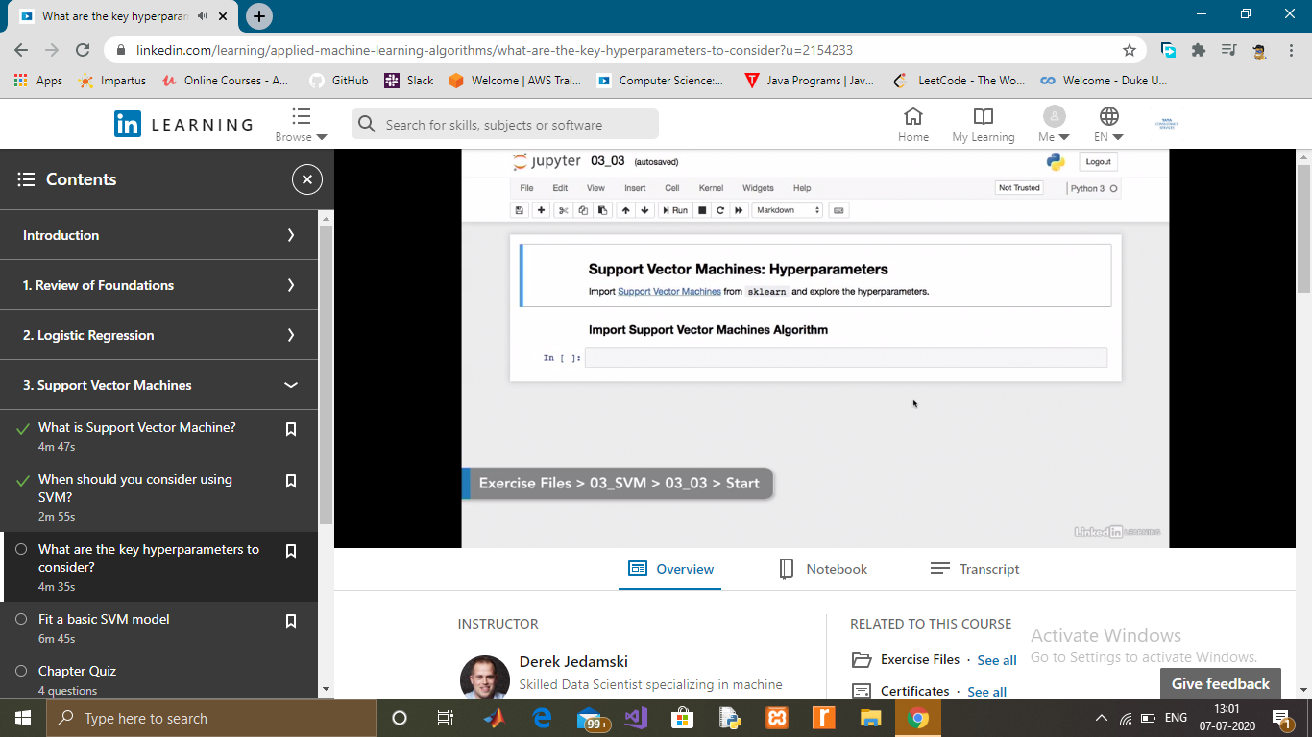

Coding Challenges Details: (Attach the snapshot and briefly write the report for the same)

Fibonacci series in Java

In fibonacci series, *next number is the sum of previous two numbers* for example 0, 1, 1, 2, 3, 5, 8, 13, 21, 34, 55 etc. The first two numbers of fibonacci series are 0 and 1.

There are two ways to write the fibonacci series program in java:

* Fibonacci Series without using recursion
* Fibonacci Series using recursion