**DAILY ONLINE ACTIVITIES SUMMARY**

|  |  |  |  |  |  |  |  |  |
| --- | --- | --- | --- | --- | --- | --- | --- | --- |
| **Date:** | **09-07-2020** | | | | | **Name:** | **P Vighnesh Pejathaya** | |
| **Sem & Sec** | **8 sem , A sec** | | | | | **USN:** | **4al16cs060** | |
| **Online Test Summary** | | | | | | | | |
| **Subject** | | **--** | | | | | | |
| **Max. Marks** | |  | | **Score** | | |  | |
| **Certification Course Summary** | | | | | | | | |
| **Course** | **Machine Learning** | | | | | | | |
| **Certificate Provider** | | | **Linkedin** | | **Duration** | | | **120 min** |
| **Coding Challenges** | | | | | | | | |
| **Problem Statement: Java program to find smallest elements in tree.** | | | | | | | | |
| **Status: Completed** | | | | | | | | |
| **Uploaded the report in Github** | | | | | **yes** | | | |
| **If yes Repository name** | | | | | **Alvas-education-foundation/p_vighnesh** | | | |
| **Uploaded the report in slack** | | | | | **yes** | | | |

Online Test Details: (Attach the snapshot and briefly write the report for the same)

Not conducted

Certification Course Details: (Attach the snapshot and briefly write the report for the same)

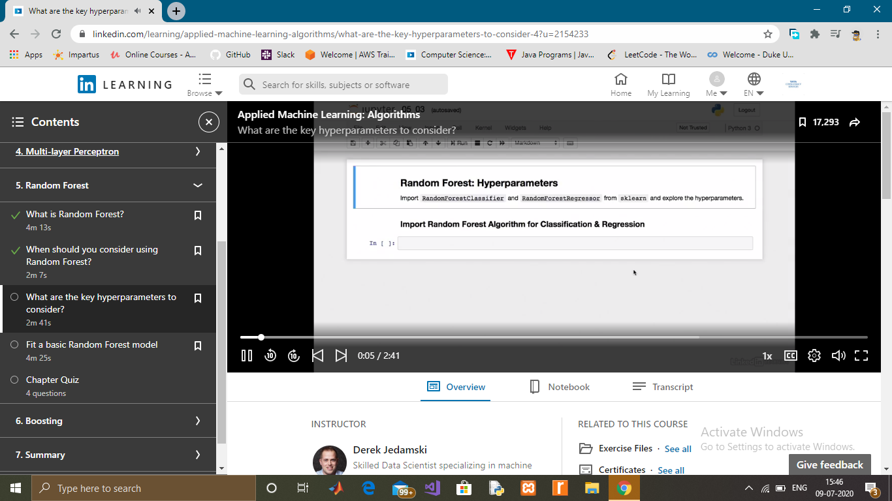

Coding Challenges Details: (Attach the snapshot and briefly write the report for the same)

## **Java program to find the smallest element in a tree**

In this program, we will find out the smallest node in the given binary tree. We first define variable min that will hold root's data. Then, we traverse through left sub-tree to find the smallest node in left subtree. Compare it with min and store minimum of two in variable min. Then, we traverse through right subtree to find smallest node and compare it with min. At the end, min will have the smallest node.

