**DAILY ONLINE ACTIVITIES SUMMARY**

|  |  |  |  |  |  |  |  |  |
| --- | --- | --- | --- | --- | --- | --- | --- | --- |
| **Date:** | **11-07-2020** | | | | | **Name:** | **P Vighnesh Pejathaya** | |
| **Sem & Sec** | **8 sem , A sec** | | | | | **USN:** | **4al16cs060** | |
| **Online Test Summary** | | | | | | | | |
| **Subject** | | **--** | | | | | | |
| **Max. Marks** | |  | | **Score** | | |  | |
| **Certification Course Summary** | | | | | | | | |
| **Course** | **Machine Learning** | | | | | | | |
| **Certificate Provider** | | | **Linkedin** | | **Duration** | | | **120 min** |
| **Coding Challenges** | | | | | | | | |
| **Problem Statement: Java program to convert object to string.** | | | | | | | | |
| **Status: Completed** | | | | | | | | |
| **Uploaded the report in Github** | | | | | **yes** | | | |
| **If yes Repository name** | | | | | **Alvas-education-foundation/p_vighnesh** | | | |
| **Uploaded the report in slack** | | | | | **yes** | | | |

Online Test Details: (Attach the snapshot and briefly write the report for the same)

Not conducted

Certification Course Details: (Attach the snapshot and briefly write the report for the same)

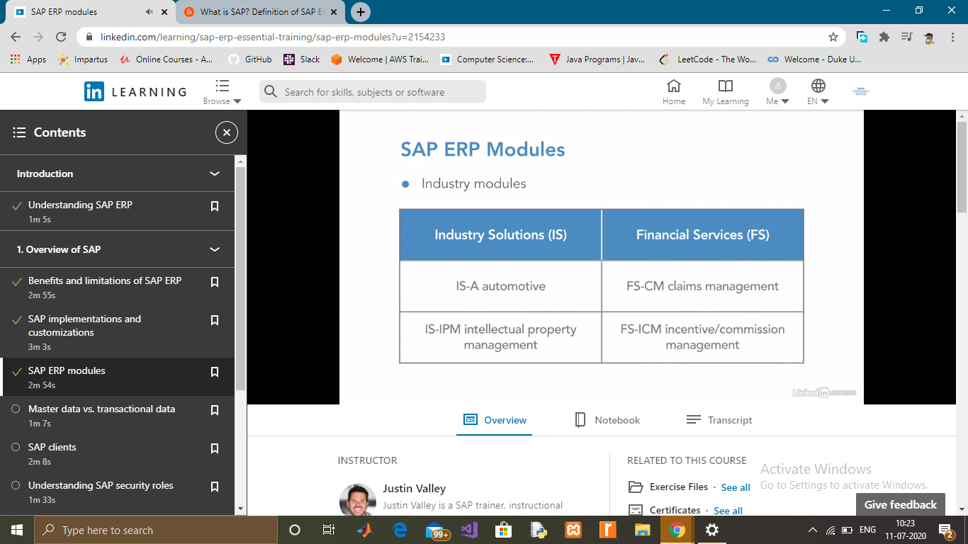

Coding Challenges Details: (Attach the snapshot and briefly write the report for the same)

# Java Convert Object to String

# We can convert **Object to String in java** using toString() method of Object class or String.valueOf(object) method.

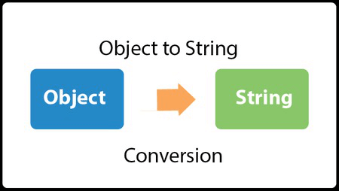

You can convert any object to String in java whether it is user-defined class, StringBuilder, StringBuffer or anything else.Here, we are going to see two examples of converting Object into String. In the first example, we are going to convert Emp class object into String which is an user-defined class. In second example, we are going to convert StringBuilder to String.