**DAILY ONLINE ACTIVITIES SUMMARY**

|  |  |  |  |  |  |  |  |  |
| --- | --- | --- | --- | --- | --- | --- | --- | --- |
| **Date:** | **12-06-2020** | | | | | **Name:** | **P Vighnesh Pejathaya** | |
| **Sem & Sec** | **8 sem , A sec** | | | | | **USN:** | **4AL16CS060** | |
| **Online Test Summary** | | | | | | | | |
| **Subject** | | **BDA** | | | | | | |
| **Max. Marks** | | **30** | | **Score** | | | **24** | |
| **Certification Course Summary** | | | | | | | | |
| **Course** | **SDLC Algorithm and design principals** | | | | | | | |
| **Certificate Provider** | | | **TCS** | | **Duration** | | | **120 min** |
| **Coding Challenges** | | | | | | | | |
| **Problem Statement: Python program to find Hash of file.** | | | | | | | | |
| **Status: Completed** | | | | | | | | |
| **Uploaded the report in Github** | | | | | **yes** | | | |
| **If yes Repository name** | | | | | **Alvas-education-foundation/p_vighnesh** | | | |
| **Uploaded the report in slack** | | | | | **yes** | | | |

Online Test Details: (Attach the snapshot and briefly write the report for the same)

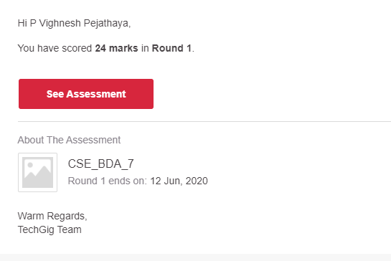

Certification Course Details: (Attach the snapshot and briefly write the report for the same)

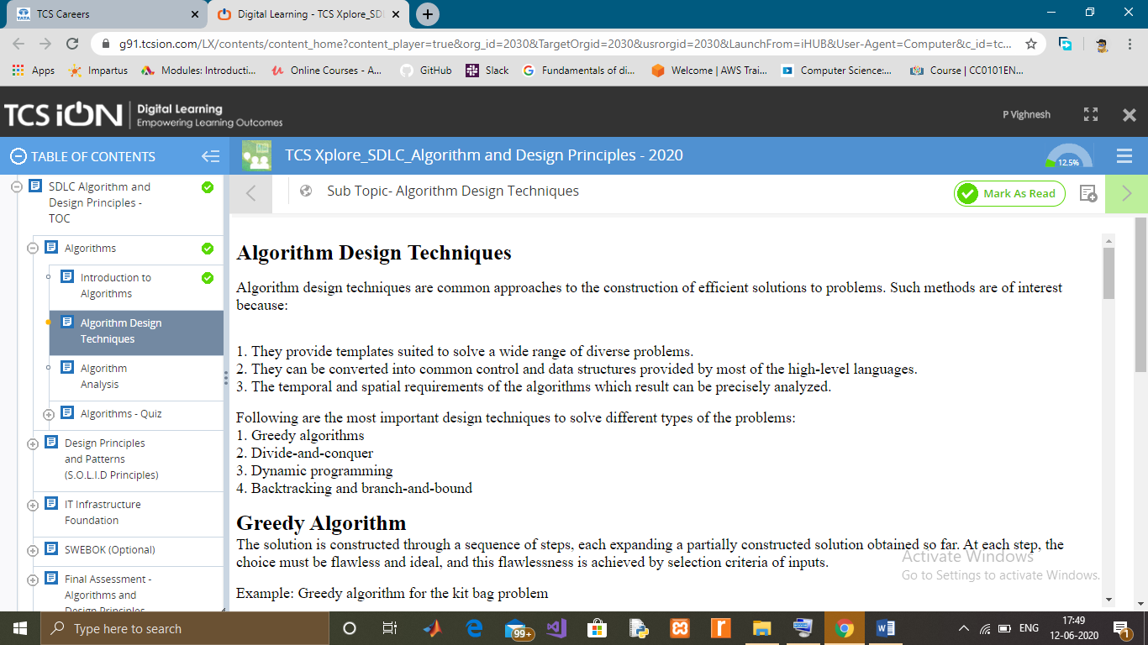

Coding Challenges Details: (Attach the snapshot and briefly write the report for the same)

Hash functions take an arbitrary amount of data and return a fixed-length bit string. The output of the function is called the digest message.

They are widely used in cryptography for authentication purposes. There are many hashing functions like MD5, SHA-1 etc. Here the SHA-1 hashing algorithm used. The digest of SHA-1 is 160 bits long.We do not feed the data from the file all at once, because some files are very large to fit in memory all at once. Breaking the file into small chunks will make the process memory efficient.

In this program, open the file in binary mode. Hash functions are available in the hashlib module. We loop till the end of the file using a while loop. On reaching the end, we get empty bytes object.In each iteration, we only read 1024 bytes (this value can be changed according to our wish) from the file and update the hashing function.Finally, we return the digest message in hexadecimal representation using the hexdigest() method.