**DAILY ONLINE ACTIVITIES SUMMARY**

|  |  |  |  |  |  |  |  |  |
| --- | --- | --- | --- | --- | --- | --- | --- | --- |
| **Date:** | **12-07-2020** | | | | | **Name:** | **P Vighnesh Pejathaya** | |
| **Sem & Sec** | **8 sem , A sec** | | | | | **USN:** | **4al16cs060** | |
| **Online Test Summary** | | | | | | | | |
| **Subject** | | **--** | | | | | | |
| **Max. Marks** | |  | | **Score** | | |  | |
| **Certification Course Summary** | | | | | | | | |
| **Course** | **Machine Learning** | | | | | | | |
| **Certificate Provider** | | | **Linkedin** | | **Duration** | | | **120 min** |
| **Coding Challenges** | | | | | | | | |
| **Problem Statement: Java program to convert object to string.** | | | | | | | | |
| **Status: Completed** | | | | | | | | |
| **Uploaded the report in Github** | | | | | **yes** | | | |
| **If yes Repository name** | | | | | **Alvas-education-foundation/p_vighnesh** | | | |
| **Uploaded the report in slack** | | | | | **yes** | | | |

Online Test Details: (Attach the snapshot and briefly write the report for the same)

Not conducted

Certification Course Details: (Attach the snapshot and briefly write the report for the same)

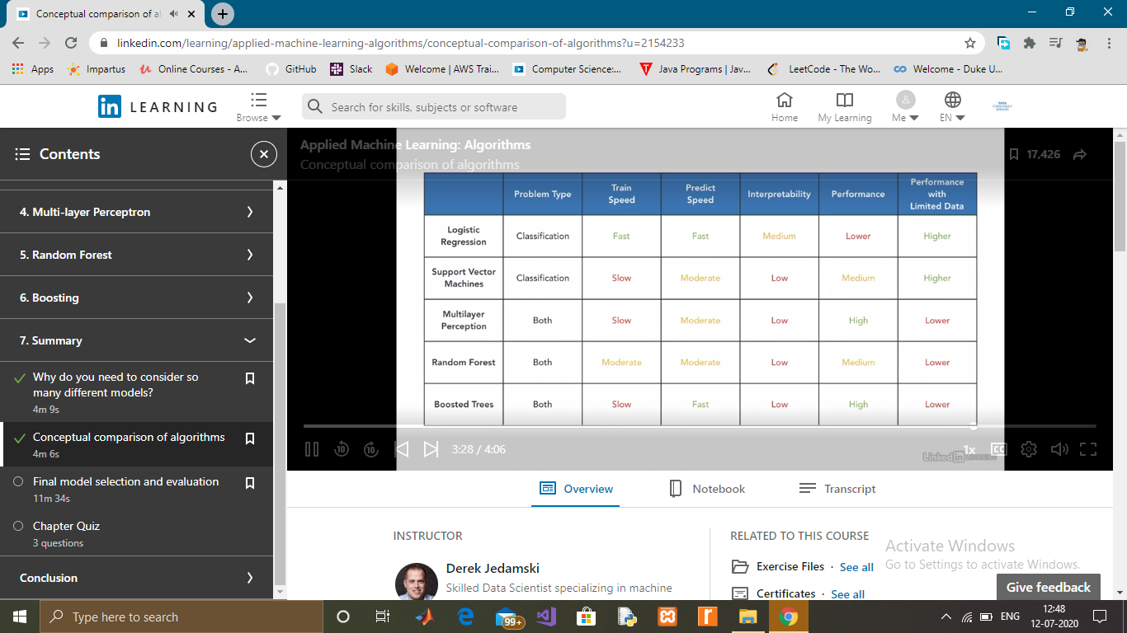

Coding Challenges Details: (Attach the snapshot and briefly write the report for the same)

## **Program to print the duplicate elements of an array**

In this program, we need to print the duplicate elements present in the array. This can be done through two loops. The first loop will select an element and the second loop will iteration through the array by comparing the selected element with other elements. If a match is found, print the duplicate element.

Program to print the duplicate elements of an array

In the above array, the first duplicate will be found at the index 4 which is the duplicate of the element (2) present at index 1. So, duplicate elements in the above array are 2, 3 and 8.